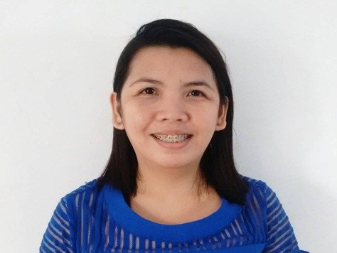***MARIDEL S. VALENCIA***

Blk 8 Lot 8 Terraza de Antipolo

Brgy.Dalig, Antipolo City, Philippines

[msison_09@yahoo.com](mailto:Msison_09@yahoo.com)

Mobile #: 0917 - 4185528

_____________________________________________________________________________________

**CAREER OBJECTIVE**

* To build a long-term career with opportunities for career growth
* To work hard and learn new things with full dedication for achievement of Company’s objectives
* To enhance my knowledge more and explore

**WORK EXPERIENCE**

**COMPANY : ABS-CBN Broadcasting Corp.**

Mother Ignacia St. Diliman Quezon City Philippines

**EMPLOYMENT PERIOD :** November 2013 to October 14, 2016

**POSITION :** RAS ENCODER (Engineering-Technical Operation Division)

**DUTIES AND RESPONSIBILITIES**

* Scheduling of Technical Broadcast Equipment/Facilities using Resource Allocation System (RAS) and recommend outsourcing
* Ensure that the client’s technical requirement will be provided and ensuring that all in-house equipment is fully maximized and properly assigned to programs.
* Ensure that the client’s technical request through RMS will be provided.
* Receiving and signing RMS hard copy which is the basis of the final equipment request.
* Approval of the request through RAS
* Attending calls from the clients concerning daily equipment request.
* Provided daily/weekly/monthly transaction report.
* Able to perform any other duties with minimal supervision.
* Perform any other duties required/requested for the good of the team.
* Maintain strong work ethics all the time.

**COMPANY : ABS-CBN Broadcasting Corp.**

Mother Ignacia street Diliman Quezon City Philippines

**EMPLOYMENT PERIOD :** January 2013 to November 2013

**POSITION :** ENCODER (Engineering-Technical Operation Division)\

**DUTIES AND RESPONSIBILITIES**

* Daily issuance and return of broadcast facilities/ equipment using RFID module.
* Analyzing discrepancy of equipment/ facilities requested to RFID module.
* Log and issue work order forms which is the basis of their final equipment/facilities request for pull out.

**COMPANY : ABS-CBN Broadcasting Corp.**

Mother Ignacia St. Diliman Quezon City Philippines

**EMPLOYMENT PERIOD :** May 2007 to 2013

**POSITION :** ENCODER (Engineering-Technical Operation Division)

**DUTIES AND RESPONSIBILITIES**

* Scheduling and allocating manpower on their respective programs deployment.
* Attending calls from the client concerning manpower request.
* Consolidate all freelancer schedule to be used for RFP (Request for Payments)
* Daily monitoring of long term manpower.
* Consolidate and prepare forms of manpower long term “raket”.
* Consolidate all memos given to IJM and their response
* Consolidate manpower daily schedule to be used on report.
* Perform any other duties required/requested for the good of the team and the company.
* Maintain strong work ethics all the time

**COMPANY : K-BON Construction Corporation**

Oro Vista Subdivision, Brgy. MayamotAntipolo City

**EMPLOYMENT PERIOD :** July 2006 to March 2007

**POSITION :** Secretary

**DUTIES AND RESPONSIBILITIES**

* Data Encoding
* Updating and filling documents
* Attending incoming and outgoing calls.
* Record all transactions and Other Assign task

**SKILLS**

* Typing skills
* Stenography
* Computer Literate (MS Word, Excel,Power point, Data & Photoshop

**EDUCATIONAL BACKGROUND**

**TERTIARY : Pasig Catholic College**

**Bachelor of Science in Office Administration**

Major in Computer Secretarial Education

**YEAR : April 2006**

**SECONDARY : Rizal High School, Pasig City**

**YEAR : March 2001**

**PRIMARY : Dr. Sixto Antonio Elementary School**

**YEAR : March 1997**

**PERSONAL DATA**

**BIRTH DATE** : March 14, 1983

**BIRTH PLACE** : Pasig city

**HEIGHT :** 5’2

**WEIGHT :** 120lbs

**CIVIL STATUS** : Married

**RELIGION** : Catholic

**CHARACTER REFERENCES**

Available Upon Request.

I hereby certify that the above information are true and correct to my outmost knowledge and belief

________________________

*Signature*