Meta Title: 5 Things I Was Surprised By After Becoming A Father
Meta Description: Becoming a father changes your life forever. Here are five interesting things I observed after becoming a father last year.

5 Things I Learned After Becoming A Father
My wife gave birth to a beautiful baby boy in January 2016 and my life has never been the same since then. While I had done my research about becoming a father, the real deal was nothing like the theory. I found myself completely unprepared in a number of areas, but my life changed for the better. While I am still relatively new to the gig, and am making it up as I go along, here are five things I learned after becoming a father that I want to share with you.

You Feel Love Like You Have Never Felt It Before
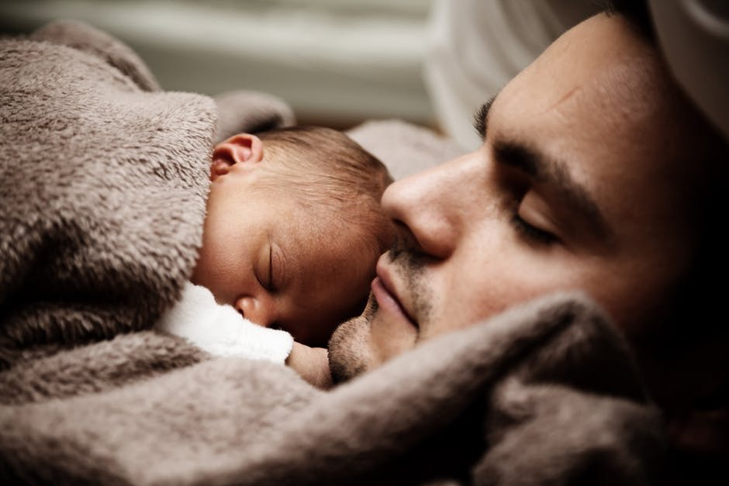
(Image: Pexels)
No parent can ever forget the moment they first held their baby in their arms. In that one moment, your life changes forever. You become the caretaker and the protector of this tiny little being, who is utterly defenseless without you. You look into his eyes and feel something you have never felt before in your life: true love. But wait, surely you have felt true love before at some point in your life, right? Well, you may love your parents, your siblings, and your partner, but there is nothing in this world like the love you feel for your baby.
Don’t take it from me. According to science, babies release pheromones that help them bond with their mothers, and trigger the same reward centers in the brain as drugs. That’s why women always rush to smell newborn babies. As for the fathers, babies rewire the brains of their fathers giving them a neuron boost. Furthermore, a father’s active involvement in his baby’s life also helps develop the baby’s brain in a quicker manner — so it is a symbiotic relationship — you get to feel the kind of love you have never felt before, and the baby gets all the love and care in the world it needs to grow up and be able to look after himself.

Your Baby Starts To Recognize You Within The First Few Weeks
(Image: Pexels)
When I held my baby in my arms for the first time, I wasn’t the only one doing all the looking. My baby boy literally stopped crying and started to look at me as you would someone you have seen before but can’t quite place where. When we got home, a number of people came to visit bearing gifts, but he made it clear that he was only comfortable with his mom holding him, or, wait for it, his dad (aka me). It was unreal, especially since I knew that he couldn’t see past a few feet in the first few weeks. In fact, I had read that babies could only see light, movement, and shapes at first. I did some further research about it and found out that babies can recognize their father’s smell and voice from the get go. In fact, they can hear you from the womb.

Your Parents Love Your Baby More Than They Love You
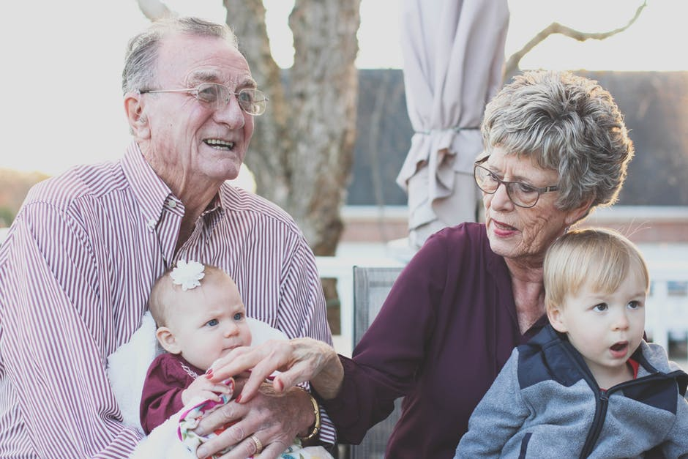
(Image: Pexels)
While having a baby changes the life of the parents forever, it also has a huge impact on the grandparents. When my son was born, I saw a huge change in my mother and my father. They wanted to spend as much time as possible with the baby, and used to buy gifts for the baby every day. My parents live at a walking distance from my house, which meant they came over every day (and still do), and showered the baby with as much love as possible. While it may not sound like something out of the ordinary, I found them to be completely different people ever since the baby was born. I tried looking it up but could not find a scientific study to back my claims, but I did find this awesome article about grandparents reacting to pregnancy announcements.

You Find Yourself Yearning For A Good Night’s Sleep
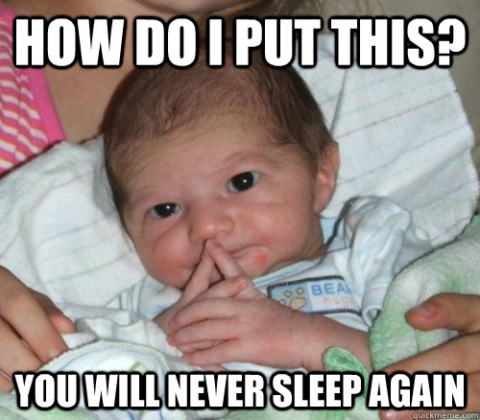
(Image: QuickMeme)
I came across this meme years ago but at the time I didn’t get it. Children have their own sleep cycles and they do not usually go for eight or more hours of sleep in one go. My son sleeps for a couple of hours, wakes up refreshed, and then wakes everyone up. It was like that for the first few months, and his sleep cycle changes from time to time, but I haven’t had a good night’s sleep in a while. Pro-tip, do take care of your health and get sleep whenever possible, may be work something out with your wife and take turns tending to the baby.

Your Relationship with Your Wife Changes Forever
(Image: Pexels)
A baby requires constant care and attention. Taking care of your baby is something that can potentially take up every waking hour of your life that you spend at home. If you are a nine to five guy like I am, you come home, watch some TV, spend some time on the internet, spend some time with your wife, have dinner and go to sleep. Put a baby into this equation, and all of a sudden you are spending a lot more money, getting a lot less sleep, and your sex life takes a nose dive like you have never seen before. Not having sex, not spending any time together, and only talking about the baby can take all the romance away from marriage. You and your partner start feeling like colleagues working on the project together, which is not a bad thing, but it takes the intimacy away from the relationship. It is important to divide chores and responsibilities, and keep working on your relationship. You can even get help from couples’ groups in order to never lose sight of what’s important.
So these were the things I was pretty much unprepared for and were surprised by after becoming a father. What’s your take on the matter? Leave a comment below.

