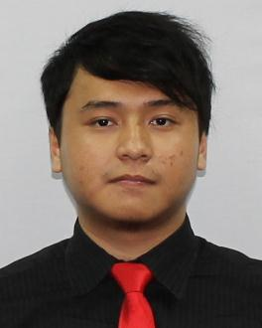
Yudi Prasetya
Taman Udayana VI no 33 Sentul City, Kel. Bojong Koneng
Kec. Babakan Madang Kab. Bogor West Java Indonesia 16810.
Phone number: +60174469538
E-mail: prasetya_yudi684@yahoo.com
Padang, West Sumatera, Indonesia

Personal Details:
Date of birth: 22nd of May 1992 Nationality : Indonesian
Sex : Male Marital Status: Single

Objective: Seeking for an internship or a job in electronic engineering field or any field related to my specific skill and to work with a progressive and forward thinking company where I can use my skills.

Working experience:
- Science and Language subject’s teacher at ITTC
- Worked voluntarily as a teacher in a junior high school
- Internship in ground panel project on automation field engineering

Skills:
- Ability to provide technical assistance and resolution
- Able to modify electronic parts, prototypes, systems and meetings
- Familiarity with Complementary Metal-Oxide Semiconductor (CMOS) logic circuit design and cadence software for final year project.
- Able to work together with other engineers and individuals to solve and define the developmental problems
- Japanese language knowledge is equal to JLPT N1
- Proficient with C++, using DevC++ ,Command prompt and HyperTerminal
- Experience in operating Orcad, multisim, Matlab and Verilog
- Knowledge in music theory and music instruments
Activities and Involvement:
- Has been traveling to several countries in order to learn other’s culture and practice language skill.
- Presentation in a Micro-Processor project using Arduino
- Achieved 8th Kyu (yellow belt) in karate
- Performed on annual Japan Festival at USM
- became resource person for general discussion on ‘artificial insemination’ topic
- Annual performance on Indonesian Culture Night at USM.
- Thesis : study of lower power design technique for analog circuits

Languages:

Proficiency: 0=poor, 10=excellent
Language | Spoken | Written
Japanese | N2 | N1
English | 9 | 9
Bahasa (Malay) | 9 | 8
Arabic | 8 | 9

Education:
- (2012 – 2016) Universiti Sains Malaysia Engineering Campus
Bachelor of Electronic Engineering (Honours)
Highlight: Final Year project : A-
Analog IC Design (elective) : A-
- (2004 - 2010) ITT college Gontor (with excellent predicate)
Graduated with 89.2% percentage

Reference

DR. NORLAILI BINTI MOHD. NOH CEng MIET M.I.E.M.
Associate Professor
School of Electrical & Electronic Engineering
Engineering Campus
Universiti Sains Malaysia
14300 Nibong Tebal, Penang
Tel: +60125106540

