[Date]

Aiman Zaidan

Portfolio

My Project Involvement

<http://accomix.com/>

* Using customized framework (Codeigniter, PHP, MySQL and Bootstrap) - Individuals

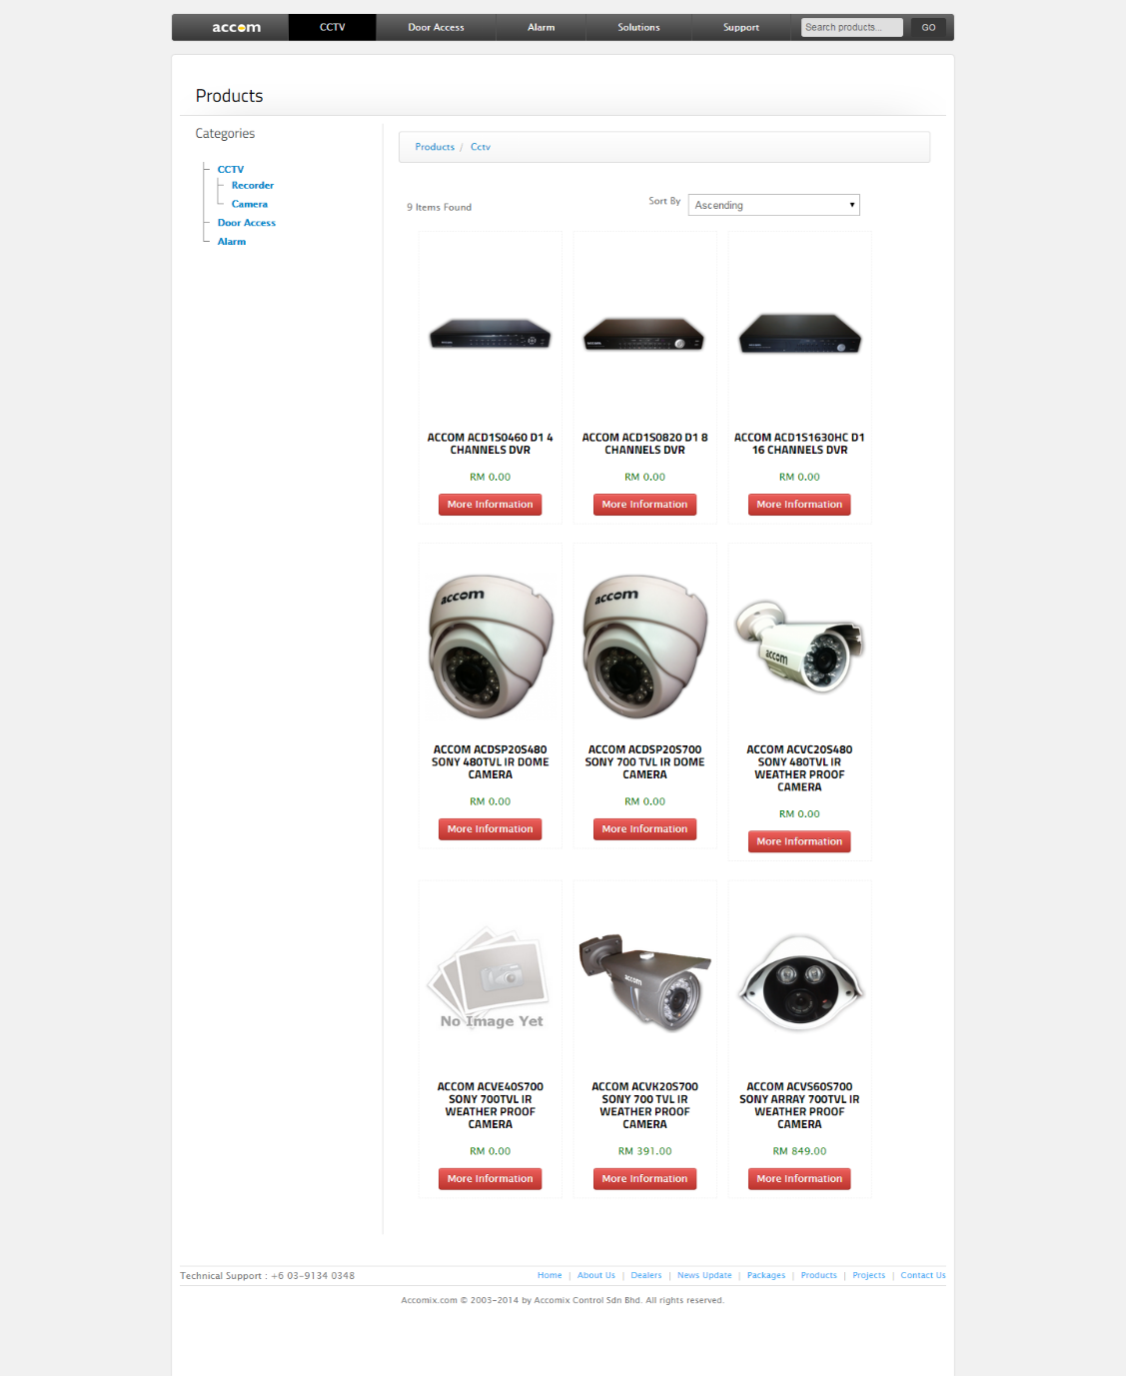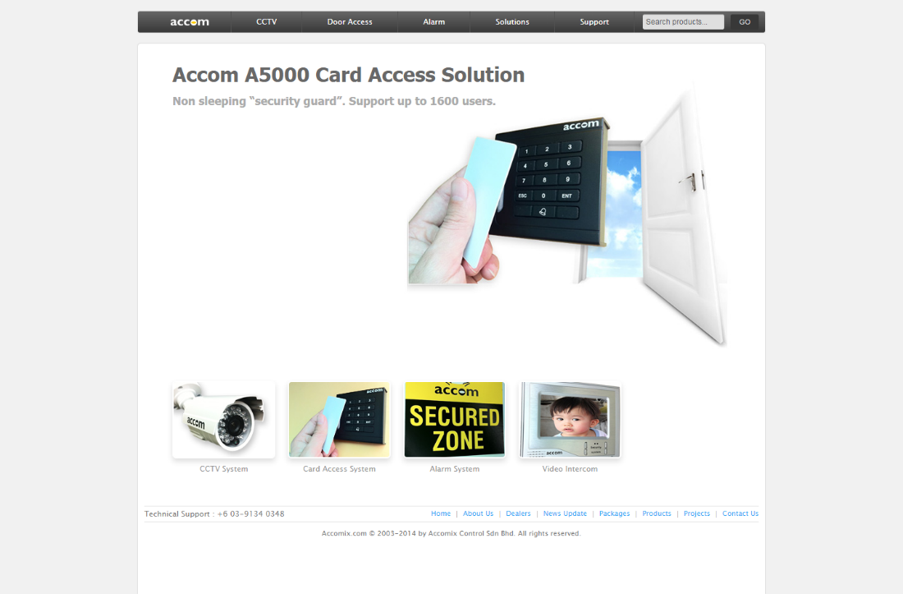

<http://daris.com.my/>

* PHP, MySQL, Custom Template - Team

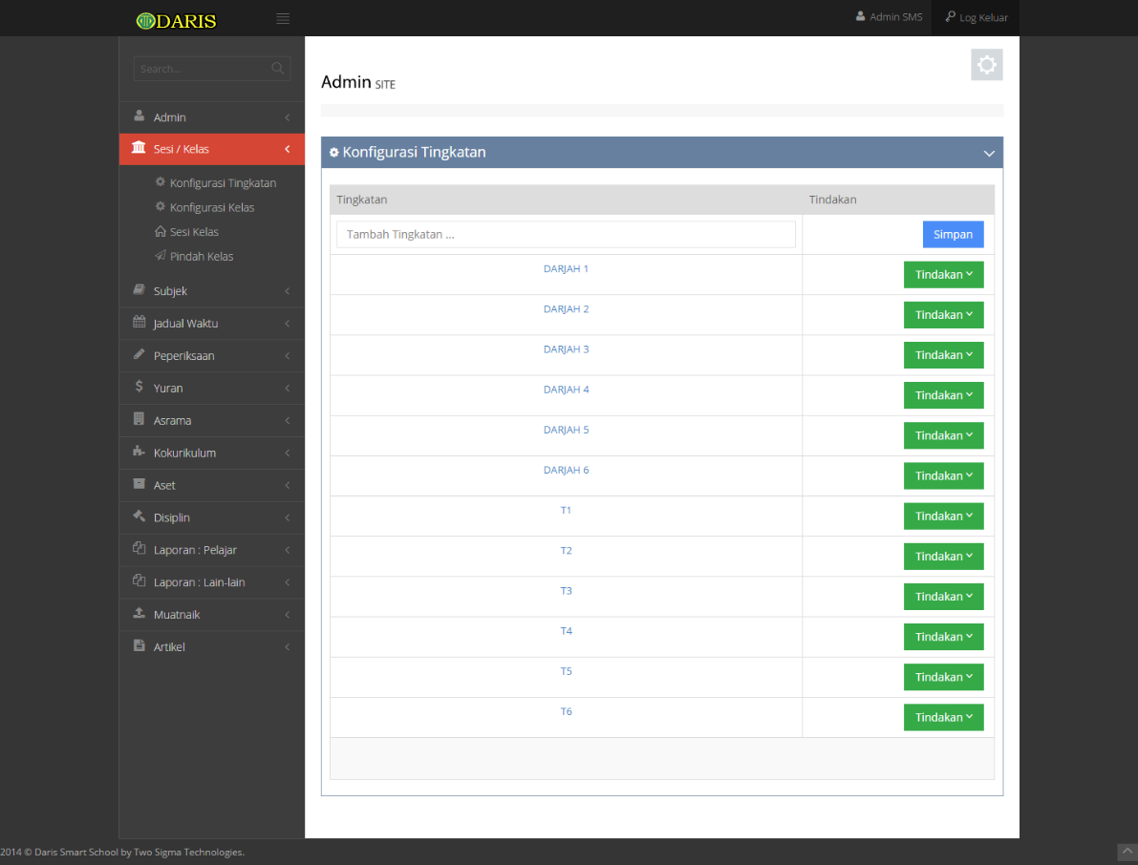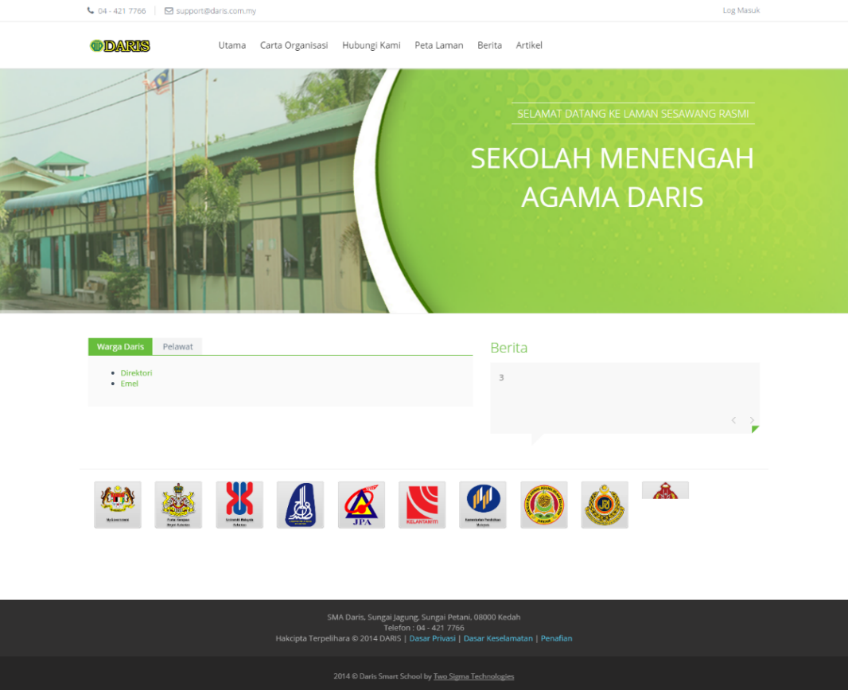

<http://ekias.my/>

* 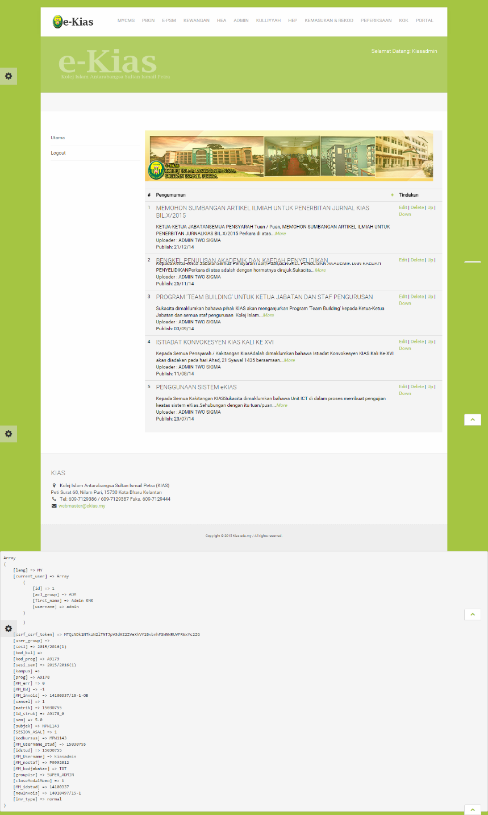PHP, MySQL, Bootstrap, Custom Template – Team

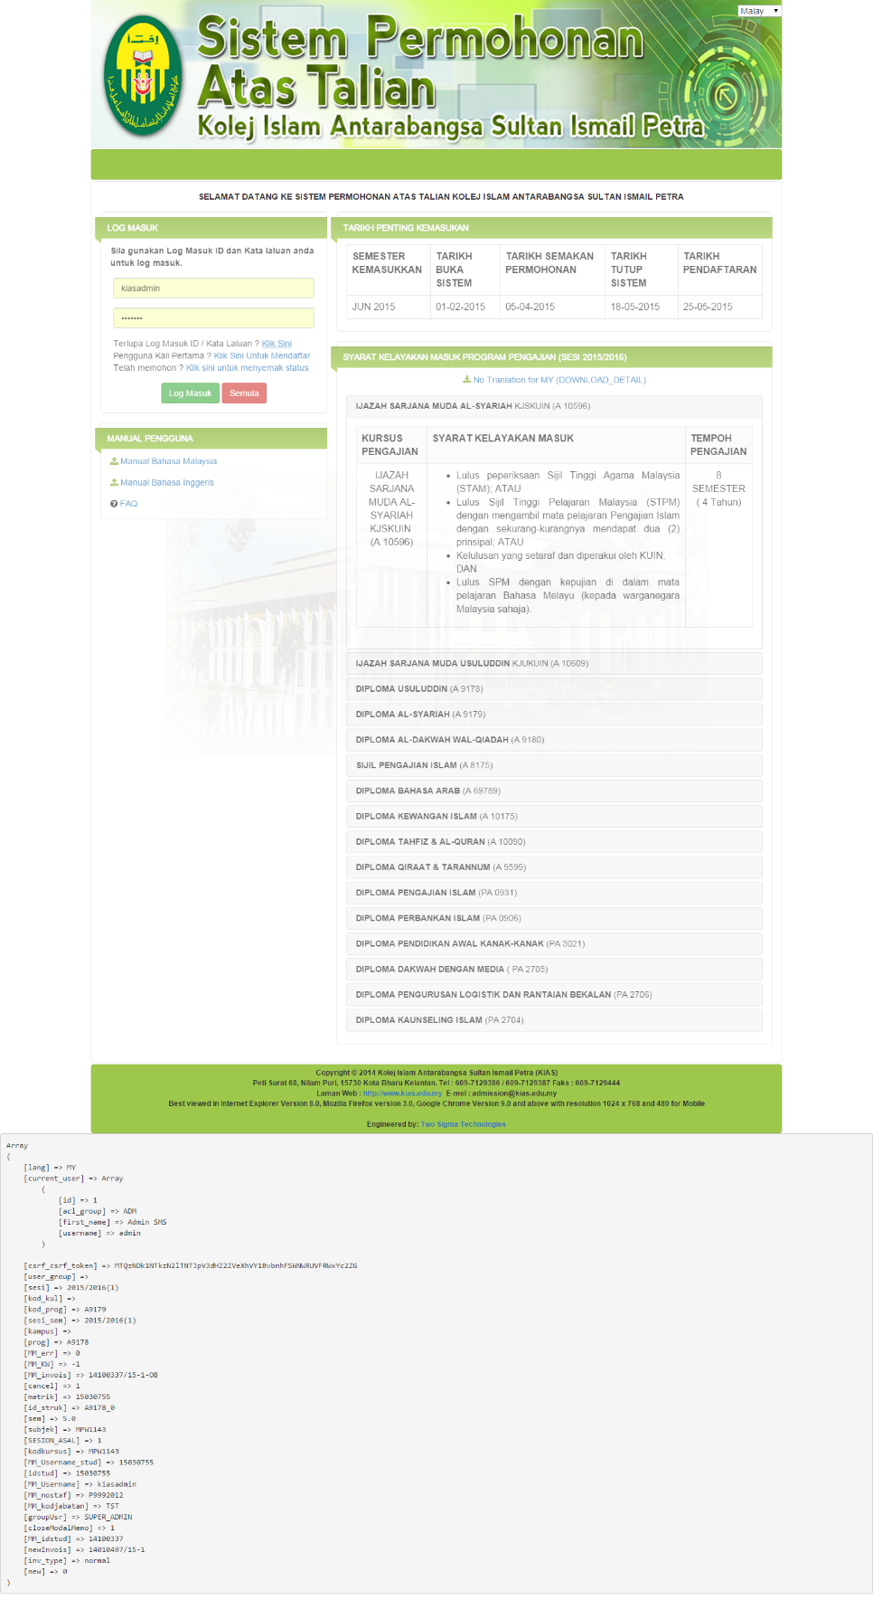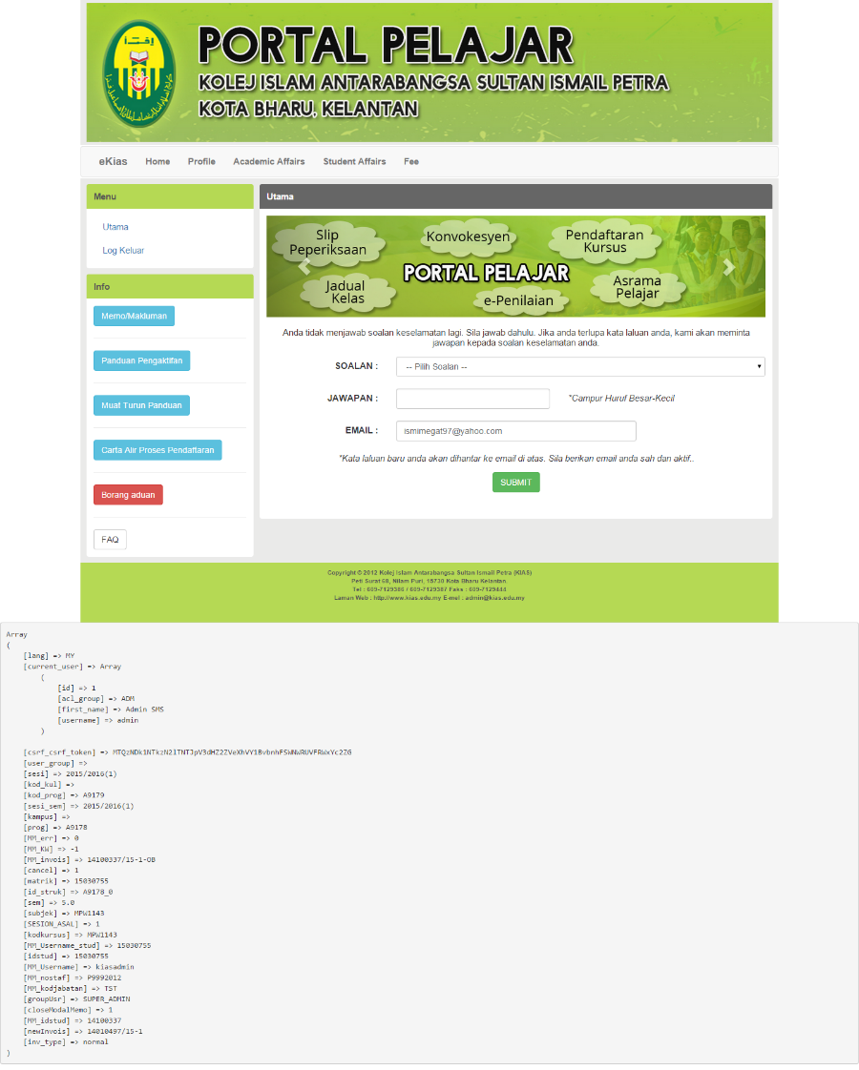

# Others

* Majlis Datuk-Datuk Negeri Melaka (Internship - 2012)
  + Joomla
* Taman Mini Malaysia Mini Asean (Internship - 2012)
  + Joomla
* America Watch (EAS – 2012 to 2013)
  + HTML, CSS
* Katag (EAS – 2012 to 2013)
  + HTML, CSS
* Torqnm (EAS – 2012 to 2013)
  + HTML, CSS
* MySIS UPSI (Multibase – 2013 to 2014)
  + Migrating Oracle Form to PHP
  + Yii Framework, PHP, PostgreSQL
* Daris (2-Sigma – 2014 to 2015)
  + Customized Template, HTML, PHP, MySQL
* E-kias (2-Sigma – 2014 to 2015)
  + Customized Template, HTML, PHP, MySQL, Bootstrap