**PORTFOLIO**

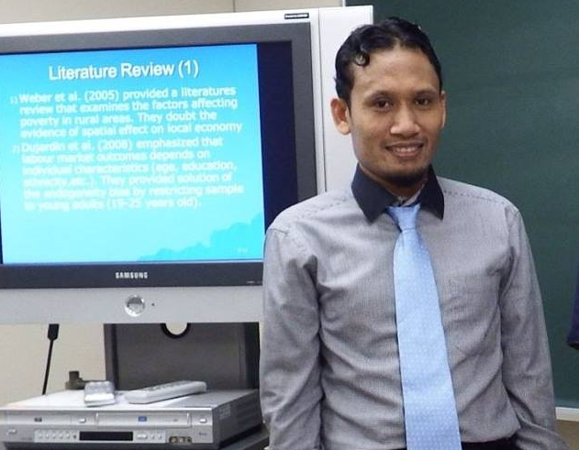

::GENERAL INFO ::

Full Name : Tatarudin

Nick Name : Tata

Sex : Male

Place/Date ofBirth : Raha, 11/01/1983

Religion : Islam

Last Degree : Post Graduate

Last GPA : 3.37

TOEFL Institution : International University of Japan

TOEFL Score : 500

Residence ID : 7403111101830205

NPWP Number : 16.496.695.4-816.000

Address : Jln. Jati No.24 Raha

Postal Code : 93611

City : Raha

Current Address : Pondok Nur Khayran Petak Kedua, Jalan Belakang Kantor Pos, Kelurahan Lasusua

Postal Code : 93611

City : Lasusua

Mobile Number : 082214462279

Email 1 : tatarudin@gmail.com

Email 2 : tata@iuj.ac.jp

Marriage Status : Single

Hobby : reading and swimming

Reference : Muhammad Syafrudin

Mobile Number : +971501425371

Expected Salary : 12,000,000,00 (IDR) per month

Current/Previous Salary : 6,000,000,00 (IDR) per month

::FORMAL EDUCATION ::

Degree : Senior High School

School : SMU 1 Raha

Major : IPA (Natural Science)

Start Date : 01/07/1998

End Date : 21/06/2001

Certificate : Available

GPA : -

Focus Major : -

Degree : College

University : Universitas Haluoleo

Major : Physics

Start Date : 02/07/2001

End Date : 12/02/2008

Certificate : Available

GPA : 3.54

Focus Major : Oceanography Physics

Degree : Post Graduate

University : International University of Japan

Major : Public Management

Start Date : 21/09/2015

End Date : 31/08/2016

Certificate : Available

GPA : 3.28

Focus Major : Public Management and Policy Analysis Program

Degree : Post Graduate

University : Padjadjaran University

Major : Apllied Economy

Start Date : 14/07/2014

End Date : 06/01/2017

Certificate : Available

GPA : 3.37

Focus Major : Public Management and Policy Analysis Program

::TRAINING ::

Course Name : English for Academic Purposes

Institution : Pusat Bahasa FIB Universitas Padjadjaran

Certificate : Available

Date of Course : 28/03/2015

Course Name : Japanese Language Study

Institution : The Center For Japanese Language Studies Universitas Padjadjaran

Certificate : Available

Date of Course : 28/08/2015

Course Name : English Course

Institution : Lembaga Pendidikan Keterampilan "SEICO"

Certificate : Available

Date of Course : 23/12/2000

Course Name : English Course

Institution : Lembaga Pendidikan Keterampilan "SEICO"

Certificate : Available

Date of Course : 07/02/1998

::ORGANIZATION ::

Organization : Student Executive Board of Haluoleo University

Position : Member

Summary Job Desc : Particapate as Committee in many events

Start Date : 01/07/2004

End Date : 30/06/2005

::WORKING EXPERIENCES::

April 2006 - March 2014 : District Statistic Coordinator of Pasir Putih in Statistics Muna Regency

March 2017- June 2017 : Staff of Poduction Statistic Section in Statistics Muna Regency

June 2017- Present : Head of Production Statistic Section in Statistics North Kolaka Regency

::OTHER SKILLS::

Computer : Able to operate Windows, Ms Office, Programming Language such as Eviews, Stata, and SPSS.

Econometric : Understand the role of Econometric, including methods, analysis and others.

Management Science : Such as Quantitative Methods for Decision Making.

GIS (Georaphic Information System).

I hereby declare that all the information given here is true.

Lasusua, September 9, 2017

Best Regards,

Tatarudin