The Frequency of Seeking News
on Gender of Hartwick College’s Students
Chi Nguyen & Annalie Fuge
Hartwick College

Abstract
This experiment tested the hypothesis that Hartwick male students seek news more than Hartwick female ones. Participants were instructed to complete a survey about seeking news via an online link made in Survey Monkey website. They were then randomly selected according to their earliest time finishing the survey. All results were based on grading points. The result was interpreted in terms of the statistical analysis and how it could apply to the market.

Table of Contents
TOC \o 2-2 \t "Heading, 3"
Abstract PAGEREF _Toc \h 2
Introduction PAGEREF _Toc1 \h 4
Literature Review PAGEREF _Toc2 \h 5
Hypotheses PAGEREF _Toc3 \h 8
Research Methods PAGEREF _Toc4 \h 8
Research Design PAGEREF _Toc5 \h 8
Sample Design PAGEREF _Toc6 \h 8
Data Collection and Fieldwork PAGEREF _Toc7 \h 8
Analysis PAGEREF _Toc8 \h 9
Results PAGEREF _Toc9 \h 9
Discussion PAGEREF _Toc10 \h 9
Implications PAGEREF _Toc11 \h 10
Limitations PAGEREF _Toc12 \h 10
Future Research PAGEREF _Toc13 \h 10
Conclusions PAGEREF _Toc14 \h 11
Appendix A: Gender Profile of News Audiences PAGEREF _Toc15 \h 12
Appendix B: American News Consumers PAGEREF _Toc16 \h 13
Appendix C: Profile of the Social Media News Consumer PAGEREF _Toc17 \h 14
Appendix D: Audience Key Findings PAGEREF _Toc18 \h 15
Bibliography PAGEREF _Toc19 \h 16

Introduction
News consumption is a large market globally with billions of consumers daily. Being such a large market, there are a variety of outlets available for American consumers to obtain their news. In a study conducted in 2013, the main sources for news were indicated as follows: 69% television, 50% Internet, 28% newspaper, and 23% radio ADDIN EN.CITE <EndNote><Cite><Author>Andrea Caumont</Author><Year>2013</Year><DisplayText>(Caumont, 2013)</DisplayText><record><ref-type name="Web Page">12</ref-type><contributors><authors><author>Andrea Caumont</author></authors></contributors><titles/><title>Fact Tank: News in the Numbers</title><periodical/><dates><year>2013</year><pub-dates/></dates></record></Cite></EndNote>(Caumont, 2013). Previous research has indicated that women express more interest in news stories regarding weather, health and safety, natural disasters, and tabloid news. Comparatively, men express more interest in stories about international affairs, Washington news, and sports. This study explores the relationship between gender and news consumption.
The purpose of this study is to determine whether male Hartwick College undergraduate students seek news more than their female counterparts. Through a survey conducted on Survey Monkey, an online survey tool, a sample of 100 Hartwick College undergraduates was gathered. Collected on this survey is data regarding gender, frequency of news consumption, and type of news source. This survey provides accurate insight through simple random sampling without replacement, ensuring that the respondents are not chosen twice to indicate their preferences on the survey. This style of research provides useful, reliable, and valid data applicable to the study.
The relationship between gender and news consumption provides insight that can be used in a variety of applications, such which outlet would be most efficient in providing news to Hartwick College undergraduates. Gender and its relationship with news consumption can also help media outlets and marketers to understand their audience’s preferences further.

Literature Review
A variety of studies have been conducted regarding the demographics of news consumers. In a study conducted in February 2008, the research concluded that women are more interested in news regarding weather, health and safety, natural disasters, and tabloids (“Where Men and Women Differ in Following the News”, 2008). Comparatively, men are more interested in news regarding international affairs, Washington news, and sports. The outlets in which males and females receive their news includes radio news (42% men, 31% women), online news (36% men, 27% women), newspapers (44% men, 38% men), and televised news (local – 53% men, 55% women). This data proves that news audiences include both males and females, with 48% male and 52% female (Appendix A). Additionally, this data concludes that news consumers have a variety of interests, news sources, and frequency of news consumption.
The demographics of news consumers and sources of news are explored further in an article published in October of 2013. First of all, nearly 50% of the public uses the Internet as their main source for national and international news (Caumont, 2013). Compared to other news sources, the Internet has become the second most popular news source, just behind television at 69%. Social media is also growing as a news source, with 19% of Americans using it as their preferred medium for news consumption. Additionally, the number of American adults consume the news on mobile devices is increasing dramatically. Currently, 66% of tablet or smartphone owners get news on their device, with 50% of the total U.S. adult population owning a tablet or smartphone. The use of mobile news allows the news consumer to receive information on the go. Twitter is emerging as a news source as well. During Hurricane Sandy, 34% of tweets on Twitter were relaying information and news about the storm. Social media websites, such as Twitter and Facebook, provide news consumers with convenient and efficient information available either through a web browser or on a smart phone device. Young people are starting to consume less news as well, with the exception of mobile devices.
Social media is a popular news outlet, as it is convenient, personal, and provides a place to share and discuss news. As indicated in Appendix C, the social media news consumer utilizes a variety of networking sites, such as Facebook, YouTube, Twitter, Google Plus, and LinkedIn. Overall, 48% of males and 52% of females consume news on a social media platform. However, men defeat the women in the use of LinkedIn, with only 33% of women compared to 67% of men. Twitter is even at 50% for each gender (Pew Research Center, 2013). Since the data is close for each gender, further research should be conducted regarding the relationship between gender and news consumption.
With social media continually evolving, news consumption is changing to keep up with technological advances. The State of the News Media annual report on American Journalism provides a variety of data on news consumption in the United States. The audience key findings (Appendix D) found that digital news has increased 7.2% between 2011 and 2012, cable increased 0.8%, audio and magazines decreased 0.1%, newspapers decreased 0.2%, network television decreased 1.9%, and local television dropped 6.5% ADDIN EN.CITE <EndNote><Cite><Year>2013</Year><DisplayText>(Pew Research Center, 2013)</DisplayText><record><ref-type name="Web Page">12</ref-type><contributors><authors/></contributors><titles/><title>Digital Developments</title><periodical/><dates><year>2013</year><pub-dates/></dates></record></Cite></EndNote>(Pew Research Center, 2013). These changes in news outlets reflect the technological advances that are supporting this shift towards digital news and information. Although the relationship between gender and news consumption isn’t explored in this report, the different news outlets are. With technology continually evolving, the shift towards digital news is evident. Whether it be on a personal computer or the newest iPhone, digital news is available virtually anywhere. With such a variety of news outlets readily available, men and women each consume a variety of news topics from a variety of sources on a variety of mediums.
In an article published in February 2013, the demographics of the American News Consumer are determined. After conducting a survey of 3,000 American adults, the results concluded that the average American News Consumer is divided into five categories (Banikarim, 2013). These profiles are described in Appendix B. The average American news consumer has a variety of interests, from local news enthusiast like News Localistas to sports-obsessed Sports Analysts. Looking at the average news consumer, it proves that local news appeals more to women than men, whereas sports appeals more to men than women. The American news market consists of 88% of the population who consume news daily. The average American consumer stays up-to-date on news information on a variety of platforms, including tablets or smartphones. Most news consumers care about what is happening close to home, so local news is important to them. These demographics provide insight to this study, as gender is explored throughout each of the five news consumer profiles.
Compared to other countries, USA remains relatively high in daily news access. Germany leads the daily news consumption, with 91% of males and 88% of females. Denmark maintains a 92% male and 83% female daily news audience, with male news consumption at the highest worldwide. The United States is third in daily news access, with 86% male and 78% female ADDIN EN.CITE <EndNote><Cite><Year>2012</Year><DisplayText> (Reuters Institute for the Study of Journalism, 2012)</DisplayText><record><ref-type name="Web Page">12</ref-type><contributors><authors/></contributors><titles/><title>News Access and Consumption</title><periodical/><dates><year>2012</year><pub-dates/></dates></record></Cite></EndNote> (Reuters Institute for the Study of Journalism, 2012). Overall worldwide, male news consumption exceeds female. The conclusion that men seek news more than women forms the hypothesis for this experimental study.

Hypotheses
H1: Hartwick male students seek news more than Hartwick female students.
H0: Hartwick male students do not seek news more than Hartwick female students.

Research Methods

Research Design
A survey was chosen to obtain the data. The survey was generated through Survey Monkey’s website and shared on social media, such as Facebook, to attract participants over 24 hours. Three questions for the survey were created, which ask about gender of the participants, how they receive news, and how frequently they seek news in a week.

Sample Design
The participants consist of 100 Hartwick undergraduates (49 males and 51 females) selected randomly according to their earliest time finishing the survey. To make sure the condition of all participants is being a student at Hartwick College, the survey link was only shared among the Hartwick students.

Data Collection and Fieldwork
News is defined as information or an event that has happened recently and communicated via word of mouth as well as mass media. In the survey, the first question asking about participants’ gender is to check the existing characteristic of independent variable. The second question is to find out how they seek news and they were allowed to choose as many as possible (television, radio, internet, newspapers, and word of mouth). Finally, the participants were required to rate how frequently they receive news on a 5-point Likert Scale (5 = extremely frequently, 4 = very frequently, 3 = moderately frequently, 2 = slightly frequently, 1 = not at all frequently).

Analysis
According to the Survey Monkey tool, 100 participants joined the survey. 49% of them were males and the rest was females. Based on the second question, 48.98% seek news through TV, 33.67% through radio, 94.90% through the Internet, 28.57% through newspapers, and 35.71% through word of mouth. The final question helps determine exposure degree of both genders to news on the Likert Scale. 22% rated 5 points, 35% rated 4 points, 28% rated 3 points, 10% rated 2 points, and 5% rated 1 point. To find out if Hartwick male students seek news more than Hartwick female ones, the data were put into the T-test: Two-sample assuming unequal variances between gender and rated points from question three. It is a two-tailed test since possibility of seeking news can be directed by either males or females (Appendix E).

Results
As the result collected from the T-test, p-value = .21, which is larger than the alpha .05. The result shows that there is no significant difference between Hartwick male and female students in seeking news. Therefore, we fail to reject the null hypothesis.

Discussion
The process of surveying was limited carefully for only Hartwick students, so the participants’ characteristic is absolutely ensured. To complete the t-test, individual responses were analyzed to apply the data, which are gender and how each of them rated his frequency of seeking news.

Implications
According to the result, both genders have the same exposure of seeking news. Therefore, marketers can apply this knowledge into their business by implanting information neutrally to both genders to achieve the result most effectively. Moreover, it is preferred by Hartwick students from both genders to get news via the Internet so this should be considered as the main channel to spread information.

Limitations
The result is not phenomenal because it was only tested through the gender of the participants. If more elements had been incorporated into the research such as student’s year, ethnic background, location where they were raised (urban, suburban, or rural areas), or type of news, the results would have been more detailed. A longer survey would have provided more detailed results that could pinpoint the average Hartwick College undergraduate student’s news preferences.

Future Research
The research can somehow hint ideas for Hilltop Newspapers – the official news channel of Hartwick College. From the result above, newspapers is not used much by students yet the Internet. Therefore, if the newspapers could be uploaded online and positioned in a specific tab on Hartwick website, there might have been a better chance for the Hilltop Newspapers read by more students. Considering both male and female students seek news equally, the content and look of the papers should be neutralized.

Conclusions
The results gathered through Survey Monkey provided useful insight into gender and news. Although the results did not support the hypothesis, since both male and female utilize similar news sources, they provide useful information that can be used in further studies, such as the relationship between gender and news topics (sports, food and restaurants, health, politics, etc.) in Hartwick Undergraduate students. The data gathered was reliable and valid, providing valuable information that could be utilized by Hartwick College regarding popular news outlets for students.

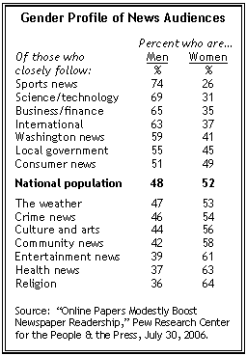
Appendix A: Gender Profile of News Audiences

Appendix B: American News Consumers
News Localistas | Sports Analysts | News Challengers | News Digerati | News Omnivores
74% female | 77% Male | Male and Female | Male and Female | 56% Male
35-49 | 35-49 | 50+ | 18-34 | 18-34
Homemaker with Kids | Obsessed with Sports | Educated and Retired | Young Professionals, High Income | Have Young Families, Urban, Business Travelers
- Local News, Weather, Traffic, Retail Sales, Deals, and Local Events  - Human Interest Stories, Crime Coverage, and News with a Sense of Humor | - Multi-platform User (including Tablet) interested in Breaking Sports News, Home Team Coverage, Fantasy Sports, In-Depth Sports Analysis, and Sports Op-Eds  - Politics and Stock Market | - Objective National and International News  - Local News  - Index High on FOX News and NPR  - Many are baby boomers who embrace technology | - Smartphones  - Value accurate news with deeper analysis  - National Media Brands  - Index High on FOX News, MSNBC, and CNN | - Variety of platforms, topics, and interests  - Wants news relevant to daily life  - National and International News, Business, Health, Food, Sports, Movies, Books

Appendix C: Profile of the Social Media News Consumer
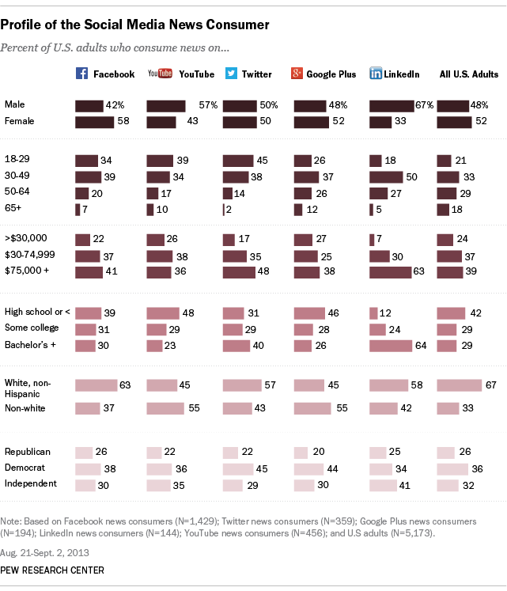

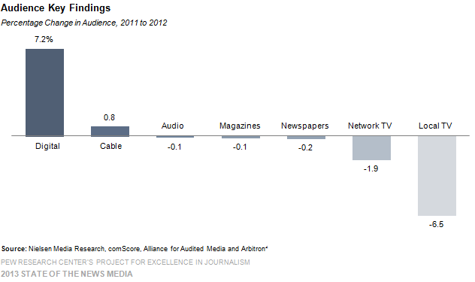
Appendix D: Audience Key Findings

Bibliography
ADDIN EN.REFLIST
Banikarim, M. (2013, Feb 6). Today's American News Consumer. Retrieved Dec 9, 2013, from The Huffington Post: http://www.huffingtonpost.com/maryam-banikarim/american- news-consumer_b_2635289.html
Caumont, A. (2013, 10 16). Fact Tank: News in the Numbers. Retrieved 12 11, 2013, from Pew Research Center: Caumont, Andrea. "12 trends shaping digital news." Pew Research Center RSS. N.p., 16 Oct. 2013. Web. 9 Dec. 2013. <http://www.pewresearch.org/fact- tank/2013/10/16/12-trends-shaping-digital-news/#twt2>.
Nguyen, C., & Fuge, A. (2013, Dec 5). A Survey About Recieving News. Retrieved Dec 9, 2013, from SurveyMonkey: https://www.surveymonkey.com/s/HRRV7F7
Pew Research Center. (2013). Digital Developments. Retrieved Dec 9, 2013, from State of the News Media 2013: http://stateofthemedia.org
Pew Research Center. (2013, Nov 13). Profile of the Social Media News Consumer. Retrieved Dec 9, 2013, from Journalism Project: http://www.journalism.org/2013/11/14/news-use- across-social-media-platforms/5_profile-of-the-social-media-news-consumer/
Reuters Institute for the Study of Journalism. (2012). News Access and Consumption. Retrieved Dec 9, 2013, from Digital News Report 2012: http://www.digitalnewsreport.org/survey/2012/frequency-of-news-access-and- consumption/
Sasseen, J. (2013). Digital: As Mobile Grows Rapidly, the Pressures on News Intensify. Retrieved Dec 9, 2013, from State of the Media: http://stateofthemedia.org/2013/digital- as-mobile-grows-rapidly-the-pressures-on-news-intensify/#the-top-news-sites-in-2012
Where Men and Women Differ in Following the News. (2008, Feb 6). Retrieved Dec 9, 2013, from Pew Research Center: http://www.pewresearch.org/2008/02/06/where-men-and- women-differ-in-following-the-news/

