**JAPAN: .”A FEW THINGS THAT YHOU SHOULD KNOW.”**

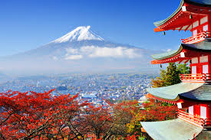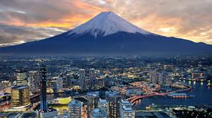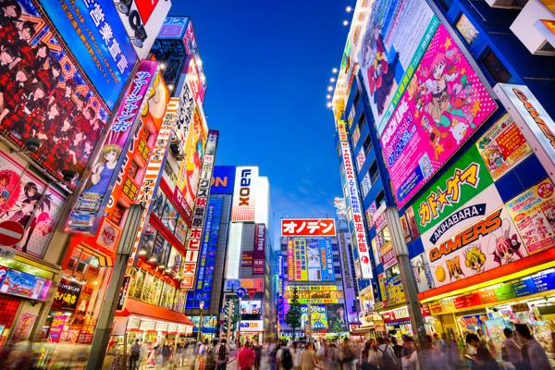

WHEN YOU ALWAYS HEARD ABOUT THE LAND OF THE RISING SUN, YOU COULD ALWAYS SAY A COUNTRY WHERE YOU CAN FIND A WHITE FLAG WITH A BIG RED DOT, **JAPAN**. THERE’S A LOT OF THINGS THAT WE CAN DISCUSS ABOUT ITS NATURAL RESOURCES, TRENDING TOPICS, SIGHT SEEINGS, AND MANY MORE.

SO WHILE WERE OBSERVING JAPAN WE ALWAYS THINK, WHY IS IT VERY POPULAR AMONG TOURIST AND OTHER COUNTRIES? YEAR 2011 WAS ONE OF THE UNFORGETABLE EXPERIENCE FOR THE JAPANESE PEOPLE. WHY? IT WAS THE YEAR WERE ALL ITS PEOPLE MUST STRENGTHEN ITS COURAGE, KINDNESS, FAITH AND LOVE THAT HAS BEEN TEST SOMETIMES WITH NATURAL DISASTERS LIKE EARTHQUAKES. EVEN SO, THEY STILL MANAGE TO STAND UP AND RISE. FOR THIS REASON, JAPANESE SOCIETY AND GOVERMENT ENGAGE MANY DIFFRENT OBSTACLES AND CHALLENGES TO PROVE THAT IT IS STILL WORTH FOR ITS TITLE: “**LAND OF THE RISING SUN**.”

WHATS THE RESULT? A BRAND NEW SCENRY OF THE JAPANESE MODERN WORLD AND CLASSIC LIFESTYLE OF THE PAST. BY THIS ARTICLE WE LEARN NOT ONLY TO APPRECIATE ITS SIGHT SEEINGS BUT ALSO TO BE AMZED BY ITS HIDDEN TREASURES. BELLOW ARE THE LIST OF REASONS WHY YOU SHOULD VISIT JAPAN.

---------------------------------------------------------------------------------------------------------------------------------------------------------------

**CULTURE**

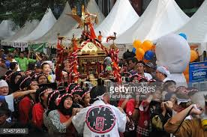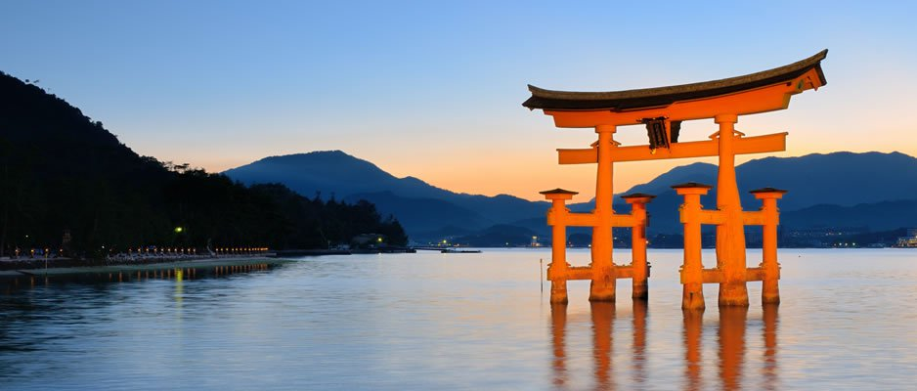JAPANESE ARE VERY WELL KNOWN FOR HAVING A GOOD MANNERS AND DISCIPLINED PEOPLE. NOT ONLY BY OBEYING TRAFFIC RULES, CLEANLENESS OF THE ENVIROMENT BUT ALSO FOLLOWING OLD TRADITIONS IN MANY WAYS. EVEN IT IS SORROUNDED BY NUMEROUS SKYCRAPERS AND TECHNOLOGY, JAPAN IS ALWAYS LOOKING BACK WHERE THEY LEARNED HOW TO BE SUCCESSFULL COUNTRY. THEY ALWAYS PUT ATTENTION ESPECIALLY FOR THE SPECIFIC THINGS LIKE OLD HOUSES, CASTLES, GATES, AND TEMPLES. IT MIGHT BE TOO OLD FOR OTHERS BUT BY DOING THIS, THEY ONLY SHOW THAT TAKING CARE ABOUT WHERE THEY STARTED IS ALSO TAKING CARE ABOUT THEIR FUTURE.

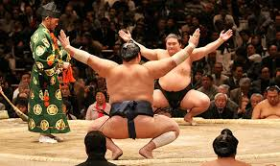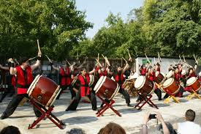

-----------------------------------------------------------------------------------------------------

**FOOD**

WHEN VISITING JAPAN, YOU CAN’T COMPLETE YOUR JOURNEY WITHOUT EATING THE TWO MOST POPULAR FOOD IN JAPAN: RAMEN AND SUSHI. DESPITE OF THE CONVENIENT STORES, MALLS AND SMALL SHOPS THAT OFFERS VARIOUS KINDS OF SNACKS, YOU STILL WANT TO TASTE THIS TWO AMAZING FOOD THAT HAS BEEN CRAFTED FOR MANY YEARS SINCE EDO PERIOD. IT WILL NOT ONLY GIVES YOU SATISFACTION BUT ALSO FILLS YOUR STOMACH WITH EXCITEMENT . THERES A LOT OF VARIETY AND LOADS OF SUPRISES WHEN YOUR TALKING ABOUT JAPANESE FOOD CULTURE, SO DON’T MISS IT AND ALWAYS TAKE A NOTE FOR IT.

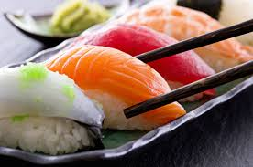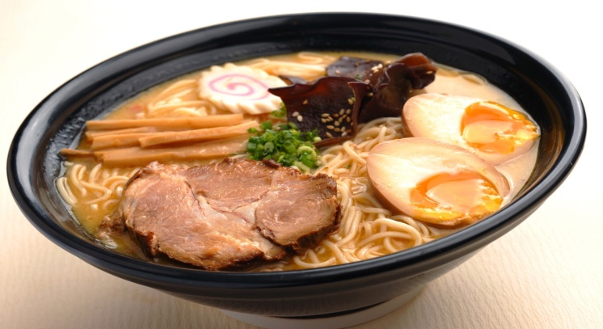

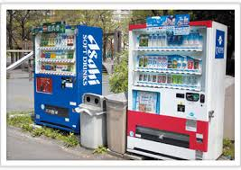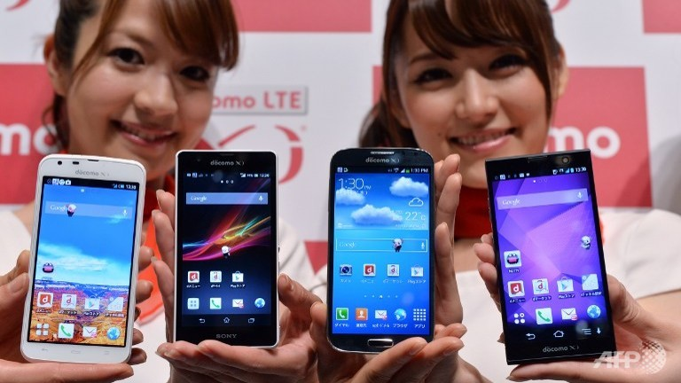-----------------------------------------------------------------------------------------------------

**TECHNOLOGY**

IF WERE TALKING ABOUT LATEST INOVATION AND TECHNOLOGY WE CAN ALWAYS RELY ON JAPANESE HIGH TECH ENVIROMENT. WHY? BECAUSE THEY’RE NOT ONLY GIVING SATISFACTION TO IT’S USERS BUT ALSO A GREAT HELP IN OUR DAILY LIFE. IN OUR HOMES WE CAN ALWAYS SAW AND HEAR JAPANESE ELECTRONICS SUCH AS ELECTRIC FANS, WASHING MACHINE, FRIDGE OR EVEN COOKING WARE. BECAUSE OF ITS LATEST TECHNIQUES AND THE WAY IT WAS MADE, JAPANESE PRODUCTS BECOME MORE POPULAR AND BEST SELLER AMONG TOURIST AND OTHER CONTRIES.

EVEN IN THE LINE OF MEDICINE YOU CAN ALWAYS MAKE SURE THAT THE PRODUCT OR THING THAT YOU BUY IS ALWAYS MADE WITH CARE AND PROFESSIONALISM. SO WHY NOT TRY TO BUY A FEW HIGH END TECHNOLOGY FROM JAPAN AND PROVE TO YOURSELF WHY IT IS THE BEST AMONG OTHERS.

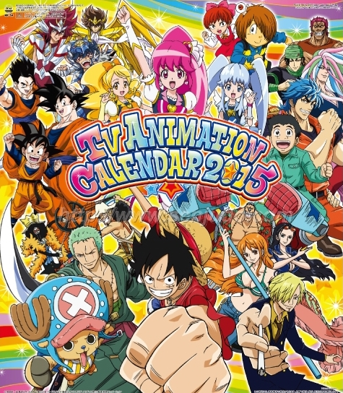-----------------------------------------------------------------------------------------------------

**ANIME**

IF YOUR PLANNING TO SEARCH AND TO FIND THE PERFECT SPOT FOR ANIME TRENDS AND TOPICS, AKIHABARA IS THE BEST PLACE THAT YOUR LOOKING FOR. THIS ENVIROMENT IS NOT ONLY FOR ELECTRONIC GADGETS AND LATEST INNOVATIONS BUT ALSO FOR ANIME LOVERS. THATS WHY AKIHABARA IS EN-TITLED WITH HEART LAND OF ANIME IN JAPAN.

FROM VARIOUS PARTS OF THE WORLD YOU CAN ALWAYS SAW HERE A LOT OF ANIME FANS FROM DIFFRENT AGES AND NATIONALITIES. JAPAN IS THE ANIME CAPITAL WERE YOU CAN ALWAYS AMAZED BY ITS CONTENT AND THE WAY IT CAPTURES YOUR ATTENTION. EVEN IN FAMOUS KANDA MIOJIN TEMPLE YOU CAN NOTICE A LOGO THAT HAS BEEN DRAW AND PRINTED IN WOODEN PLANKS WHICH REPRESENT THE ANIME MANGA CHARACTER CALLED: “LOVE LIFE.”

THEY EVEN USE ANIME MANGA CHARACTERS IN FOOD, CLOTHES, COLOGNE OR EVEN ON THEIR OWN PERSONAL ITEM. SO IF YOUR AN ANIME LOVER OR MANGA FANATIC AKIHABARA IN JAPAN IS THE ONE THAT WILL GUIDE YOU IN THE LAND OF ANIME.

-----------------------------------------------------------------------------------------------------

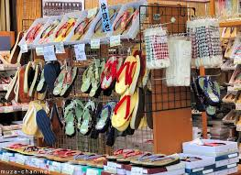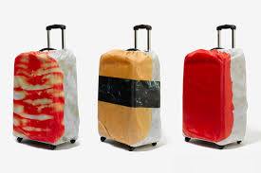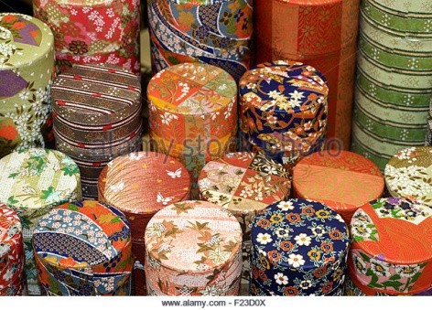

SOUVENIR

AS YOUR JOURNEY ENDS IN A FEW DAYS OR WEEK WHY NOT TRY TO BUY SOME MEMORABLE ITEMS? SUCH AS SUSHI KEY CHAIN, PLASTIC FOOD SAMPLES, OR EVEN WOODEN BENTO BOXES. THIS ITEMS IS ALSO PART OF THE JAPANESE CULTURAL HERRITAGES AND HISTORY. THERES A LOT OF SOUVENIR SHOPS THAT HAS BEEN SCATTERED ACROSS JAPAN SO FINDING THEM IS EASY. ONE OF THESE LOCATIONS CAN BE FOUND IN TOKYO STATION A GATEWAY TO THE BIG CITY INSIDE IS FULL OF SOUVENIRS FOR TRAVELERS AND TOURIST WHO CAME FROM VARIOUS PART OF JAPAN. THEY CAN SELECT FROM RICE CRACKERS, SWEET BREADS, OR EVEN FOOD SAMPLES FROM DIFFRENT PREFECTURE. SO HAVING A SOUVENIR OF YOUR OWN WILL MAKE YOU REMEMBER THE PLACE WHERE THE SUN RISES.