MOTHERHOOD: THE ESSENCE OF BEING A WOMAN

There has been an ongoing discussion of how to answer this beauty pageant question, which, probably made titleholder’s brains freeze for seconds. “What is the essence of being a woman?” Trying to find the right answer, I think our friendliest neighbor, Google has this top answer:

"Just being a woman is God's gift that all of us must appreciate. The origin of a child is a mother, and is a woman. She shows a man what sharing, caring and loving is all about. That is the essence of a woman."
- Sushmita Sen (actor), Miss Universe 1994.

Watching Sushmita Sen compete for the crown during the 1994 Miss U, I was still a grade school student back then. I have no idea on what the question was or how did she come up with that answer that crowned her to the top. I was just a frivolous elementary student, nothing more, nothing less.But now, that I’ve become a mom, I finally understood what she meant. Being a mother, has it’s own essence. Being a woman, makes you a mother not just to your own kin but to others as well.

When I was still single, I had a very different outlook of how I’d imagine myself of being a mom. When asked about being pregnant or having a baby, I’d cringed. It wasn’t that I hate the thought of being called a “MOM” but I had no plan to have my family at a young age of 20 something. I was not yet ready to face the world of being peed at, barfed at or being pooped at! I was still enjoying my life, what I love to do and even my work. I was at the peak of everything. Having a family was not my concern. I was into shopping, clubbing, partying etc. Friends would go out with me and I too, with them.
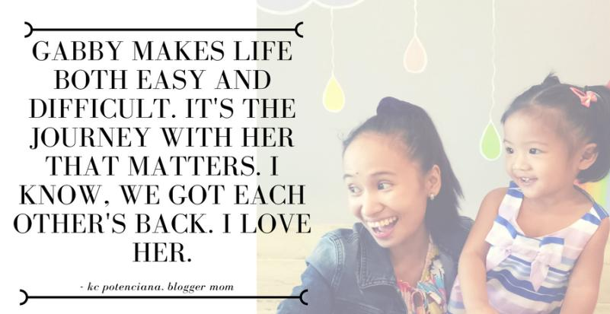
But that changed when I met my husband who was then my boyfriend of 4 years. Everything became clear. I was a late bloomer actually. Being pregnant and married at the age of 30. Giving birth to a wonderful baby girl at the age of 31. And just like that, my life changed. Ever heard of the cliche saying “When you become a mom, your view of life will change 360 degrees” or something like that. I guess, that’s true! I know I was prepared to handle everything but I guess, no one is up to the challenge.

I thought that having a stable job and working in a private company was the toughest work yet that I had to face. But no one beats the job that a mother has to handle. Just to tell you a backstory, I stopped working for a year because of pregnancy complications and also my husband wants me to concentrate on my pregnancy. The first trimester was the hardest part of my pregnancy days. I had to lie down in bed for 2 weeks as advised by my OB. Nothing to do, just eat and sleep and then, repeat. Seriously, it was a complicated pregnancy but I felt I was a princess, being taken care of by my husband, family and relatives. Pregnancy got the best of me.

Giving birth was a different story. It was when I gave birth that I suffered from Post-partum depression. I didn’t believe that it existed at all. It’s all in the mind, at least that’s what I think it is. That you can put it aside and just bluntly ignore it. But I was wrong. One does not simply walk away from PPD. Surge of emotions was like shadows for me. These emotions, I kind of got attached to them. Not knowing what I was supposed to do and if I can get away with it. Not knowing if I’m being a good mom to my daughter and a wife to my husband. Not knowing that I am loosing myself in the entirety of the whole process of being a new mom. There were days when I would cry, when my husband and daughter is sleeping. I cried. A lot, actually. And I don’t know why. There were days when I felt like if someone talks about something, I am the shittiest sensitive person there is. One time, I looked at myself in the mirror and felt alone. My husband was at work. I was at home. I felt alone. Then, I’d look at my daughter and floods of tears would flow. Social media became a friend. It kind of got me away with reality. It became an invisible wall to my feelings. I became pretentious of everything around me. Unhealthy, I know.

Months passed and I still felt the same. Sanity was not my type of word. My husband and I got separated. I will not talk into details but it was a sigh of relief for me. He wanted to come back to us. He did a lot of things just to get us back. Suddenly, one day, I gave in. We got back and moved to his parents house. Which I think made a lot of chaos as well. Our marriage crashed just liked that. But I at least I had my daughter. We made negative choices. And we got negative consequences. That was a hellish moment for me. Given the chance to go back in time and reorganize my life, that would be my top priority.

It’s not easy to be separated and be a single mom. You can name all the emotions that you can feel even if you don’t feel anything the least. But I have to be strong for my daughter. I have to stand up and be a mom. Become a woman of essence for her and my family. I have to work. Be on my own and take care of my daughter. I think, until now, I have PPD. But I learned how to recuperate. I learned how to fight. My daughter has to know about the world and about me. Her mom. Everyday, I see her grow. Everyday, I see her progress. And I wouldn’t trade that for anything.

It’s been a year and a half that my husband and I were separated. We are in constant communication with each other. We are trying to fix our marriage. He is trying to fix himself and his personality. I am changing as well. We both want to make things work out again for our family. I am a mom. I am woman. I have to forgive and be at peace with myself. I forgive him. I love him still. And I want him to be my husband and grow old with him. I want him to be the father of my children and be proud of him.

Now, what is the essence of being a woman? For me, it is being able to know your strengths and weaknesses, not just as a mom but as a person. It is when you find meaning to what you want to get in life. Striving and fighting everyday. No matter how tough life gets back at you, as a woman, you stand up and cease the day. Life lessons will always be a guide to a woman’s essence.

