https://www.elitereaders.com/katie-davis-majors-adopts-ugandan-daughters/
23-Year-Old Woman Adopts 13 Ugandan Girls As Daughters Before Getting Married  The newly-married couple instantly had a huge family!  By  Mark  40.2K  SHARES  ShareTweetWeibo  To say Katie Davis is an extraordinary human being is probably an understatement. Back when she was 18, she was homecoming queen and senior class president but despite all that, she knew her focus and purpose.  While she was a senior high school student, Katie flew all the way to Uganda for a mission trip. It was there that eventually decided what to do after graduation. Instead of going to a university, she decided she’d spend a year in Uganda so she could teach kindergarten students in an orphanage.  Unknown to her at the time, she was going to make Uganda her permanent home several years from that.  Katie founded Amazima Ministries in Uganda to help people develop a closer relationship with Jesus Christ.  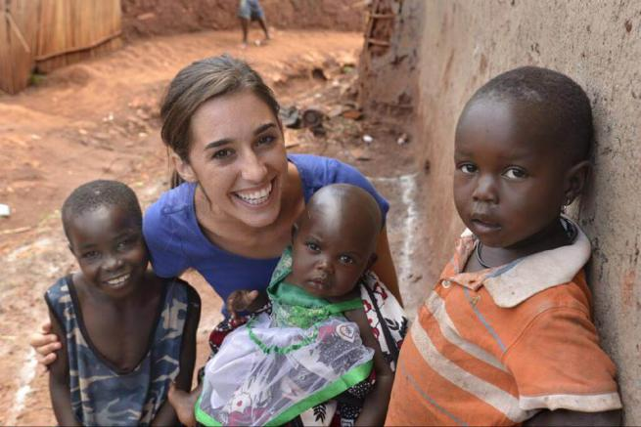  Source: Katie Davis Majors  In a FaithIt feature, we learn that the organization’s name is based in an Ugandan word which literally means “truth”. The organization “seeks to transform lives, restore relationships and radically change communities through the truth of Jesus Christ,” the article mentioned.  Katie would eventually write a book entitled ‘Kisses from Katie—A Story of Relentless Love and Redemption.’  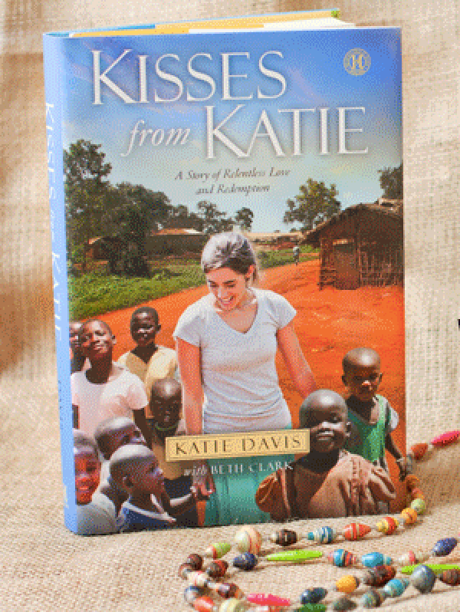  Source: Katie Davis Majors  The title rose to become a New York Times bestseller.  At 23 years old, Katie has already adopted 13 young Ugandan girls.  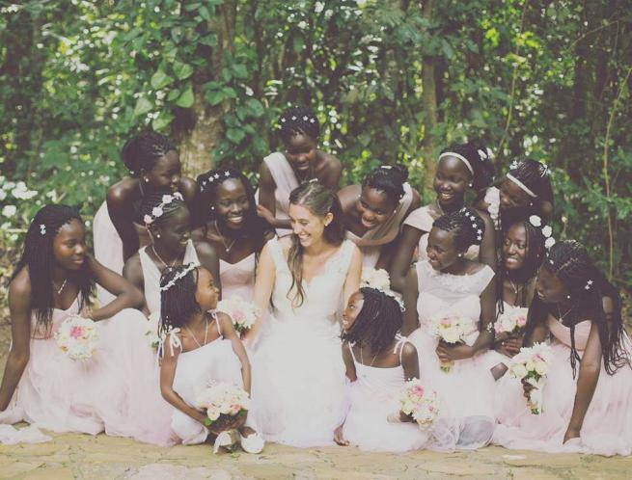  Source: Katie Davis Majors  In an interview with Today, she opened up how this decision has affected her life for good.  Source: Katie Davis Majors  “In those early days of laying sleepy heads on pillows and training tiny hearts to know Jesus, I had no comprehension of the wild, devastating, uncontainable love I would feel for them. I didn’t know that they would somehow become extensions of me, that when they hurt I would hurt more deeply than I ever had before, and that when they showed delight over a success or an excitement for God’s Word, my heart would swell within me and I would be unable to contain tears of joy. I didn’t know that sometimes I would look at them and feel so much love that my heart would physically ache within my chest.”  Love later came knocking when she met Benji Majors.  Source: Katie Davis Majors  Although they both grew up in Franklin, Tennessee, they only met in Uganda when the Majors came there to serve as missionaries. The couple fell in love and decided to tie the knot in 2015.  The rest, as they say, is history.  As Katie wrote on her blog:  “We shared a hometown with only a few hilltops to keep our adolescent lives from ever intersecting.  “My husband’s love is just another way God has chosen to pour [out] His extravagant love on me, another constant reminder that He rejoices over me, and over each one of our daughters. I watch them come alive under the loving gaze of their new father, I hear the delight and the certainty in their voices as they call ‘Dad.’”  Katie’s story has indeed inspired many but she shares anyone can really do what she did, without living in Uganda or even adopting 13 daughters.  She explained:  “I live in Uganda with my husband and my children. The people here, they are my neighbors, my friends, my family. These are the streets on which we live, the community we pray with, the friends we eat with, the people I wave to on the street. This is my home. What I do here, you can do there, right where you are.”  Watch Katie’s amazing story here: | 23 岁女孩未婚前认养了 13个乌干达女儿  这对新婚夫妇婚后立即就有了个巨大的家庭！  Picture 1  如果把凯特. 戴维斯(Katie Davis)形容成一位非凡的女子，这样的描写可能是低估了她。 在18岁时，她是可说是校园里的风云人物，尽管如此，她深知她的人生的重点和意义。  当时，凯特还是一名高中生生，她就专程飞往乌干达做义工。 谁知这一去就让凯特决定了他往后的发展，她当下做出了决定，放弃上大学，并花多一年的时间逗留在乌干达担任孤儿院里的育幼院老师教导儿童读书识字。  那时候的她不知，这一去将让她决定往后定居在乌干达。  凯特随后在乌干达创办了Amazima，该组织帮助当地人拉近与耶稣基督的关系。  Picture 2  在宗教里，我们意识到，该组织的名称在当地语言指的是"真相"的意思。该组织的目是改变当地人的生活并恢复他们与耶稣基督的关系。  凯特最终撰写了一本书题为 《凯特之爱》。  Picture 3  这本书也很快地就成为了纽约时报的畅销书刊。  在 23 岁的，凯特也已认养了13名乌干达女童。  Picture 4  在接受Today采访时，她也透露了这一个决定如何正面地影响了她的一生。  Picture 5  来源： 凯特  "早期，我不了解耶稣的爱，我也感受不到。我也不知道她们将成为我生活的一部分。当她们受伤害时，我比她们更难受。当她们表现出喜悦或是成功时，我比他们任何一个都感到兴奋无比。我也不知道从何时开始，有时候，我看到他们后，就会感受到爱散发在全身。"  过了不久，凯特遇见了班吉(Benji)，两人从此就彼此深爱。  Picture 6  虽然它们俩都在田纳西州的富兰克林长大，但不曾遇见彼此直到班吉到乌干达前来传教。 这对夫妇就开始相爱，并决定在2015年共结连理。  正如他们所说的其余的都是历史。  凯特曾在她的博客所写到：  “我们共享的只有少数几个山顶的故乡。”  “我丈夫的爱，只是神选择的另一种爱我的方式，我也不断地提醒自己，伟大的他赐于我的喜悦，当每一个女儿看着他们新父亲的目光时，我看到的是喜悦和确定性，以及她们叫他爸爸那温柔的声音。  凯特的故事的确是激励了不少人，她告诉了我们即使不在乌干达生活以及认养 13 女儿，我们也可以为社会付出一份力量。  她解释说：  "现在，我与我丈夫和孩子们一起在乌干达生活。 这里的人是我的邻居，我的朋友、我的家人。 这些有的都是我们熟悉的街道，社区，朋友，以及在街上与我们时常到招呼的人们。 这是我的家。 我在这里做的，您可以在您所处的位置做着。"  观看这奇女子-凯特的故事：  视频 1  如果您想了解更多信息，请游览Amazima官方网站以了解更多资讯。

