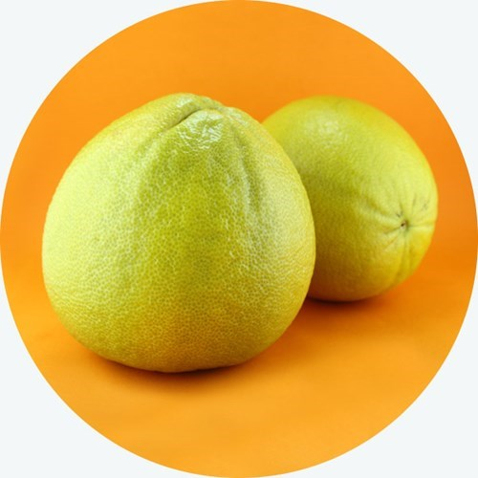
What is Bergamot?
Hailing from the Calabria region of Italy, bergamot is a bitter citrus fruit that blossoms in winter, cross bred for its aromatic peel, resembling a bitter orange and a lemon. Bergamot is used in a variety of products from Earl Grey tea to perfumes! Historically nobles of France coveted the scent of the bergamot, dousing themselves in beautiful perfumes, including King Louis XIV. The fruit was believed to have curative powers, namely the ability to aid fevers. With a dense and wonderful history, the bergamot continues to grow in popularity, now available to drink in Bergotto, Berga Spina and Berga Crem!

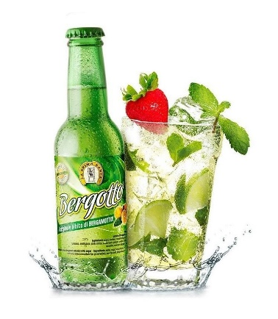
Bergotto – The King of Citrus
Unique, organic, refreshing; these three words describe Bergotto perfectly. With its beautiful blend of natural flavours, Bergotto is one of the most organic drinks in the world currently. It contains 20% bergamot juice, as well as bergamot essence, enhancing the sweetness of the drink whilst maintain a pleasant bitter taste.
This drink can be enjoyed with any spirit, cocktail, or on its own. It is a drink made for summer.

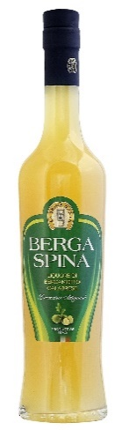

Berga Spina – The Extraordinary Craftmanship
No matter where you are this summer, bring the feeling of Italy with you. This liqueur perfectly balances the citrus flavour of the bergamot fruit with any spirit you can imagine. It is made using a traditional recipe to maintain the most natural flavouring possible. Have it as an aperitif, an addition to your favourite cocktail, or with the delicious Bergotto!
If you’re feeling fruity, try adding a splash to your prosecco, and feel the sun wash over you as though you are in the Ionian region.

Berga Crem – The Velvety Delight
Citrus and cream has long been considered a magical culinary pairing; Berga Crem is no exception. Used as an after-dinner treat, the Berga Crem can be drank on its own, added to a cocktail, or as a delectable topping to ice cream.
However you choose to savour this decadent digestif, know that it will leave you with a satiated stomach and a warm glow.

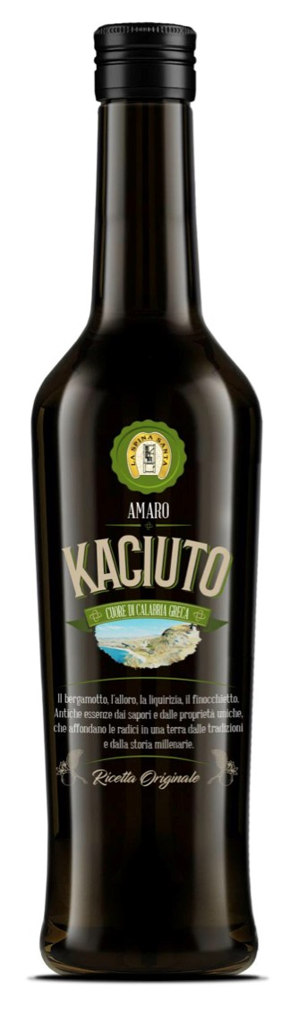

Kaciuto – The Mediterranean Taste
Laurel, wild fennel, liquorice root, bergamot; these flavours combined bring the ancient essences of Calabria together with properties that are rooted in the ancient lands with ancient traditions and history. The health benefits associated with the wild, organic ingredients is prominent throughout European medicine.
Kaciuto can be used in man ways, including as an after dinner digestif, part of a cocktail, or as on its own.

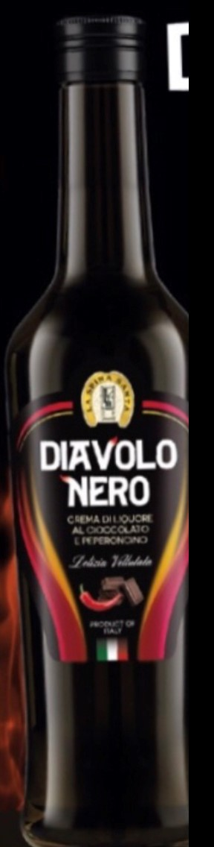

Diavolo Nero – The Daredevil
Diavolo Nero combines the softness of chocolate with the strength of the chillipepper. This velvety, creamy liqueur combined with the chilli pepper creates a warm taste in the back of the mouth, not scorching, but leaving a creeping hint of spice.
The ideal way to enjoy this powerful liqueur is with sweets, ice creams and fruit as a tasty companion to bring out unexpected flavours. Diavolo Nero can also be enjoyed on its own as an after dinner treat.

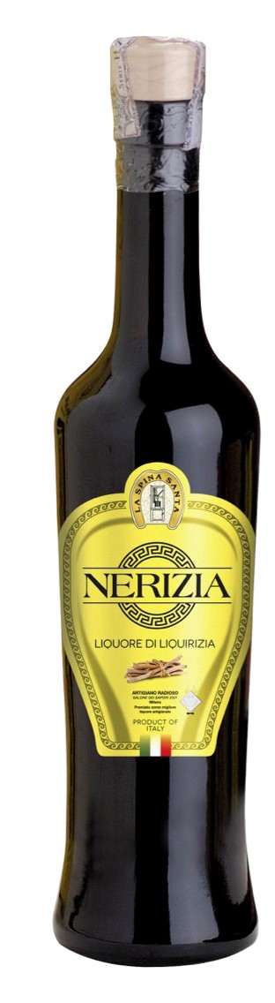

Nerizia – The Strength of Calabrian Roots
Liquorice is a medicinal plant found mainly in the southern regions of Italy, and in particular Calabria is a historical producer. In addition to countless uses dictated by medicinal properties, liquorice, thanks to its unmistakable aroma, is widely used for liqueurs, candies, sweets and drinks.
Nerizia is a liquorice liqueur, retaining many of its natural characteristics, free of preservatives and colourings, and is best enjoyed frozen. It is a wonderful digestif, aiding natural digestion after a filling meal.

