**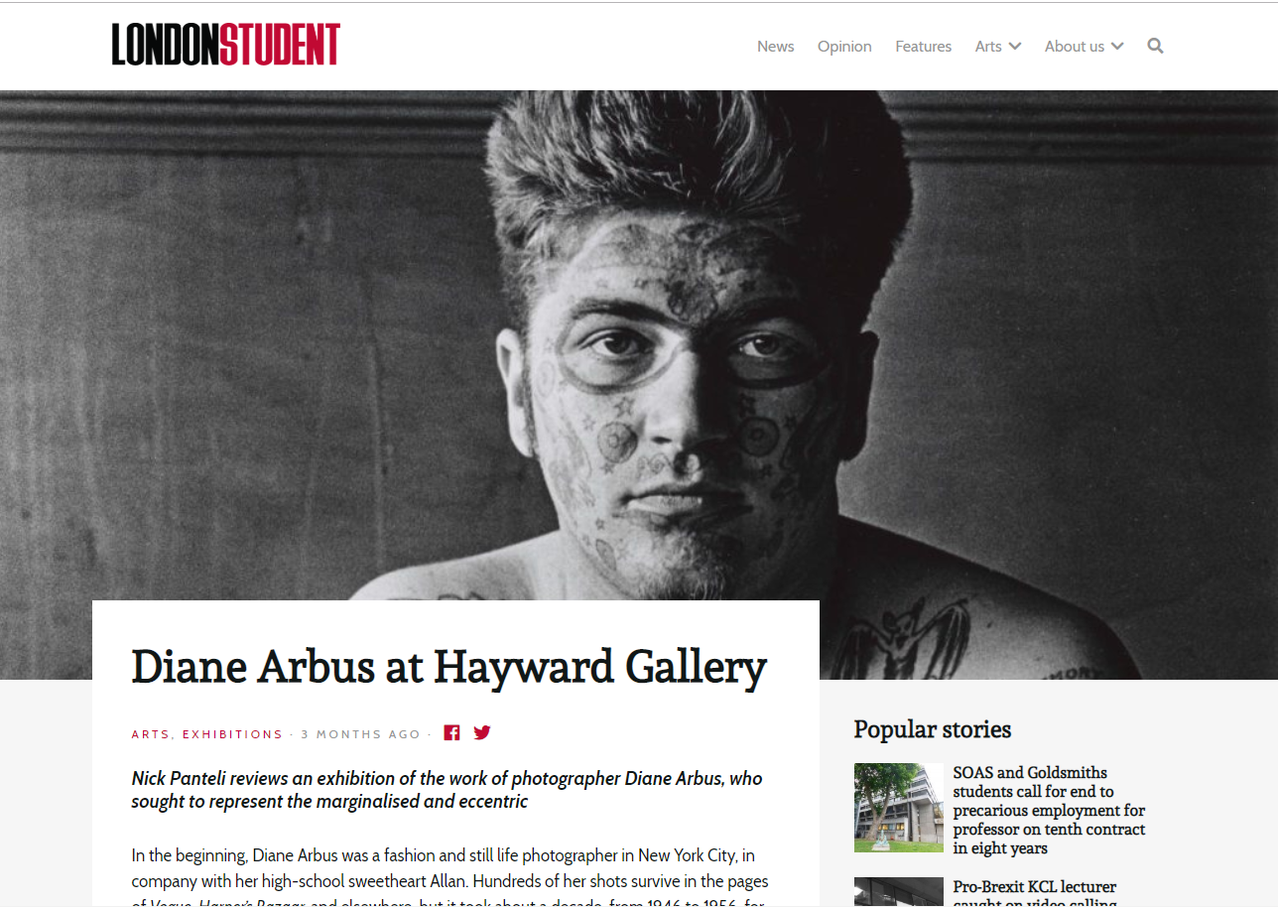  
  
  
  
Diane Arbus at Hayward Gallery**

[ARTS](http://londonstudent.coop/category/arts/), [EXHIBITIONS](http://londonstudent.coop/category/arts/exhibitions/) · 3 MONTHS AGO ·

***Nick Panteli reviews an exhibition of the work of photographer Diane Arbus, who sought to represent the marginalised and eccentric***

In the beginning, Diane Arbus was a fashion and still life photographer in New York City, in company with her high-school sweetheart Allan. Hundreds of her shots survive in the pages of *Vogue*, *Harper’s Bazaar,*and elsewhere, but it took about a decade, from 1946 to 1956, for Diane to arrive as the mercurial figure of 20th century photography. Her subject matter were the so-called freaks, lowlifes, and other so-called rejectamenta against which others defined themselves as “normal.”

Before this emergence, she was besides a wife and mother, a child of privilege. Her parents owned the famous Fifth Avenue department store Russek’s, as much a part of New York’s built environment as its less salubrious citizenry. For the most part, she and her siblings were raised by maids and governesses. Such a status-conscious environment contained nothing indicative of her (ongoing as much as latterly developed) internal world.

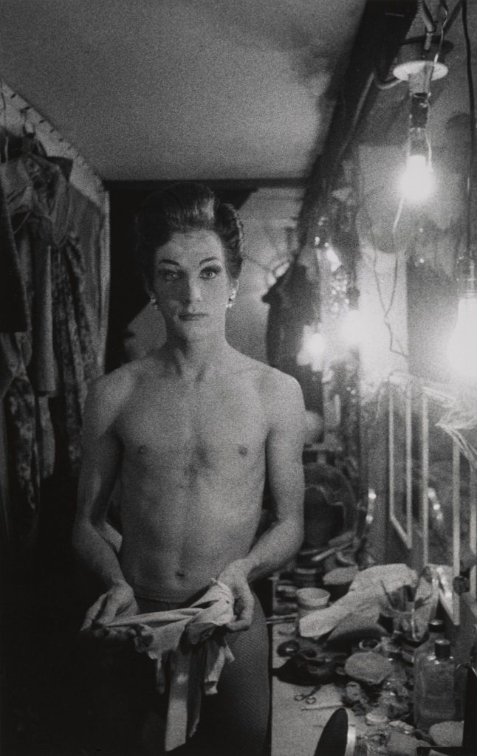Female impersonator holding long gloves, Hempstead, L.I. 1959 ©The Estate of Diane Arbus, LLC. All Rights Reserved

“One of the things I felt I suffered from as a kid was I never felt adversity,” Arbus once observed. “I was confirmed in a sense of unreality which I could only feel as unreality. And the sense of being immune was, ludicrous as it seems, a painful one.” It was this sense of a magazine-perfect universe—where bodies were beautiful, everyone had ten fingers and toes, and faces were capable of expressing the full range of human emotions in all the conventional, habitual ways—that she slunk away from; building relationships, it would seem, with the travelling carnivals, peeling hallways, and hotel rooms where the leftover lives rested uneasily on dominant WASP America’s images of its post-war self. In spite of the expectations of caregiving, and depression, she repeatedly placed herself in situations that others would have found discomforting or dangerous.

There was life here too, and, if the next decade-and-a-half was an indication, Arbus became fascinated. Though her legend grows and warps [it has been suggested](https://www.thecut.com/2016/07/diane-arbus-c-v-r.html) that such a way to live was a startling position for someone of her social positioning to grow into.

*In the Beginning* is something unique in that there are more than 100 prints previously unseen in Europe from the Diane Arbus Archive—gifted to The Metropolitan Museum of Art in 2007 by her children. Seven key years, 1956 to 1963, and hundreds of shots: some of them less sharp than the few pin-prick-sharp mid-format prints; some visceral, blurry and spontaneous. In exhuming the majority of prints that were, for the most part, negatives that were undeveloped until the 21st century—some Arbus herself would not have necessarily wanted for public consumption—it calls up questions on the right to put out creative production on behalf of the dead.

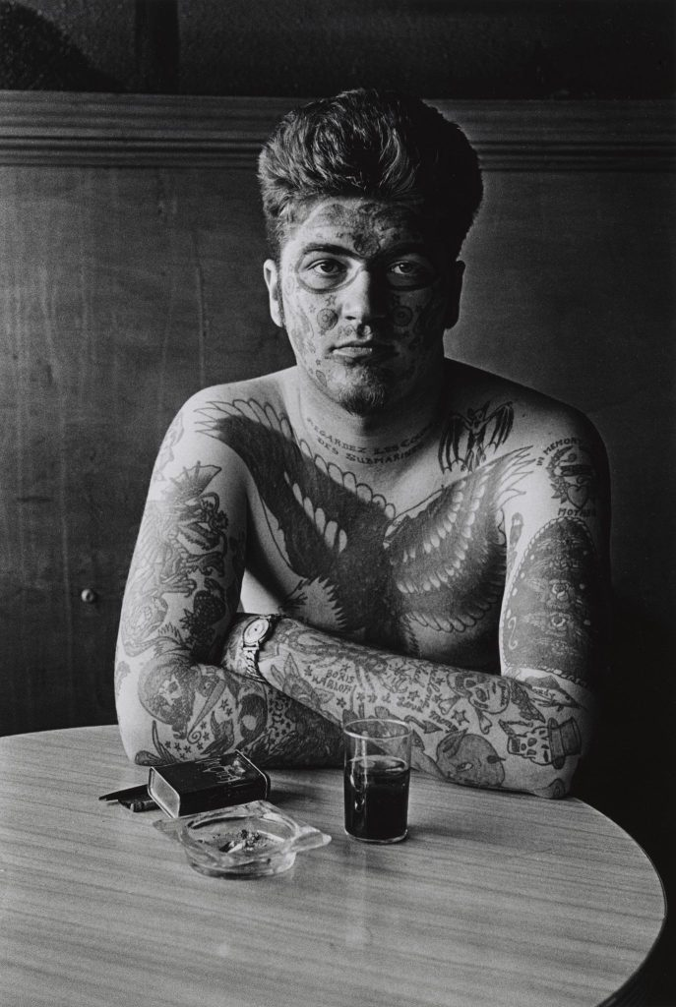Jack Dracula at a bar, New London, Conn. 1961 © The Estate of Diane Arbus, LLC.

On this theme, take in the selective uses of chiaroscuro, namely in the portrait of ‘Jack Dracula in a bar, New London Conn.’, used for the promotional posters. Why is half his face obscured but his tattooed, bat-crammed chest not? Surely this is not just a quirk of the light source but an after-effect of the development process. It was, after all, printed later from negatives later, thus not a choice made by Arbus. A photographer friend shares her suspicions on this detail too. However, this may be more pragmatic than artistic: a tattooed body cannot be beheld in darkness. The development process is as important in the messy, up-and-at-it world of belonging and division. Throughout, note the selective use of soft, seraphic faces and their shadowy counterparts, particularly between parents and children.

These first prints of hers make visible Diane’s turn from something of an uptown heiress into someone willing to stare down strangers. In these portraiture encounters there is the evidence that people will stop for her, that they might invite her to follow them home, and show her their secrets: their tattoos, their scars, or their dispensations for transvestism.

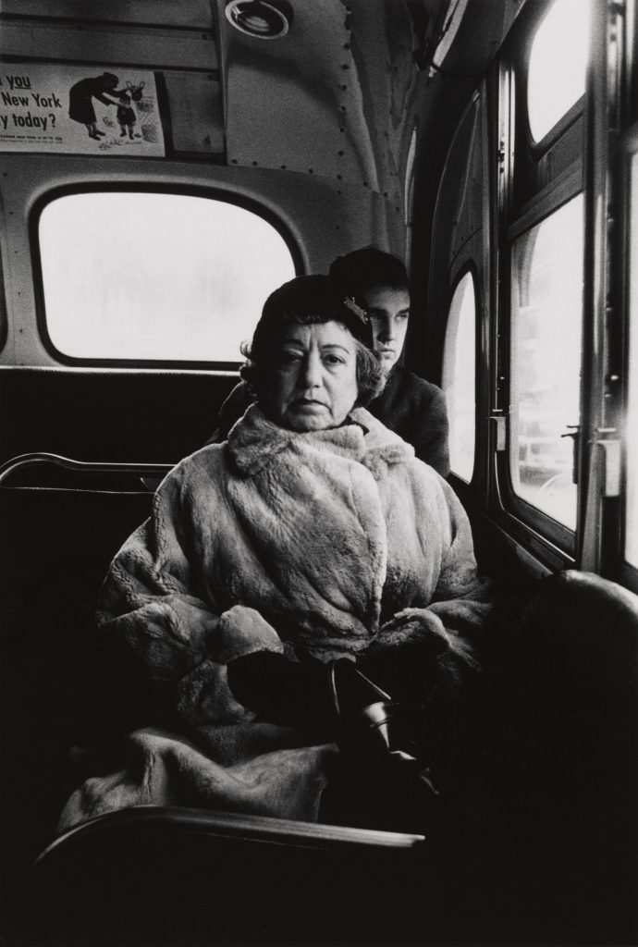Lady on a bus, N.Y.C. 1957 ©The Estate of Diane Arbus, LLC. All Rights Reserved

At first, though, there appears to be no real human contact: wax-museum mannequins and stills of cinema screens or stealing shots in the showers at Coney Island. As observers, we are wont to judge the ethical handling of these more candid shots.  “What distinguishes Diane work from the very beginning is this idea that she was communicating and revealing her practice to her subjects” says Jeff L Rosenheim, Curator and Head of the Met’s Photography Department. Though she forged lifelong friendships in the margins, could this be said of everything that was committed to celluloid? There is therefore a contradiction in her work: Arbus as humanist and as voyeur. As her practice evolved, she was considered calculating, controlled, and prepared to do almost anything to grab the image she wanted. When her subjects stare back at the camera—barbers through their shops windows, a woman across a delicatessen—it is often with startled or suspicious looks. New Yorkers begin facing her straight-on, like an angry bible-handling man on Times Square (yelling at her?), a boisterous crew of boys on the beach to a stern old-monied women in furs. Their body language suggests a tacit agreement with the photographer.

There are also the somewhat less noticeable preoccupations resonant with her own life: the caregivers of single fathers and single mothers straining under the weight of their children or cradling them, governesses pushing strollers and walking children, themselves with toy prams, in Central Park.

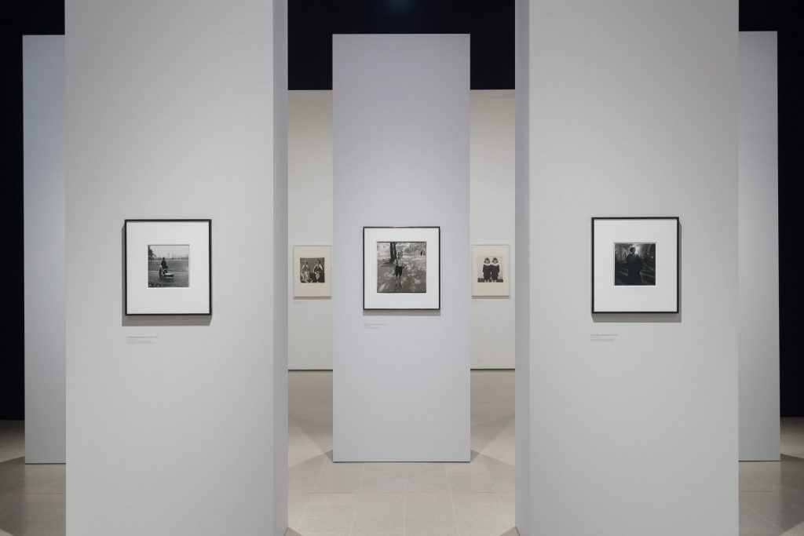Installation view of *Diane Arbus: In the Beginning*at Hayward Gallery, 2019. Photo: Mark Blower

In 2016, the same exhibition in New York was preceded by the publication of an unauthorised biography by New York Times journalist Arthur Lubow, *Diane Arbus: Portrait of a Photographer*. Among other details it claimed that Arbus sometimes slept with her subjects, had participated in group sex, and had a long-term incestuous relationship with her brother. Many rejected the claims as flimsy and prurient; if there’s veracity in them though, they suggest that far from being detached with lives were nothing like her own, doing more than observing entailed a life that knew what it meant to live outside societal norms.

Curatorially, the exhibit is served well by the two large spaces of the gallery, divided by equidistant pillars. Rosenheim has emphasised a free-standing arrangement: visitors choose their own migration pattern over the gallery space: “you have to be like the artist herself searching for your own subjects in the patterns that you choose.” And not unlike the skyscrapers of an American metropolis they divide and prohibit a deeper view of the whole.

*Diane Arbus: In the Beginning*runs at London’s Hayward Gallery until 6 May 2019. For more information, visit the website [here](https://www.southbankcentre.co.uk/whats-on/exhibitions/hayward-gallery-art/diane-arbus-beginning).