Production and Innovation Management

Student’s Name

Institution

Course

Date

# **Abstract**

Technological innovation has been a major theme in modern day mobile production with companies across the world competing to outdo each other. Mobile technology innovation has changed lives with the industry growing in a higher rate than any other. New mobile devices, applications and technology is being developed and released while also demonstrating huge potential for the future. IPhone X which was released by Apple in November 2017 was a revolution in smart phone market with its breathtaking features breaking new ground and setting it above other mobile devices. It unique features, processor, sleek design and enhanced user interface has made iPhone X the preferred smart phone, selling more than any other smartphone in the world since its release. Its stellar performance can be attributed to the sound product management strategies applied by Apple. This paper analyses the product management, financial performance, market performance, customer satisfaction and the competitor analysis of iPhone X in the smartphone market since its release.

Table of Contents

Abstract 2

1.1. Introduction 4

1.2. The Product 5

1.3. Product Performance 6

*1.3.1.* *Financial Indicators of the Product Performance* 6

*1.3.2* *Market Indicators of the Product Performance* 8

*1.3.3 Other Performance Indicators* 11

1.3.3.1 Customer Satisfaction 11

1.3.3.2 Competitor Analysis 12

*1.4* Theme 13

*1.5* Recommendations 14

*1.6* Conclusion 15

References 17

**List of Figures**

Figure 1: IPhone X Supply in Units 6

Figure 2: Top 10 Global Handset Profit Share 7

Figure 3: Cost of iPhone X in Selected Countries (US Dollars) 8

Figure 4: iPhone X First Weekend Adoption 9

Figure 5: Market Share of iPhones in Fiscal Quarters 10

Figure 6: Adoption Trend of iPhone X 12

**Production and Innovation Management**

* 1. **Introduction**

In the recent years, the business environment of various industries has shifted significantly due to the technological advancements that are experienced. The ability of any organization to remain relevant and be sustainable is determined by how they are able to adapt to these changes in the market (Li, et al., 2016). As a result, innovations have been viewed as a means by which various companies can maintain their relevance in the market. Firms which have not been able to adapt to these changes by including innovation in these management process have failed to success and most of them are becoming extinct. Product innovation is one of the key areas that many companies have invested in to ensure that they provide the client with products that are useful to them (Greco, et al., 2015). As a result, many companies tend to provide new updates to their products on a yearly basis. One such company is Apple Inc.

Apple Inc. is an American multinational corporation that is known for its technological products. Additionally, the company offers online services, computer software, and consumer electronics to their clients. In the technology industry, Apple Inc. is the largest company based on revenue (Eftekhari & Bogers, 2015). One of their most renowned product, which contributes to a large portion of their revenue in the world is the iPhone. The company has over the years produced various variants of the phone with every new one having a different innovation that attracts the consumers (Reuters, n.d.). The following paper will analyze the new iPhone X and evaluate it performance in the market. Consequently, this write-up will provide reasons for this product’s performance.

* 1. **The Product**

The iPhone X was announced in September, 2017 and was later launched in the market in November, 2017. iPhones are considered the primary product of Apple Inc. The iPhone is a company’s smartphone line based on its own iOS operating system. Some of the standard features that are included in all iPhone include camera system, iTunes store, App Store, and a retina display (Roth, et al., 2015). However, in the recent years the company has been moving towards more innovative products that are considered necessary in the current market. For instance, starting with iPhone 7, the company has added new innovative features in their gadgets which include Siri, a voice activated artificial intelligence feature, Apple Pay, dust and water resistance, and touch ID (Apple, 2017).

Currently, iPhone X is Apple Inc.’s newest product in the market. This product comes with a variety of new features which include Face ID for security purposes. Over the years, many people have become very conscious about the security of the data that they store in their phones (Apple, 2017). As a result, the innovation of more security features for their new products was a great idea by the Apple Inc. think tank. Other innovative features that were included in this product include the OLED screen technology, wireless charging, bezel-less design, and gesture-based navigation system to replace the typical home button, which had previously been located at the bottom of the screen (Sørensen, 2017). Based on the features that were included in this new product, Apple Inc. marketed it as a future phone in a bid to recognize the innovations involved.

* 1. **Product Performance**
     1. ***Financial Indicators of the Product Performance***

Since its introduction in the market, iPhone X has been the best-selling smartphone in the world. According to Apple, 29 million units of iPhone X were sold within the first quarter of its introduction in the market (Apple, 2017). This may have been boosted by the quarter coinciding with the holiday period, at time when most people replace their mobile phones. Considering that a total of iPhones sold within the quarter were 52.2 million. In the United States however, iPhone X represented a proportion of 20% of the total iPhone sold in the 4th quarter of 2017 followed by iPhone 8 plus which accounted for 17% of the total iPhone sold in the US. In terms of revenue, the three new models of iPhone released in 2018 accounted for 61% of the total iPhone revenue (Bud, 2018). This is slightly lower than that of iPhone 7 and iPhone 7 plus which accounted for 72% when they were released in 2016. This can be attributed to the late release of iPhone X which was only in the market for less than two months in 2017.

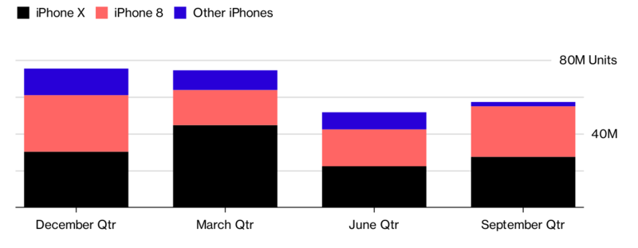

*Figure 1: IPhone X Supply in Units Source:* (Liu, et al., 2018)

IPhone X has performed remarkably well financially and was on high demand immediately after its release. The smartphone was the bestselling accounting for 35% of the total profits in the smartphones market all over the world. IPhone X also contributed 21 % of the total revenue in the mobile phone industry. It was the most profitable leading iPhone 8 which represented 19.1% and iPhone 8 plus which represented 15.2% (Bowers & Khorakian, 2014). This propelled Apple products to earn over 90% of the total profit in the market. Despite competition from Chinese smartphone manufacturing companies such as Oppo and Huawei, iPhone X has continued to dominate financially in the market with the product generating five times more profit than that generated by over 600 android smartphones combined in the last quarter of 2017 (Caniëls, et al., 2014). The performance of iPhone X as the most profitable smartphone in the world also means that Apple products dominate the smartphone market in terms of profitability, with only Samsung Galaxy Note 8 and Samsung Galaxy S8 Plus appearing in the list of 10 most profitable smartphones in the world.

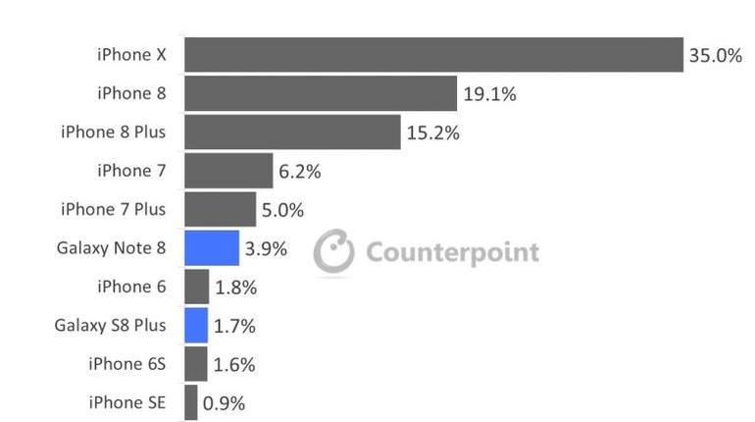

*Figure 2: Top 10 Global Handset Profit Share Source:* (Bud, 2018)

The high demand for iPhone X in the market coupled by its high price led to apple recording total revenue of $38 billion in the last quarter of 2017 which is an increase of 16% on the previous quarter’s sales before iPhone X was introduced into the market (Elerud‐Tryde & Hooge, 2014). In the first quarter of 2018, the company sold 77.3 million iPhones which is less than the first quarter of 2017 where the total number of iPhones sold were 78.3 million representing a 1.24 % decrease despite the introduction of iPhone X. However, the total revenues increased by 11.69% to 61.58 billion up from $54.38 billion (Caniëls & Rietzschel, 2015). The company’s earnings per share increase from $3.36 to $3.89 within the same period. The increase in revenue is attributed to the high price of iPhone X which led to the increase in the average price of iPhone units increasing from $694 in the first quarter of 2017 to $ 796 in the first quarter of 2018.

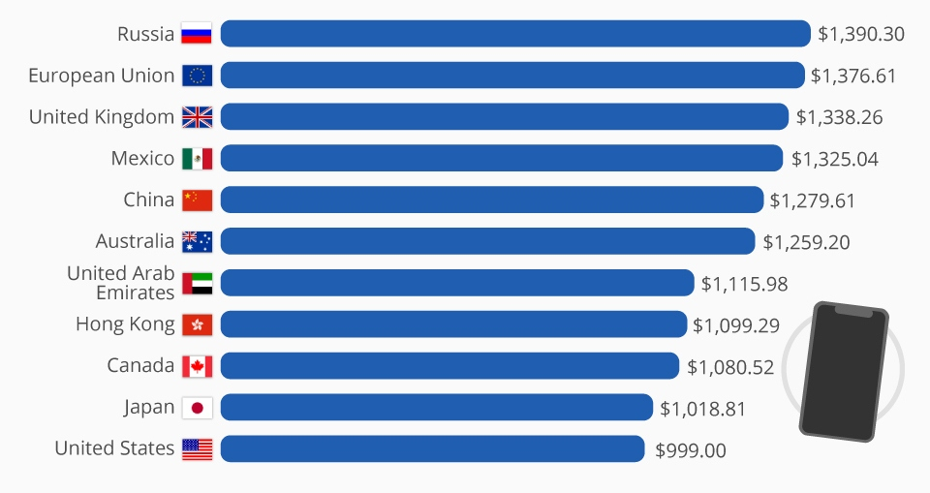

*Figure 3: Cost of iPhone X in Selected Countries (US Dollars) Source:* (Apple, 2017)

* + 1. ***Market Indicators of the Product Performance***

IPhone X has performed remarkably well in the market since its release in November 2017, leading in terms of global market share. During the last quarter of 2017, the smartphone accounted for about 20% of the total market share despite being in the market for less than two months (Bock, 2018). This demonstrates remarkable success in terms of market demand and sales despite having a steep price of $999. According to Tom Cook the CE of Apple, iPhone X was very popular among buyers as it has been chosen more than any other iPhone since its inception in September. IPhone X has however faced multiple challenges in the market with its high price inhibiting buyers. The retail price of iPhone X is $999 which is more than iPhone 8 which retails at $699 and iPhone 8 plus which retails at $799 (Goller & Bessant, 2017). The market success of iPhone X can partly be attributed to the rather unconventional marketing strategy that presents the product as a phenomenon and not simply as a device. The product promotion strategy concentrates on presenting iPhone X as having the best processor, new color, better camera and sleek design that creates a captivating feeling on the buyers (West & Bogers, 2014). The unconventional marketing push is coupled by the availability of the product in almost every corner of the globe as the brand fights off competition from the low priced Chinese smartphones.

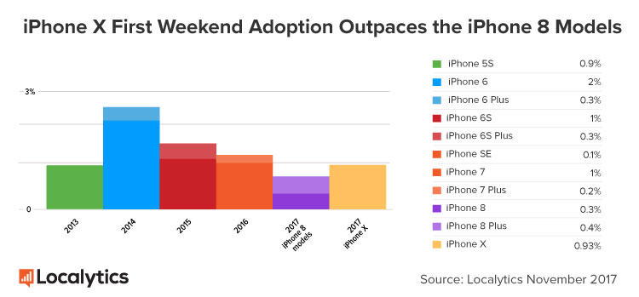

*Figure 4: iPhone X First Weekend Adoption*

The number of sales from iPhone X has however decreased with its demand slowing down in 2018. The demand for the market performance of the product has not turned out as Apple had expected which has raised concerns within the company. The company is concerned on the strategies to implement to manage the reduced sales of the product since iPhones account for about 60% of the total revenue for the company (Bengtsson, et al., 2015). The slowed performance of iPhone X can also be attributed to the reduction in price of the iPhone battery replacement scheme which followed multiple concerns over the throttled batteries in older versions of iPhone. The move to reduce the price of battery replacement from $59 to $29 was aimed at preventing unanticipated shutdown due to worn out batteries (Humphrey, et al., 2018). The move has led to multiple iPhone users preferring to replace the batteries of the old phones rather than acquire new phones which is more expensive thereby reducing the demand and sale of iPhone X.

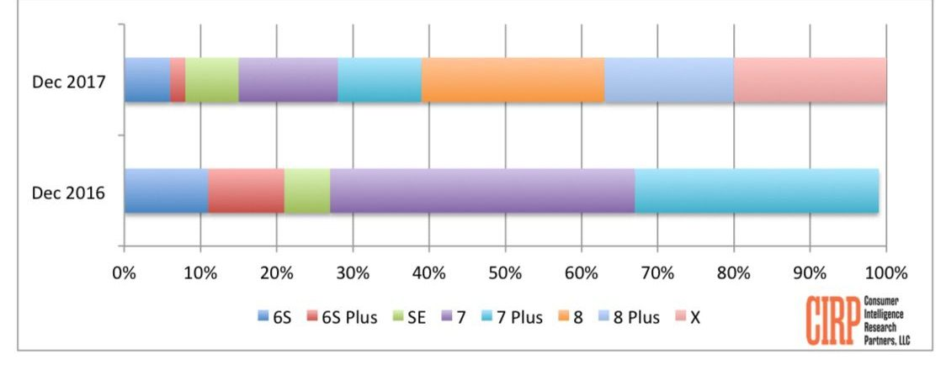

*Figure 5: Market Share of iPhones in Fiscal Quarters*

The release procedure of the iPhone X has been taunted as one of the reasons behind its below par performance in 2018. Apple took a risk by releasing three iPhone in the fall compared to the normal procedure of releasing two iPhone at a time. The release of iPhone X which was the flagship smartphone was not only late but had a high price compared to iPhone 8 and iPhone 8 plus (Liu, et al., 2018). The company had intended to manufacture about 40 million units of iPhone X in the first quarter of 2018, but that figure was reduced to 20 million due to the reduced market demand. This followed a survey that was undertaken on the proportion of people seeking to buy iPhone X which decreased from 43% to 37%.

## *1.3.3 Other Performance Indicators*

### 1.3.3.1 Customer Satisfaction

There is a strong acknowledgement from customers that iPhone X the best smartphone in the world judging by its sleek model, fastest hardware and the ability to deliver software experience that is more optimized (Noviaristanti, et al., 2017). Tests carried out by High profile Youtube Users EverythingApplePro, SuperSaf TV and XeeTechCare who has a combined subscription of 7 million people shows that the performance of iPhone X cannot be compared to other smartphones in the world. Some of the features that has made iPhone X a popular device with customers include the machined smooth waterproof nature, the 256 GB storage that can accommodate millions of applications, the FaceID for immediate face recognition and the amazing high resolution screen (Ooms, et al., 2015).

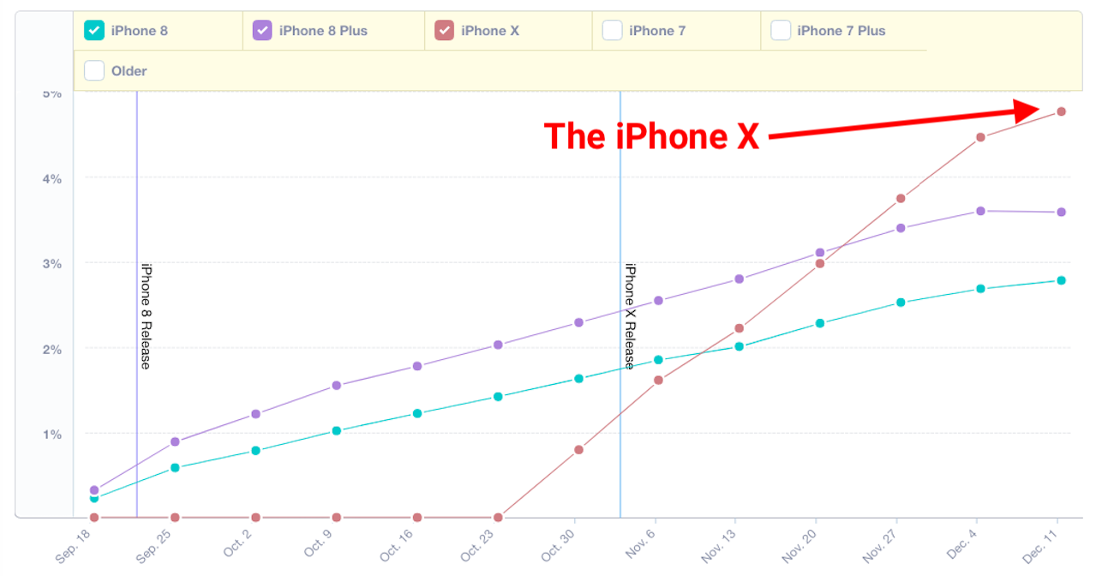

*Figure 6: Adoption Trend of iPhone X Source:* (Sørensen, 2017)

### 1.3.3.2 Competitor Analysis

IPhone X has faced immense competition from Chinese smartphone manufacturing companies such as Oppo and Huawei as well as Japan’s Samsung who have been producing devices with similar or even better features than iPhone X with a lower price. The performance of iPhone X in the market however shows that its market acceptance and demand is still high. This can be attributed to its high dependability and its long lasting nature (Safa & Daraei, 2016). The device has dominated the market smartphone since its launch by being the highest selling smartphone in the globe in terms of units and revenue. In the last quarter of 2017, iPhone X generated five times more profit than that generated by over 600 android smartphones combined in the last quarter of 2017 (Son, et al., 2015). The performance of iPhone X as the best-selling smartphone puts it ahead of other devices such as iPhone 8, iPhone 8 plus and even rival products such as Samsung Galaxy Note 8 and Samsung Galaxy S8 Plus which take up position six and eight respectively in the list of the best-selling smartphones in the world.

* 1. **Theme**

The perceived cost vs benefits of a product are a critical determinant of consumer behavior. Before making a decision to purchase or acquire a newly invented product, consumers undertake a comparison of the perceived extra benefits they will get from the product and compare that with the price of the product to evaluate the aspect of value for money (Stierand, et al., 2014). The evaluation process is subconscious and automatic and forms a major component of the decision-making process. The aspect of cost involves the release of a negative and the receipt of a positive. On the other hand, the perceived benefit involves the receipt of something positive and the release of something negative. The release of IPhone X came barely two months after the release of earlier upgraded versions in IPhone 8 and IPhone 8 plus (Schulz, et al., 2015). With the price of IPhone X much more than that of the earlier released versions, consumers were bound to undertake a perceived cost and perceived benefit analysis to establish whether the acquisition of the products presents value for money. This has been a major determinant in the success and demand of IPhone X and ultimately its market performance.

The aggressive ingredient marketing undertaken through the spread of internet brochures and videos aims at creating strong emotional appeal to the audience (Sørensen, 2017). IPhone X demonstrates the various aspects of product differentiation that have been adopted by Apple through a series of double iPhone releases every year. Of main concern in the production of iPhone X is the improvement of product design to enhance user interface with the introduction of features such as Face ID, the elimination of the Home button, Face emoji, wireless charging and enhanced battery life. The international markets have been a critical in the sale of iPhones with the products sold across the globe (Slater, et al., 2014). This is a similar case with iPhone X which has been advertised through online sites and distributed to the international market.

The product has adopted a forward loop where products are brought to the international market to compete with existing products and to revolutionize the smartphone industry (Agogué, et al., 2015). The forward loop international product development have been a success for iPhone X as it has been the most successful smartphones in terms of units sold and revenue generated. However, the high price which many individuals in developing countries cannot afford has inhibited its adoption. The forward loop has seen positive adoption of the product in major markets such as China, where the competition is fierce due to the presence of local companies such as Oppo and Huawei. Due to the good performance of IPhone X in China, the total sales of IPhone in China grew by 32% in a smart phone market that is shrinking. The Chinese market experienced a sales decline of 8% in 2017, which is worst decline in years.

* 1. **Recommendations**

Despite the stellar performance of iPhone X in the last quarter of 2017, the product has recently experienced a decrease in demand that led to Apple reducing the production capacity from 40 million to 20 million units. The decrease in demand that has characterized iPhone X in 2018 after the successful release and demand in 2017 may have been caused by the choice of the release strategy that was adopted by Apple in 2018. The release of iPhone X followed the earlier release of iPhone 8 and iPhone 8 plus within a period of 2 months, with consumers facing a choice of too many iPhones and too many variants in iPhone X. the massive difference in the cost between iPhone and the other iPhones may have led to consumers adapting to the continuous improvements (Fay, et al., 2015). The choice overload may have led to preference uncertainty, difficulties in decision-making, complexity of choice and decision goals as explained in the paradox of choice.

With many people shying away due to its high-end price, it is important that Apple comes up with a marketing strategy that demonstrates the products features and new developments that sets its above other competing iPhones and Android smartphones. With the release of iPhone X coinciding with the reduction in the price of battery replacement, many users chose to upgrade their current iPhones rather than replace them. Apple can decide to review the battery replacement charges in a move that would remove the incentive to upgrade their old phones and instead lead them to acquire new ones. One of the main reasons for a decrease in demand on iPhone X is the steep price of $999 that is far much higher than competing products such as iPhone 8, iPhone 8 plus, Samsung Galaxy note 8 Galaxy S8 plus, Apple should consider reviewing the price of the product with the increase in demand providing the company with higher economies of scale.

* 1. **Conclusion**

The tag of innovation and brand equity has been a major attribute of all Apple products that has helped build customer loyalty. The recently released iPhone X is major milestone in the smartphone market with multiple improved features offered to the ever-expanding and competitive smartphone marketing. The marketing strategies adopted by Apple to showcase iPhone X have been a key component in the success of the product in the market. The marketing strategies entail the fusion of multiple elements in advertisements that showcase its multiple features that are appealing to the intended market audience while also retaining the sleek design that has for long been popular with the current iPhone users. With the decreasing demand in the product, Apple needs to come up with measures that ensure that the demand for iPhone X stabilizes.

# **References**

Agogué, M., Levillain, K. & Hooge, S., 2015. Gamification of creativity: exploring the usefulness of serious games for ideation. *Creativity and Innovation Management,* 24(3), pp. 415-429.

Apple, 2017. *The future is here: iPhone X.* [Online]   
Available at: https://www.apple.com/newsroom/2017/09/the-future-is-here-iphone-x/  
[Accessed 22 June 2018].

Bengtsson, L. L. N. et al., 2015. Open to a select few? Matching partners and knowledge content for open innovation performance. *Creativity and innovation management,* 24(2), pp. 72-86.

Bock, R., 2018. May. Low-cost 3D security camera. In Autonomous Systems: Sensors, Vehicles, Security, and the Internet of Everything. *International Society for Optics and Photonics,* 106(43), pp. 106-430.

Bowers, J. & Khorakian, A., 2014. Integrating risk management in the innovation project. *European Journal of innovation management,* 17(1), pp. 25-40.

Bud, A., 2018. Facing the future: the impact of Apple FaceID.. *Biometric Technology Today,* 18(1), pp. 5-7.

Caniëls, M., De Stobbeleir, K. & De Clippeleer, I., 2014. The antecedents of creativity revisited: A process perspective. *Creativity and Innovation Management,* 23(2), pp. 96-110.

Caniëls, M. & Rietzschel, E., 2015. Organizing creativity: Creativity and innovation under constraints. *Creativity and Innovation Management,* 24(2), pp. 184-196.

Eftekhari, N. & Bogers, M., 2015. Open for entrepreneurship: How open innovation can foster new venture creation. *Creativity and Innovation Management,,* 24(4), pp. 574-584.

Elerud‐Tryde, A. & Hooge, S., 2014. Beyond the generation of ideas: Virtual idea campaigns to spur creativity and innovation. *Creativity and Innovation Management,* 23(3), pp. 290-302.

Fay, D., Shipton, H., West, M. & Patterson, M., 2015. Teamwork and organizational innovation: The moderating role of the HRM context. *Creativity and Innovation Management,* 24(2), pp. 261-277.

Goller, I. & Bessant, J., 2017. *Creativity for innovation management.* Abingdon: Tylor and Francis.

Greco, M., Grimaldi, M. & Cricelli, L., 2015. Open innovation actions and innovation performance: a literature review of European empirical evidence. *European Journal of Innovation Management,* 18(2), pp. 150-171.

Humphrey, J. et al., 2018. Platforms, innovation and capability development in the Chinese domestic market. *The European Journal of Development Research,* 6(2), pp. 1-16.

Liu, J., Zhai, X. & Chen, L., 2018. Optimal pricing strategy under trade-in program in the presence of strategic consumers. *Omega,* 67(2), pp. 19-32.

Liu, J., Zhai, X. & Chen, L., 2018. Optimal pricing strategy under trade-in program in the presence of strategic consumers. *Omega,* 6(2), pp. 52-71.

Li, X. et al., 2016. A commonsense knowledge-enabled textual analysis approach for financial market surveillance. *Informs Journal on Computing,* 28(2), pp. 278-294.

Noviaristanti, S., Acur, N. & Mendibil, K., 2017. A Bibliometric Review of the Innovation Intermediary: Mapping Roles and Setting a Research Agenda (Forthcoming). *Creativity and Innovation Management,* 54(3), pp. 129-212.

Ooms, W., Bell, J. & Kok, R., 2015. Use of social media in inbound open innovation: Building capabilities for absorptive capacity. *Creativity and Innovation Management,* 24(1), pp. 136-150.

Reuters, n.d. *Apple Inc (AAPL.O).* [Online]   
Available at: https://www.reuters.com/finance/stocks/company-profile/AAPL.O  
[Accessed 22 June 2018].

Roth, S., Schneckenberg, D. & Tsai, C., 2015. The ludic drive as innovation driver: Introduction to the gamification of innovation. *Creativity and Innovation Management,* 24(2), pp. 300-306.

Safa, L. & Daraei, M., 2016. Determining the Relationship between Brand Personality and Brand Loyalty in Tehran, Iran: Case of iPhone Smartphone. *International Journal of Research in Management,* 8(6), pp. 17-18.

Schulz, K., Geithner, S., Woelfel, C. & Krzywinski, J., 2015. Toolkit‐Based Modelling and Serious Play as Means to Foster Creativity in Innovation Processess. *Creativity and Innovation Management,* 24(2), pp. 323-340.

Slater, S., Mohr, J. & Sengupta, S., 2014. Radical product innovation capability: Literature review, synthesis, and illustrative research propositions. *Journal of Product Innovation Management,* 31(1), pp. 552-566.

Son, I., Lee, H. & Kim, J., 2015. Preannouncement effect of innovative new product on global telecom industry: focused on iPhone. *Indian Journal of Science and Technology,* 8(24), pp. 14-29.

Sørensen, C., 2017. *The iPhone X in context.* [Online]   
Available at: http://blogs.lse.ac.uk/businessreview/2017/10/05/the-iphone-x-in-context/  
[Accessed 22 June 2018].

Stierand, M., Dörfler, V. & MacBryde, J., 2014. Creativity and innovation in haute cuisine: Towards a systemic model. *Creativity and Innovation Management,* 23(1), pp. 15-28.

West, J. & Bogers, M., 2014. Leveraging external sources of innovation: a review of research on open innovation. *Journal of Product Innovation Management,* 31(4), pp. 814-831.