Name
Course
Professor
Date
Introduction
Abortion is one of the main controversial and debated issues in different parts of the world today. While it’s a two-sided type of argument, with constituents being either profile or prochoice, the discussion over abortion is overpoweringly complex and requires an extensive look into the biology, healthcare, constitutional rights, morality and ethics, which affect this issue. It is absolutely impractical to produce a reasonably consistent stand on the issue of abortion without being forced to abandon another belief, leaving alone an attempt of finding the middle ground (Blendon, 56).
Abortion discussions start with the moral status of the fetus; if the fetus in the womb of the other does not have any right then abortion won’t be an issue. However, if the fetus has rights no matter how minute, then determination of pregnancy will not exclusively concern the freedom of the mother, but instead constitute the cautious destruction of a mankind with freedom.
Statistics and methods of abortion are very different from contraceptive statistics. This is mainly because abortion is defined as ending of pregnancy instead of its prevention; hence they are measured differently. According to the statistics obtained from Center for Disease Control website show that the highest number of women who receive abortions are unmarried, and teenagers of age ranging from 20 to 24. The time when most of these women receive abortion is within the first 8 weeks of gestation that correlates to the use of curettage method.
The graph below shows total abortion, abortion ratio and abortion rate by age group of girls who obtain it, the data was from United States, 2014.
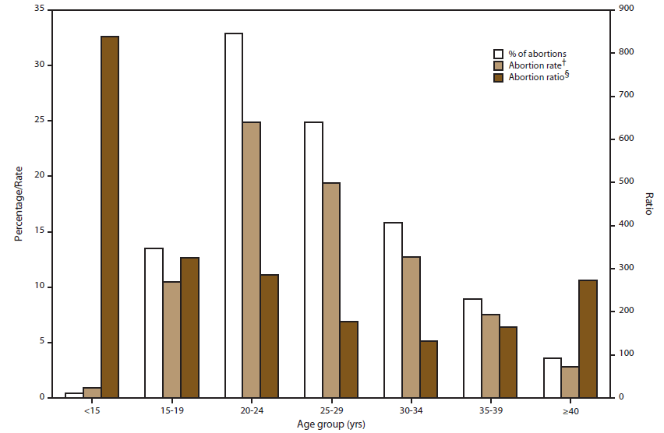
During the first eight week of gestation, the most preferred method is suction aspiration, whereby a vacuum tube stronger than household vacuum is used to remove the embryo from a woman’s body. Another method which is used during this period is dilation and curettage, where the woman’s cervix is well dilated, and a very sharp knife tears at the body of the fetus until all the fetus remains are scrapped out. Just like any all surgery procedures there is high risk of puncture, infection, bleeding and even death.
A research conducted by CDC in 2013 show that ladies who are in their early twenties are the ones who participate in abortions. The abortions in 2013 mostly took place in the early gestation; about 90% of abortions done in United States were performed at less than thirteen weeks’ gestation; a smaller number of about 7% of were performed at gestation period of fourteen to twenty weeks, and a much reduced of about 1.3% were performed at more than twenty one weeks of gestation.
Percentage of reported abortions by weeks of gestation; CDC, 2012
≤6 wks | 7 wks | 8 wks | 9 wks | 10 wks | 11 wks | 12 wks | 13 wks | 14-15 weeks | 16-17 weeks | 18-20 weeks | ≥21 weeks
38.2% | 19.4% | 14.4% | 9.5% | 6.4% | 5.2% | 3.7% | 3.9% | 3.5% | 1.8% | 1.9% | 1.3%

One of the greatest controversial kinds of abortion is the one that is normally known as partial birth abortion. This type of abortion has come under fire in many countries. With this type, abortion is done during the trimester of pregnancy and requires complicated and major surgery. It mainly entails removing the fetus partially from the woman’s uterus through the vagina, first the feet, and use of suction to remove spinal fluid from the skull and brain. Fetus’s skull collapses to give way for complete removal. Most of the people feel that this type of abortion is barbaric and doctors should be prevented from performing this type of abortion.
For centuries now abortion has always been practiced around the globe as unusual and cruel birth control method. Before the start of nineteen century, abortion was considered an illegal and forbidden practice in many countries; different religions also forbade it. For example in 1803 England banned any form or type of abortion (Jelen, 89). This policy was later spread to Latin America, Africa and Asia. Throughout late and middle 1800’s almost all the states in U.S kept similar laws of banning abortion. However, since 20th century a lot has changed, since many countries started to relax their laws on abortion and started to make some few changes in their abortion laws.
The topic of abortion is very controversial in our society today. Most of the women feel that it is upon them to choose, but others feel the exact opposite. Some of the people in the society think that if a woman is raped, the woman’s life is in danger or a victim of incest abortion should be applied.
Conclusion
The recent laws in most of the countries only approve of abortion if the woman’s life is at risk. Unfortunately most people are abusing this and go ahead to use different forms of abortion. It is estimated that more than fifty million abortions are performed every year. Still, this issue of abortion is very controversial, and there is no much that can be done. There are so a lot of pro-choice supporters and their number keeps on growing. People from all works of life hope that the dialogue will continue to broaden to include much bigger spectrum of perspectives that will expand the chances of ending the controversy.

Work cited
Blendon, Robert J., John M. Benson, and Karen Donelan. "The public and the controversy over abortion." JAMA 270.23 (2012): 2871-2875.
Chervenak, Frank A., and Laurence B. McCullough. "Does obstetric ethics have any role in the obstetrician's response to the abortion controversy?."American journal of obstetrics and gynecology 163.5 (2003): 1425-1429.
Coope, Christopher. Worth and welfare in the controversy over abortion. Palgrave Macmillan, 2006.
Jelen, Ted G. "Respect for life, sexual morality, and opposition to abortion."Review of Religious Research (2013): 220-231
Sarvis, Betty, and Hyman Rodman. The abortion controversy. New York: Columbia University Press, 2014.
Rubin, Eva R., ed. The abortion controversy: A documentary history. No. 1. Greenwood Press, 2004.
Morowitz, Harold J., and James S. Trefil. The facts of life: Science and the abortion controversy. Oxford University Press, USA, 2002.
Nicholson, Susan T. Abortion and the Roman Catholic Church. Vol. 2. Religious Ethics, 2008.
Ventura, Stephanie J., et al. "Trends in pregnancies and pregnancy rates by outcome: estimates for the United States, 2013-14." Vital and health statistics. Series 21, Data on natality, marriage, and divorce 56 (2015): 1-47..

