University

Analysis of a shopper marketing campaign

By

Student’s name

Date

Lecturer’s name

Course number

Analysis of a shopper marketing campaign, drawing on ideas from the whole module.

Shoppers marketing campaign is the next evolutionary step in strategic retailer marketing, and a compulsory element of effective marketing. For a greater realization of effective form of a shopper marketing, there is a need for a collaboration between the product manufacturer and retailers (Deloitte Manufacturers Association, 2007, p. 6). Shopper marketing embraces a lay out of integrated merchandising and marketing activities that can shape behavior in the three stages of shopper behavior cycle i.e. planning, shopping and consuming (Lecture 3a, 2017, p. 9). For effective and essential shopper marketing, manufacturers and retailers must form working relationships that are productive, open and result-oriented.
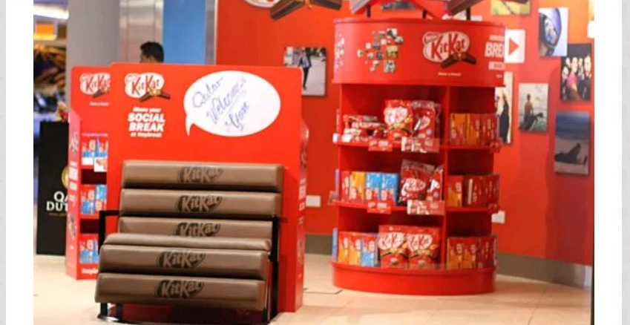
Kit Kat was developed 80 years ago in England as “Rowntree’s Chocolate Crisp”, and since then it has become a staple in convenience stores and groceries. The catchy jingles and marketing slogans has changed over years from “Have a break, Have a Kit Kat first used in 1958 “, “Give me a break 1988”, to “Have a break” and now “Snapping fingers”. Kit Kat has used shopper marketing over the last few year to permeate the market mainstream. In the previous years, Kit Kat was using the adversarial and short term past sales and marketing promotional tactics. Now, it is using a more strategic marketing discipline that has a major role to engage in an integrated marketing approach. Recently Kit Kat, which is produced by Nestlé, introduced unique in-store display in retailers stores. This promotional and tactical initiative set up has proved great in not only catching the eye of a potential customer and boost sales, but also creating brand attention. This Kit Kat promotional in-store display campaign is great because of the front bench, the big banner at the back and the unique shape that the shelves have. The spectacular round design of the shelf is fabulous as it permits the customer to take the product from either side without causing obstruction. There are also shelves with a back, which allow the customer to view a certain amount of products boosting sales. Customers can relax on the bench as they enjoy the sweet taste of the chocolate.
The bench is fantastic for eye catching promotional product for unique in-store display. “Social Break”, is a phrase that perfectly fits this product, going very well with breaking the Kit Kat chocolate biscuit bar, creating this exciting fun-effect too. Promotion effected in such a unique in-store display, will create brand awareness and attention. Customers cannot hold discussing this advertisement as they buy this product in the stores. They will take snaps sitting on the bench and having this spectacular display as their background. This unique in-store display is a sure way of getting additional customers. This campaign will not just attract current customers, potential customers will also be lured to relax on the bench and enjoy the Kit Kat chocolate bar.
Kit Kat shopper marketing style is a brilliant strategy for driving sales and a different approach all the same to the old tactics. Nestlé is utilizing insight into shopper motivations and behaviors as a major fundamental of shopper marketing as opposed to the traditional brand push tactics. In this era of digital marketing, where shoppers are highly informed about the item they put in the basket, such understanding is vital. Chocolate bars are non-essentials. Nestlé confectionary has made Kit Kat to be an essential on the shelves. They have reframed the value by upping the value and downing the price. Promoting taste, value and nutritional benefits and lowering price ‘a major driver of choice’, will reduce the inevitable trade-offs decision of shoppers. Nestlé recently reformulated Kit Kat, which now contained more milk and cocoa in their effort to reduce sugar. Nestlé confirmed that it was going to cut three billion of calories and more than 1000 tonnes of sugar from United Kingdom diet. Good news to the consumers was that the size of the bar and the recommended retail price was not going to change. It also come with a new wrapper printed “Extra milk and cocoa.” This new Kit Kat on the shelves has additional nutritional value, at the same recommended retail price. The ever-increasing trend towards healthy eating habits is a realistic shift in consumer habits (behavior) and shoppers can even spend more on items they feel is suitable for their health.
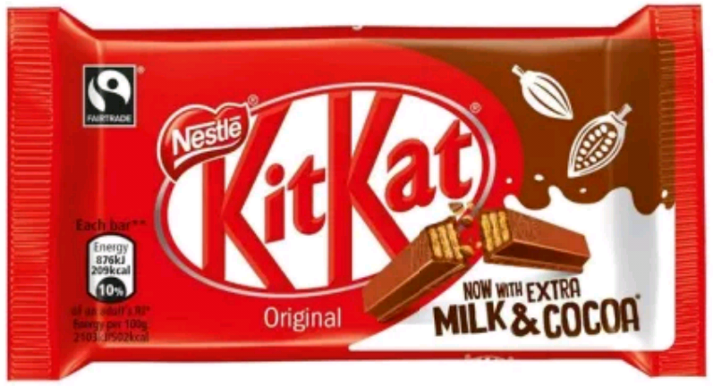
Nestlé confectionary has a good retailer collaboration. It has collaborated with several key retailers on campaigns. Kit Kat marketers are working well with retail partners to meet their shoppers. They have brought their knowledge of usage and consumption to the retailer’s understanding buying behavior of consumers. A shoppers journey include: the road a shopper take from the time they conceptualize they need to purchase a commodity, influences on their buying decision along the road, final purchase and their post-purchase behavior (Ziliani and Ieva, 2015 p. 489). The decision to buy one commodity over the other does not entirely take place on the shelves. Shoppers do plan and look for deals. Kit Kat has created paths of purchase by doing retailers loyalty programs and raising awareness using on-line channel promotions, which influences planning decisions. Nestlé launched a personalized Kit Kat promotion that ran from 1 February to 29 March 2017across Kit Kat 4 finger and chunky singles, multipacks and two finger biscuit packs. Consumers were required to enter on-line through the on-package code, with personalized messages and photos from the winning entries printed on unique Kit Kat wrappers. Winners were posted out with gift boxes. Nestlé confectionary’s business head, Kit Kat and biscuit, Haseeb Rahman, said “retailers looking to maximize sales should be sure to stock as soon as possible to ensure consumers cannot miss promotional packs when the media campaign launches and awareness is at its highest”. Adding photos to packs is an interesting phenomenon towards creating path of purchase.
Kit Kat has really worked on its packaging. They have used few colors on their wrappers; and make it as simple as possible. Shoppers use seconds at stores before deciding which product to buy. If the packaging is complicated with colors, a shopper instant reaction will to move to the next commodity on the shelves. With so many things on the shelves and having a lot to buy, no one wants to be confused. Nestlé has also unveiled a gold-wrapped Kit Kat which is intended to lure Easter holiday shoppers. It has worked with package design companies like global creative agency Anthem to create in class pack design for Kit Kat brand. This new redesigned Kit Kat packaging, is to capitalize on its unique equity with shoppers. The redesign purpose is to stimulate the UK consumer’s right at the shelves. Kit Kat has been very innovative in redesigning its packaging.
Nestlé Kit Kat UK team, has formulated a network of distributive means that ensures every Kit Kat consumer get it at whenever time or whatever time. The sales of confectionaries will entirely depend on its availability in groceries stores. Kit Kat is available in almost all leading stores in the UK. This convenience of availability is vital as it goes with consumer behavior change. Consumers will like to take the shortest time possible to get a commodity.
The development of an integrated shopper-marketing tactic and strategy takes a surmountable effort and time if an organization has to be effective (Deloitte, 2008, p.27). It needs to be engaged from the top to the bottom. It cannot be effective without insight into the shopper cycle of behavior, retailer buy –in and integration between consumer marketing and trade marketing team.

Bibliography
Deloitte/Grocery Manufacturers Association, 2007. Shopper Marketing: Capturing a Shopper’s Mind, Heart and Wallet. accessed April, 24, p.2009.
Deloitte, G.M.A., 2008. Delivering the promise of shopper marketing: Mastering Execution for Competitive advantage.
Lecture 3a, 2017. Promotional Marketing & Event Management. University of Westmnster
Ziliani, C. and Ieva, M., 2015. Retail shopper marketing: the future of promotional flyers. International Journal of Retail & Distribution Management, 43(6), pp.488-502.

Other bibliography
Institute of Promotional Marketing, 2016. 1 Shopper Marketing: Shopper Marketing 2016(1) reading.
Les B, Malcolm E, Tim B & Sven O, 2004. Evaluation: A best practice guide to evaluating the effects of your campaigns
Lecture 1, 2017. Promotional Marketing & Event Management. University of Westmnster

