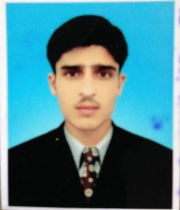
Personal Information
Name: Sohail Ahmad
Father’s Name: Muhammad Hussain
- Permanent Address: Ziarat Talash Distt dir (lower) Tehsil Timargara.
- Present Address: Kuwait Hostel International Islamic University Islamabad.
- Contact No: 0344-0904206 / 0343-1993853
- Email: sohailahmad9595@gmail.com
Goals.

- Education is the key to success in life, and teachers make a lasting impact in the lives of their students.
- Education is not just about going to school and getting a degree. It's about widening your knowledge and absorbing the truth about life.
Professional Skills:
- Extensive knowledge of physics.
- Comprehensive knowledge of Windows installation.
- Skilled in developing and evaluating Ideas planning.
- In-depth knowledge of the concepts of Physics, mathematics.
- Familiar with laser safety Standards and fundamentals of occupational Health and Safety Administration
- Skilled in evaluation and analysis of radiation health effects, Federal Emergency Management, and risk analysis.
- Work on Nano Materials.
Education Details:
Class | Passing Year | Total marks | Obtained Marks | Board /University
Metric | 2011 | 1050 | 745 | Bise Malakand Chakdara.
FSC | 2013 | 1100 | 645 | Bise Malakand Chakdara.
BS | 2019 | 4 Gpa | 2.7 Gpa | International Islamic university Islamabad.

Languages:
Language | Reading | Speak | Writing
Pashto | Good | Excellent | Good
Urdu | Excellent | Excellent | Good
English | Good | Good | Good

Hobbies.
- Cricket.
- Volleyball.
- Poster Competitions.
- Novel reading.
- Computer programing.

