Cindy Lawas

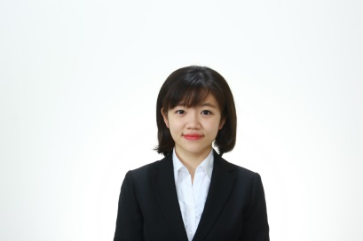Age 25 years

Current location Medan City, North Sumatra Indonesia

Nationality Indonesia

Phone (+62)81269981613

Email address cindyhiro9@gmail.com

EDUCATION

2009 – 2012 SINGAPORE PIAGET ACADEMY

International high school based on Singaporean education.

Majored in physics and chemistry.

2013 – 2014 OSAKA BUNKA KOKUSAI GAKKOU

Japanese Language degree

Learned Japanese language and passed N2 in July 2013.

2014 – 2018 **AICHI GAKUIN UNIVERSITY**

Bachelor degree of The Department of International Culture

* Cultivating a broad and deep cross-cultural understanding in both Japanese and English.
* Narrowed down the focus on American and British studies
* Studied and practiced about human culture through cultural exchanges, diplomacy and policy development.

Graduation Thesis: Analyzing the Change of Indonesia’s Political New Order Regime to Current Political System.

AWARDS

* 2016 Aichi Gakuin University Japanese Speech Contest First Place
* 2015 世界平和女性連合(WFWP) の日本語スピーチコンテスト

Women’s Federation for World Peace Japanese Speech Contest First Place

* 2017 Uniqlo’s The Best Smile Award Staff

EXPERIENCE

1. – 2018 **Private English School , Nagoya (Part-Time job)**
   * Teaching English grammar and vocabulary to Japanese students.
   * Managing schedule for students.
   * Developing mini tests in the class.
   * Engaging English and NPO Assic events with students such as Ugandan cooking events.

2014 – 2017 Uniqlo – Fast Retailing , Nagoya (Part-Time job)

* + Arranging layouts for display and clothes.
  + Operating the cash register.
  + Sales Assistant – providing good customer service such as finding products that meet their demands and in-depth information. As well as developing individuals passionate in fashion.

2017 – 2019 Doutor Coffee Shop, Tokyo (Full time employee)

* Managing schedules for part-timers.
* Checking and placing an order for food storages and coffee beans.
* Receiving and making calls from customers and other shops.
* Providing sandwiches and drinks.
* Food and kitchen tools hygiene check.
* Doing inventory count once a month and submitting it to the headquarters.
* Training new staffs.
* Operating and closing the cash register.

LANGUAGES

Indonesia – native language

English – speak fluently and read/write with high proficiency

Japanese – speak fluently and passed N1 test in year 2017

Chinese – speak and read in basic levels