**Meta Title:** The Usage, differences and Effects of using Percocet and Oxycodone

**Meta Description:** To create a better understanding of Percocet and Oxycodone by examining their composition, usage and effects, and to understand the option to choose.

The Harmful Effects of Percocet vs. Oxycodone And The Best Option

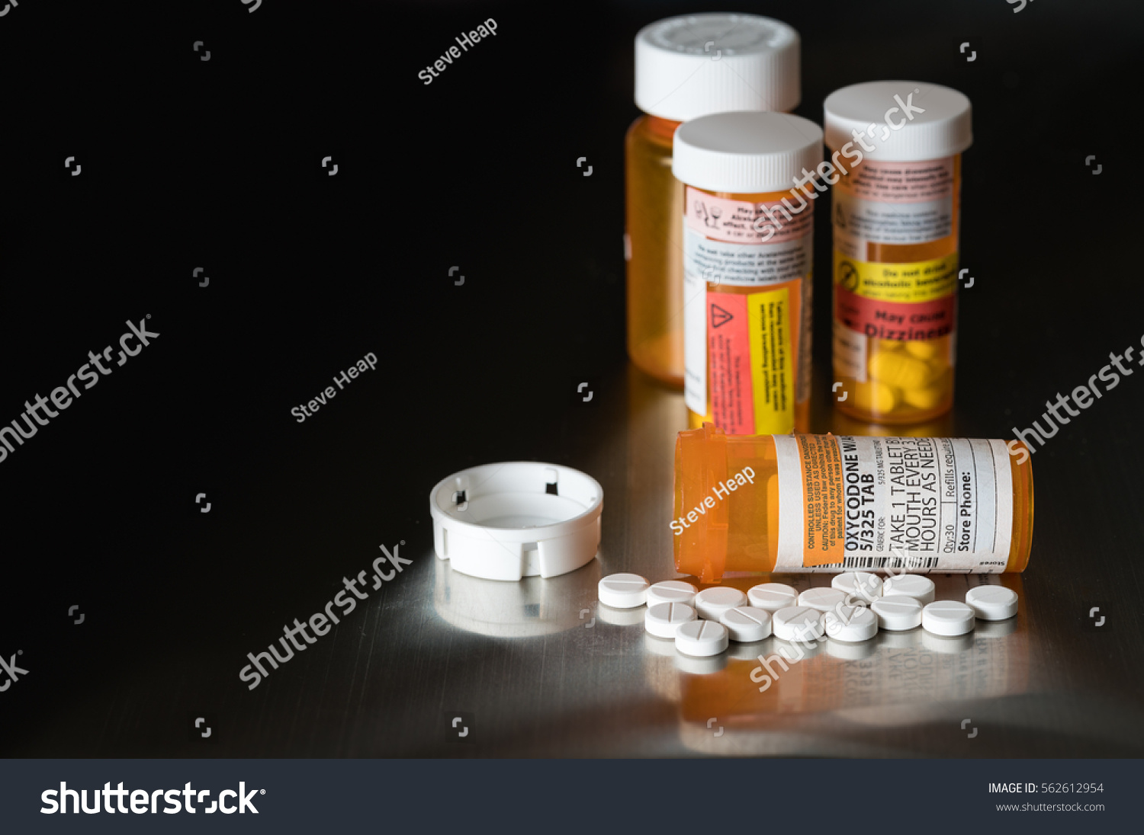

Oxycodone and Percocet are powerful narcotic painkillers which interfere with the functioning of the central nervous systems pain signals. They prevent the nerves in the body from sending pain signals to the brain. Oxycodone is used in the treatment of moderate to severe pain and dosage is usually on an around-the-clock basis until a medical personnel ends the prescription. Following that oxycodone creates in the patient a euphoric feeling, it now ranks as one of the most abused opioid around the world. There are a lot of questions surrounding the consumption of both drugs amongst which are “is Oxycodone Percocet?” and in this study; attempts are made to provide answers to these questions surrounding the consumption of the drugs.

[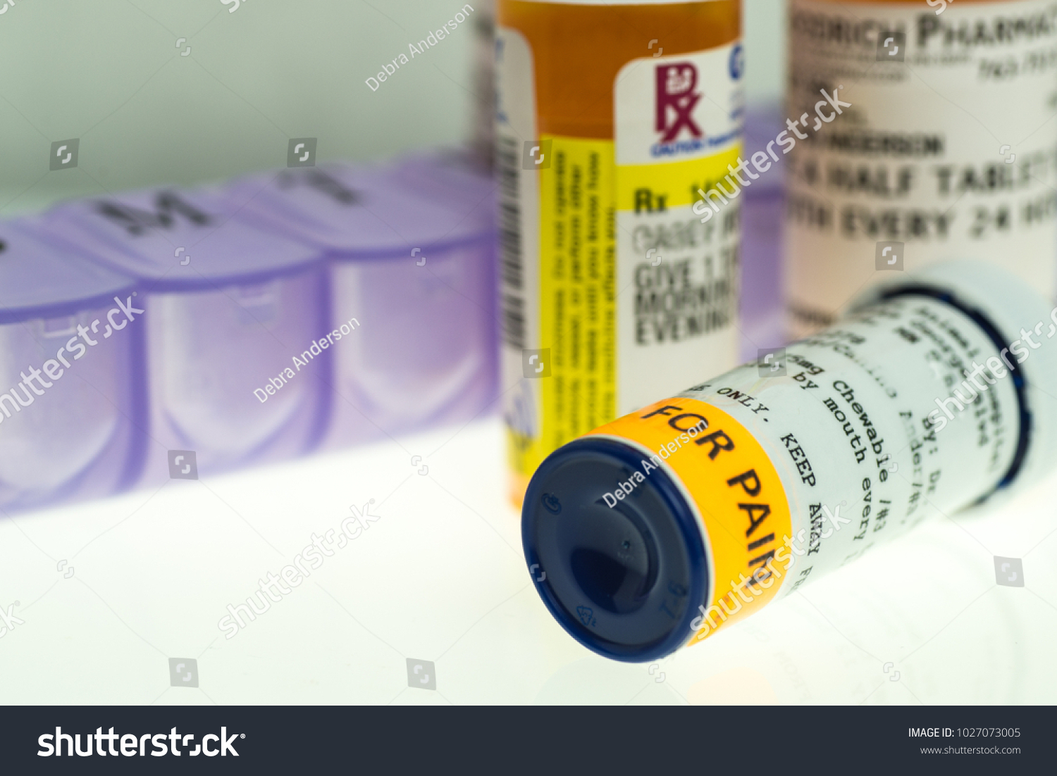](https://www.shutterstock.com/image-photo/horizontal-image-pain-medication-prescription-bottles-1027073005?src=OdWcIaDj1YFVQ4Qh3A7f8A-1-49)

**OXYCODONE**

Oxycodone is a prescription pain killer. It is used in the treatment of short-term pain or injury that was caused during or by a surgery. It can additionally be prescribed to treat other conditions including chronic cough, pain from Cancer and arthritis. Oxycodone in the fall of 2014 was moved to a schedule II drug. A drug schedule is a number assigned to a medication or chemical substance. The schedule number indicates the likelihood the substance could be misused and at the same time is accepted for medical use.

Oxycodone has been medically in use since 1916 for pain management and it is available as a regular tablet and as a controlled release tablet which is believed to help reduce the potential for abuse. It is approved in the United States for oral use only in tablet and oral solution form but in other countries, it is approved for intravenous administration.

Oxycodone when administered takes between 3 to 5 hours before the effects fades off. However, it can take up to 20 hours for the drug to be entirely out of the body system. Age is an important factor to consider in determining the duration of Oxytocin in the body. Younger people are able to expel drugs faster than older people and this is largely because of optimal kidney and liver functions in younger people as well as the potential for other health problems that can also slow down body metabolism. Body weight does play a role in the duration of Oxycodone in the body. The ph. of an individual does also affect the duration of Oxycodone in the body. The more alkaline the urine, the slower it will take for Oxycodone to be eliminated. Also, for periodic users of Oxycodone, it takes longer period of time for the drug to be eliminated from the body system.

**Abuse and Effect**

Often prescribed as a pain killer and a result of the euphoric high, there are tendencies that people who Oxycodone are administered to develop a dependence and addiction. Oxycodone addiction however can be managed with proper support and medical resource. Oxycodone addiction like many other opioids has many effects which often times results in death. Some other effects include

* Headache and nausea
* Heart failure
* Seizures and loss of consciousness
* Cold clammy feeling to the skin
* Weak muscles.

**Managing Oxycodone Addiction**

Before now, there were no viable treatment options for Oxycodone addiction but all of that has changed totally as they are a multitude of effective options and methods being researched every day.

Addiction changes brain chemistry and so in attempting to manage that, treatment has to address those issues. The following are some ways to effectively manage addiction:

* Counseling – family, friends or individual
* Cognitive Behavioral Therapy
* Medically Supervised detoxification
* Skill building
* Motivational interviewing.

**PERCOCET**

Percocet tablets are a schedule I I controlled substance with an abuse liability similar to morphine and other opioids used un analgesia and can be abused and subjected to criminal diversion. However, physical dependence does not signify addiction. Clinically, physical dependence is only seen after weeks of relatively high dosage andin this case, abrupt discontinuation may result in visisbl withdrawal symptoms which are majorly determined by dosage of oiod and the duration of therapy and medical status of the patient.

**Effects**

Opioids like Percocet are known to cause serious health complications. The possibility of falling into a coma.Addiction to Percocet affects work performance and relationship with others. There is the possibility of experimenting with other drugs and certain combinations of medicines could be fatal. The drug could slow down breathing and ultimately death. Addicts are usually tempted to experiment with other drugs and certain combinations of medicines could be lethal. There have also been situations where addicts have been known to engage in criminal activities especially in situations where they have to steal, forgo a prescription or even lie to get more pills.

**Medication guide and the question of "who can take Percocet"**

Oxycodone could be abused in a manner similar to other opioids, legal or illicit and this should come into consideration in the administration and dispensing of Percocet. Drugs of this nature are highly sought by abusers and due subject to criminal diversion.

Tolerance is the need for an increased dose of opioids to maintain a defined or desired effect especially in the absence of disease progression. Percocet tablets may disrupt clinical diagnosis in patients and oxycodone may aggravate convulsions in some patients.

Nursing mothers are also advised to desist from nursing infants while on Percocet medications due to the possibility of sedation or respiratory depression in the infant. Oxycodone has been proven to be excreted on low concentrations via brest milk.

**Dealing with Addiction**

Breaking from addictions and withdrawal stages can be really hard but staying drug free for as long as life goes on could prove to be even harder. Support can come from a lot of places such as friends and family; plus a whole lot of organizations out there can be there to help. There are churches that now offer recovery-based programs. The important thing is finding something that helps stay clean and focused.

**Differences between Percocet and Oxycodone.**

What is the difference between Percocet and Oxycodone? There has been a lot of questions surrounding the usage of Oxycodone vs Percocet and it has bothered mostly on the nature of the drugs, if they are the same and if they can substituted for each other. There has also been the question, is Percocet and oxycodone the same? It is important to note here that there is essentially very little difference and here's why.

Is oxycodone Percocet? Is hydrocodone Percocet? And are oxycodone and Percocet the same thing? These three questions are the same in different formats and they wish to provide solution to the quest to know which is better

- Oxycodone is an opioid that is a major ingredient in the production of numerous pain controlling medications which include Oxycontin and Percocet.

- Percocet contains two pain relieving drugs. It contains the non-steriod anti-inflammatory drug acetaminophen and the opiate Oxycodone.

- Percocet will contain 325 mg of acetaminophen along with other doses of oxycodone.

- Acetaminophen is used in the production of different medications that contain opioids. The acetaminophen enhances the pain relieving effects of the oxycodone in Percocet which is used to control fever and swelling. It is believed that when a prescription of Percocet is given, a more efficient response is expected as opposed to just a prescription of oxycodone by itself. It is also believed to have other potential benefits which varies according to the needs and circumstances of the individual receiving the prescription.

**Comparisons**

In answering the questions of what is the difference between roxycodone and Percocet, it's is important to state that both drugs are the same and using both drugs will result in similar effects unless the patient has an allergic reaction to the acetaminophen found in the Percocet.

**Oxycodone (Oxycontin)**

Oxycodone treats moderate to severe pain but can be habit forming, especially if used long term.

Oxycodone is available in a tape resistant form to lessen risk of abuse.

Liquid form is available if patient has trouble swallowing.

The extended release pill provides around-the-clock pain relief with convenient once or twice dosing.

Oxycodone sells for $51.80 at its lowest price.

**Percocet**

Percocet is the strongest prescription combination pain medicine for as needed pain relief.

Provides quick relief for moderate to severe pain to improve quality of life.

Percocet is generally considered stronger than Norco or other combination pain medicine.

Good for as-needed short term use but may be helpful to manage more long-term pain problems if used at the appropriate dose and intervals.

Lower rates of misuse compared to pure opioids.

Percocet at its lowest price sells for around $132.34.

**Being Cautious and Seeking Help**

The quest to provide answer to the question, is oxycodone stronger than Percocet? is yet to be filly answered. However, it has been shown that Percocet is better for pain relief. However, it is important to always be cautious in taking both drugs and if there is anyone with signs of addiction to drugs or who is to make that decision today to go clean? Please call 352 771 2700, 855 899 6836 to speak to a treatment specialist