|  |  |
| --- | --- |
|  | MR. Denise Holloway, CEO of 4MyCurls  Client Website: <http://www.4mycurls.com.au>  Client budget: (Assigned 20 Hours Per Week) |

About Client Website:   
  
4MyCurls, a web-site offering the best curly hair products for those of us fortunate enough to have naturally curly hair!! We aim to cater to every type, be it wavy, curly or coily. Carrying brands that are hard to find here in Australia, you are sure to find something to keep those luscious locks looking and feeling fabulous!!

As an ex-pat living in Australia, I noticed a lack of hair care products for the curly-haired market. It would drive me crazy going from one hair supply store to the next, ending up empty handed or just making ‘do’ with what was available. I kept asking myself…am I the only one going through this frustration?! Surely not! Well suffer no more my fellow curly tops 4MyCurls is here to save the day…as well as those gorgeous curls!!  
  
  
Challenge:  
  
Challenge: 4MyCurls is organic traffic was very low. Being a E-commerce company, Organic traffic can help user to land up on right web page and place the order. No brand awareness.   
  
Solutions:  
  
To Increase the organic traffic we need to work on the keywords part. We need to increase the brand awareness through Social Media channels such as Facebook, LinkedIn, twitter, Pinterest and etc.

Project Execution:   
  
Project Started on 15- Dec 2014  
  
Below are the stats:

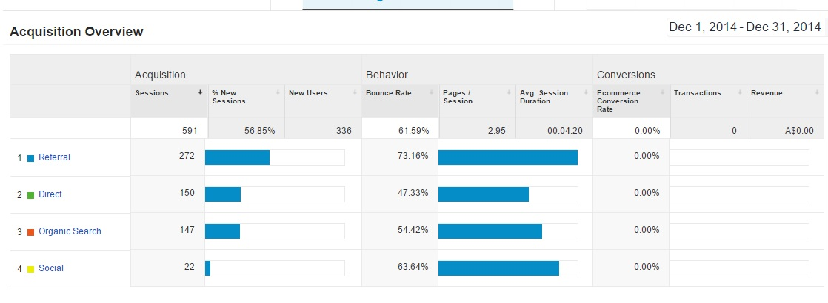

# Initial keywords Rankings :

|  |  |  |  |
| --- | --- | --- | --- |
| **Google Ranking – 4mycurls.com.au** | | | |
| **S.no.** | **Keywords** | **1 Dec 15** | **Landing Page** |
| 1 | Mop Top Products | 15 | www.4mycurls.com.au/brands-c19/moptop-c8 |
| 2 | Mop Top Hair Products | 29 | www.4mycurls.com.au/mop-top-daily-conditioner-p12 |
| 3 | Jessicurl Australia | 21 | www.4mycurls.com.au/brands-c19/jessicurl-c10 |
| 4 | Mop Top Hair Care Products | - | http://www.4mycurls.com.au/shampoos-c1/ |
| 5 | Curly Coily Hair Products | - | www.4mycurls.com.au/hair-types-c13/coily--kinky-c15/ |
| 6 | Jessicurl Products | 27 | http://www.4mycurls.com.au/jessicurl-c10/ |
| 7 | Mixed Chicks Conditioner | 186 | www.4mycurls.com.au/mixed-chicks-deep-conditioner-p25 |
| 8 | Mixed Chicks Shampoo and Conditioner | 155 | www.4mycurls.com.au/brands-c19/mixed-chicks-c9 |
| 9 | Mixed Chicks Products | 190 | www.4mycurls.com.au/brands-c19/mixed-chicks-c9 |
| 10 | Fuzzy Duck Hair | 41 | www.4mycurls.com.au/fuzzy-duck-anti-frizz-gel-p18 |
| 11 | Curly Hair Care Products | - | http://www.4mycurls.com.au/curly-hair-solutions-curl-keeper%E2%84%A2--p37/ |
| 12 | Coily Hair Products | - | www.4mycurls.com.au/hair-types-c13/coily--kinky-c15 |
| 13 | Jessicurl Gentle Lather Shampoo | 17 | www.4mycurls.com.au/jessicurl-gentle-lather-shampoo-p73 |
| 14 | Best Hair Products Australia | - | www.4mycurls.com.au |

Post 8 Months of SEO campaign:  
  
Traffic per Month:

|  |  |  |  |  |  |  |
| --- | --- | --- | --- | --- | --- | --- |
|  | Dec-14 | Jan-15 | Mar-15 | May-15 | Jul-15 | Oct-15 |
| Traffic | 591 | 694 | 1670 | 1877 | 1862 | 3077 |
| Organic | 147 | 234 | 403 | 744 | 1146 | 1230 |

# Below are the stats:

Rankings shot up:

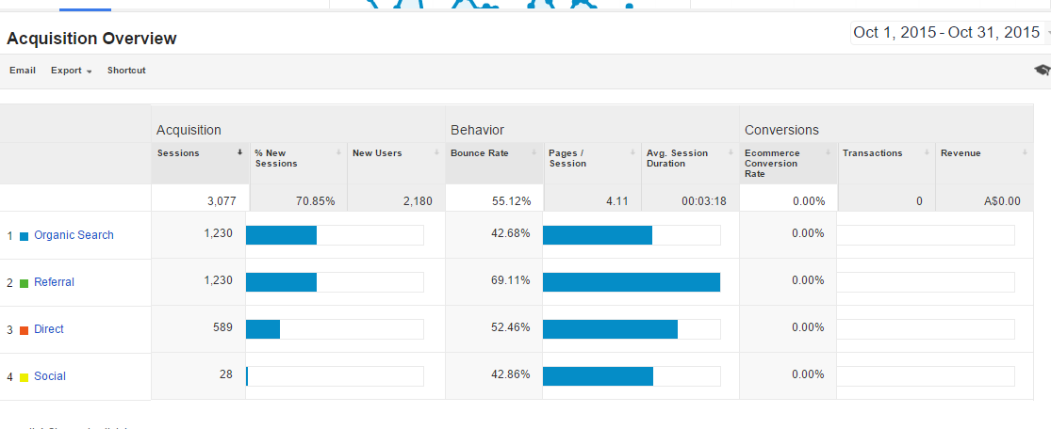

|  |  |  |  |
| --- | --- | --- | --- |
| **Google Ranking – 4mycurls.com.au** | | | |
| **S.no.** | **Keywords** | **1 Dec 14** | **24 Oct 15** |
| 1 | Mop Top Products | 15 | 2 |
| 2 | Mop Top Hair Products | 29 | 2 |
| 3 | Jessicurl Australia | 21 | 2 |
| 4 | Mop Top Hair Care Products | - | 3 |
| 5 | Curly Coily Hair Products | - | 5 |
| 6 | Jessicurl Products | 27 | 5 |
| 7 | Mixed Chicks Conditioner | 186 | 9 |
| 8 | Mixed Chicks Shampoo and Conditioner | 155 | 9 |
| 9 | Mixed Chicks Products | 190 | 8 |
| 10 | Fuzzy Duck Hair | 41 | 7 |
| 11 | Curly Hair Care Products | - | 7 |
| 12 | Coily Hair Products | - | 8 |
| 13 | Jessicurl Gentle Lather Shampoo | 17 | 8 |
| 14 | Best Hair Products Australia | - | 8 |

Results:  
  
Organic Traffic Increase 835% in 8 Months  
14 Keywords in first page of Google  
Getting 15 Sales per Month