Housing Market Trend In 2016: What Does The Future Hold For Grand Rapids, MI?
Owning a house is the dream of every average mature American citizen. The peak of housing bubble was last seen over ten years ago and the boom that surrounds it has temporarily reduced the obsession for owning a house. But, now that the dream is being rekindled, there is a growing concern that achieving that dream of owning a house will be difficult in the years ahead as a result of some factors. Take a look at the trend.
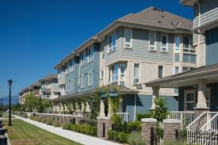
Trends
Let’s take a look at some of the striking trends:
- There is the rising consciousness among the citizens about the American dream of owning a house.
- In the face of increasing interest rate, 22% of Americans are of the opinion that it will be difficult to access a mortgage facility in year 2016 than it was in 2015.
- Many millennials (about 31%) plan to buy a home in a period of two years from now, saving for down payments and strong jobs are the key determinants to turn from a home renter to a homeowner.
Predictions
Based on these trends, the following predictions will likely play out in 2016:
- Housing markets in the west and northeast commonly referred to as the Costly Coasts will continue to drop, while the southern and Midwestern markets commonly referred to as Bargain Belt will continue to boom.
- Multi-family construction will continue to boom while in the expensive metros, renters are likely to get some relief.
- Nationally, buying will be more favorable than renting despite the rising rates of mortgage loan; while renting will be more favorable than buying in various California markets.
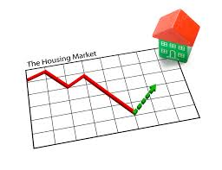
As a result of these predictions, ten major markets to watch out for in 2016 have been identified based on the combination of several factors such as job growth, online search activity as well as affordability. Majority of these markets so identified reside in the Bargain Belt of which the top three are Grand Rapids Housing Market, Mi., Charleston real estate market S.C., and Austin housing market, TX.
Factors Limiting The Selling And Buying Of A House
Increasing interest rate – The Federal Reserve has expressed plans to increase interest rates by early 2016. In this regard, customers are becoming more anxious about the possibility of increased mortgage rates. Many people believe that getting a 25% mortgage to buy or 22% to refinance a home will be difficult in year 2016.
Obstacles To Owning A Home In America
Enumerated below are the major challenges facing Americans from owning a home:
- Increasing mortgage rates
- Rise in house prices
- Having a poor credit history
- Inability to pay off existing debt
- Limited inventory
- Having an unstable job
- Qualifying for a mortgage
- Saving for a down payment, which still remains the greatest challenge for renters.
What about the millennials? Will they start to buy houses in 2016? I think that it is more money that will make more millennials take a quantum leap from being renters to homeowners.
Factors That Will Encourage Home Buying Than Renting
In as much as there are many factors facing prospective homeowners as enumerated above, there are also factors that will encourage renters to become homeowners and they are:
- Lower interest rates
- Improving credit history
- Promotion in job as well as increased pay
- Fall in prices of house
- Ability to save for a down payment
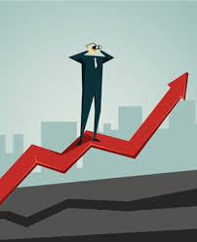
Expectations For 2016
1. Expectations are that housing markets along the Costly Coast (the costly metros in the west and northeast) will continue to slow down and it will be characterized by:
- Decrease in affordability
- Houses will be staying on the market slightly longer
- Saving for a down payment will take such a long time.
2. Another expectation is that getting a mortgage to either buy or refinance a house will worsen especially in the combined regions of the northeast and the west. Also, house renting will greatly be affected in these regions.
3. Further expectation to watch out for is the Bargain Belts Boom in the Midwest and the south region of the country. There will be increase in house affordability in these housing markets and increase as well in how quickly houses move off the market.
4. Buying will remain cheaper than renting despite the expected rise in interest rates.
Potential Markets To Look Out For In 2016
Some of the hottest housing markets will experience a downward economic trend this year whereas ten markets have emerged as having strong potential for growth in this year 2016. These markets were favored by the following five metrics:
- High affordability
- Low vacancy rates
- More inbound home searches
- Strong job growth in previous years
- Large population of millennials
These markets include the following:
- Grand Rapids, MI
- Charleston, SC
- Austin, TX
- Baton Rouge, LA
- San Antonio, TX
- Colorado Springs, CO
- Columbia, SC
- Riverside – San Bernardino, CA
- La Vegas, NV
- Tacoma, WA
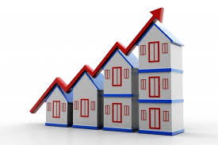
Among these markets, Grand Rapids MI tops the list and the reasons are not far-fetched:
- It is one of the most affordable cities in America with a reputation as a city where people and their businesses can earn more for their money
- It has a strong and robust job growth
- There are plenty options for low cost commercial real estate and residential housing is affordable too.
So, from the foregoing, the city of Grand Rapids has gathered enough strength to be considered the number one hottest real estate housing markets in America. This city has become a hotspot for real estate investors as a result of the combination of two factors, namely: economic pointers and strong fundamentals.
Therefore, Grand Rapids Real Estate investment will make so much progress this year and investors can expect increased positive trends in this direction.

