# CHAPTER ONE

# INTRODUCTION

## Background study of Barclays Bank

Barclays is a London-based British multinational bank and a financial services business. It is commonly a bank that specializes in retail, wholesale and investment banking and money managing, mortgage and credit card businesses. It operates in more than 50 of countries and has approximately 48 million customers. Barclays is divided into four core businesses: individuals and businesses (personal banking, corporate banking, and wealth and investment management), Barclays, investment banks and Africa. This case study is focused on Barclays UK(Alamy, 2018).

As one of the world's leading banks, Barclays employs 135,000 people in more than 50 of countries and has been instrumental in bringing banking to emerging market clients in partnership with governments in major infrastructure projects. Barclays is comprised of two major businesses: Global Retail and Commercial Banks and Investment Banking and Investment Management. One strategy is to grow through a different type of profit base (Jes Staley, 2017).

Barclays acknowledged its place as a global company that made it their responsibility to be a responsible global citizen. With this in mind, their goal is to achieve carbon neutrality by 2009 and to set high standards to reduce waste and increase recovery. They also value the importance of human rights and uphold them in projects they fund, communities and employees (Padmalatha, 2011). Barclays also tried to raise its profile by connecting with England Premier League and Scottish Open Golf of Championships (John Varley, 2007).

## 1.2 Research Problems

The trouble Barclays may have in future is that the constant economic conditions in Britain and Europe the conditions may lead to increased uncertainty among retail consumers and the lack of credit in the market. This again puts an increasing emphasis on companies' ability to offset the deficit in the UK domestic market through progress in emerging markets, thereby increasing the company's overall profitability. All businesses, including Barclays, have to reconsider the retail aspects of their business, hoping to remain competitive in the major streets and reduce when necessary. In the current financial environment, banks are reluctant to fund each other. The UK market is heading for a severe recession. Any detail factor that may affect High competitiveness depends largely on the Bank of England and Treasury, seeking to rebuild and strengthen the stock market. As seen in other financial institutions, the sharp decline in market value and speculation may have great consequences (Linda, 2017).

### 1.2.1 Human resource management issue

Strategic human resource management is a program that helps organizations operates. Human resources management strategies and business strategies must be fully integrated. (Kearns, 2008). In Barclays bank where diverse of work and where people works collectively and they need a clear structure through which they communicate to every one other and through which there can be a management of their efforts. The defined work among the essentials of an institute, specifically people, responsibilities, structures, and information and organize processes that describe all organizations is referred to as organizational structure.

In today's modern world, with the help of human resource management within the organization operates in different ways, and then they focus on three main areas of management, staffing, compensation and definition or design work. Each HR department in any organization has the goal of maximizing productivity and profitability and optimizing employee productivity.

According to Edward L. Gubman in the Business Strategy magazine, the fundamental mission of human resources will always be to acquire, develop and retain talent; to align work forces with business; and to be an outstanding contributor to business. These three challenges will never change. The backbone of any successful company is the human resources department. Human resources departments must provide executive management with a basic philosophy that not only helps to gain market share but also attracts and retains talent. Once an organization's human resources strategy is in place, its management responsibilities will see the company's goals accepted and they can do this in a number of ways, including: communication, engagement, feedback, positive reinforcement, values, and more. In recent years, observers have come up with the decisive trend of reassessing human resources structures and positions (Kearns, 2008).

Research Questions

* What are the strategies to deal with the workforce management problems as compare to other banks in UK?

### 1.2.3 Management Problem

In the case of Diamond, shareholders are angry about the package that Bob Diamond presented to them Barclays, last year. In public protests over the overpayments of top employers, shareholders have had to focus on this issue Bonus to Bob Diamond Chief Executive Barclays. The total number of diamonds the package value ranges from 630,000 pounds to 27 million pounds and it is depending on how it is calculated. Some shareholders dying out to vote against the bank's pay report in the bank (Financial Times, 2017).

However, the top concern to shareholders is that Mr Diamond's bonuses are the same as the bank's not in line with his own public goals. Mr Diamond receives a prize of £ 2.7 million His salary was 1.35 million pounds, and profits fell 3% to 5.88 billion pounds. To solve the problem, the bank said last week that Mr Diamond would not get full bonus until Barclays returns on assets exceed the cost of capital. The bank also promised to increase shareholder returns. But this does not happen Sufficient to persuade all investors to vote for pay transactions. They also worry about the controversial "tax balance" paying £ 5.75 million Proposed by Mr Diamond on behalf of the bank(Financial Times, 2017).

Barclay's CEO Bob Diamond, his COO and the chairman resigned, judging by the repetition of bank management errors, it seems that the bank has not learnt its lessons or not learned fast enough.

Research Questions

* What governance has been put in place to assure shareholders interest?

### 1.2.4 Operational Issues

The revelations are destructive to the bank at a time when Mr Staley appeared to be making movement at the firm. Previous this year, the lender posted a near trebling of yearly pre-tax profits is to £3.23bn from £1.15bn in 2015 after it waged out less to settle legal action and to the victims of the sum protection insurance mis-selling scandal. Mr Staley also said he would be finishing Barclays’ non-core division at the end of June, six months ahead of plan and signalling his turnaround was taking hold quicker than he had in usual (Ben Martin, 2017).

Research Questions

* What role of management in arriving at closing Barclays Bank non-core division?

### 1.2.5 Technological Issues

Bulks of Barclay’s customers come into view that they are unable to access their online bank accounts following purported outage crossways the UK. When demanding to the login into the service users are currently being faced with a empty screen. Barclays Bank clients trying to access their accounts via the cellular phone app have also been left unable to access the online system. Responding to annoyed complaints about the online banking system not working, Barclays told clients on Twitter that it was “seeing information reports now”.“We’ve got the crew looking into it right now. Sorry for any hassle,” the certified Barclays UK Help account added. When asked when the difficulty would be resolved, the Barclays account tweeted: “I’m anxious we don’t have any timescales on how lengthy it will be and take time to fix this” (Aaron Brown, 2017).

Research Question

* What is the guarantee to its effectiveness after it is been fixed?

## 1.3 Research Questions

Barclays is one of the major financial services in the globe, in a modified project more influential online banking certification customer (Gemalto, 2007). The bank aims at customer fulfilment and so is over and over again innovating to provide best banking practices in the business. Increasingly use of technology to develop their habitual businesses. But the question as stated above are:

* What are the strategies to deal with the workforce management problems as compare to other banks in UK?
* What governance has been put in place to assure shareholders interest?
* What role of management in arriving at closing Barclays Bank non-core division?
* What is the guarantee to its effectiveness after it is been fixed?

## Research Aims

* + To ascertain how management strategies affect the company’s growth and impact on customers

## Research Objectives

The objective of this study is to

* In order to achieve the aim, I will oversee the management strategies and companies governance adopted by the successful banks
* Analysing the factors of governance towards the bank to overcome the expenses
* Suggest strategies for growth
* Suggest a research and development department to give best to its customers

## Structure of the Report

This case study is detailed in five chapters

.

# CHAPTER TWO

**LITERATURE REVIEW**

# 2.1 Industry Analysis

At present, Member States are required to perceive each other's reorganisation measures concerning banks and investment firms (plus application of the bail-in tool). Nonetheless, post-Brexit, while the UK could administer for Member States' determination measures to be recognised in the UK, there would be no assurance of complementary acknowledgment in EU nations of resolution measures taken by the UK. This could put at risk the adequacy of any move made by the Bank of England as the UK's resolution control so may lead the PRA to require all UK-based banks, post-Brexit, to incorporate an authoritative recognition statement like the Article 55 Requirement (see Contractual recognition of bail-in below) in EU-law represented contracts. Despite this potential complexity, given that the UK is strong of FSB initiative and pan-EU efforts by and large and is a FSB part, it appears to be likely that the position post-Brexit would not change significantly for UK banks (James Coiley, 2017)

Figure 2.0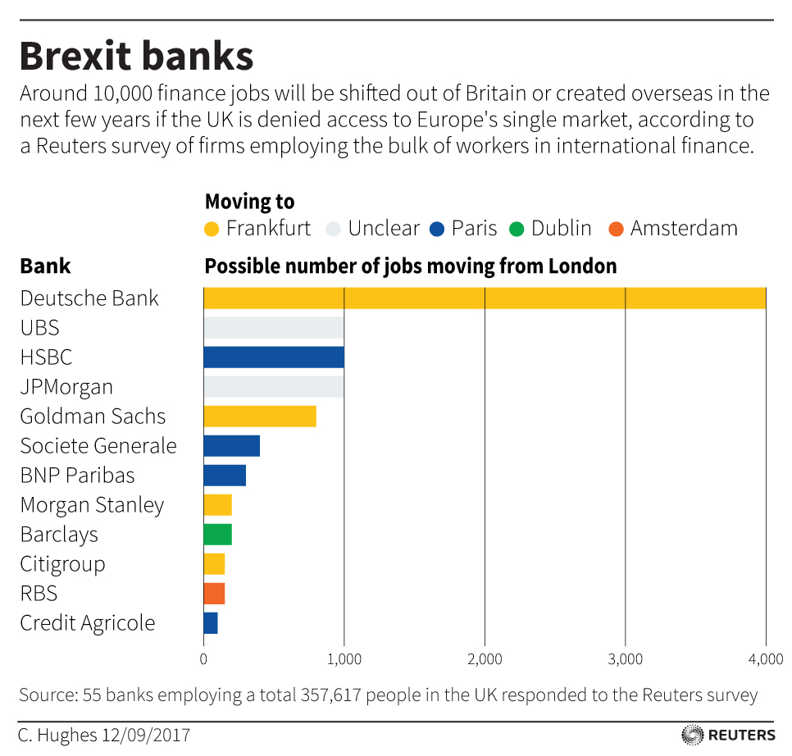

Source: Financial Time.com (Hughes, 2017)

The above includes the 20 investment banks that earned the most fees from investment banking in Europe, the Middle East and Africa in 2016, according to Thomson Reuters’ data 2017.

## 2.2 Industry size

This contextual analysis portrays the management utilized by administration to demonstrate the trends and behaviours of people and organizations in keeping money industry by Barclays bank. It is the effect of the administration techniques that a large number of clients will respond to the banks administrations. In spite of the fact that the bank sees a a small number of clients also prepared in their comprehension on web based saving money and need no assistant in getting to the service, some then again have no self-support.

Barclays Bank constantly makes a move to accomplish objective and convey an incentive to investors and financial specialists. Proactive administration of the bank's Principal Risks guarantees that the move made is tending to the outside components that effect its working condition.

Credit Risk: Financial trouble of clients should not satisfy contractual commitments to the Group.

Market Risk: Earnings or capital effect because of unpredictability of exchanging book positions or failure to fence the managing an account book asset report.

Funding Risk: Failure to keep up capital proportions and liquidity obligations prompting powerlessness to help normal business action and meet liquidity regulatory requirements.

Operational Risk: Losses or expenses coming about because of human factors, insufficient inside procedures and frameworks or outside events.

Conduct Risk: Detriment caused to the clients, customers, counterparties, or the Bank and its employees through improper judgment in execution of business movements.

Reputation Risk: Damage to Barclays mark emerging from any affiliation, activity or inaction saw by stakeholders as unseemly or deceptive. From first January 2015, Reputation Risk will be joined with Conduct Risk.

## 2.3 Industry Growth

# Figure 2.1

# 

Source: The Reporter (Chris Johnston, 2017)

The development forecast for the UK economy this year has been sharply raised by the budget controller. The Budget Responsibility Office now expects financial development of 2%, up from 1.4% earlier forecast. In any case, it is normal that the development rate in the second year will ease back to 1.6% and gradually to 20% out of 2021.

The OBR anticipates that government borrowing will achieve 51.7 billion pounds in 2016-17 - a drop of 16.4 billion pounds from the earlier month's estimate of November and a drop of 4 billion pounds from the 2016 budget plan. It is evaluated that by 2021-22, the deficiency will drop to 168 billion pounds. It is normal that government borrowing will drop from 3.8% a year ago to 2.6% this year. This figure will rise to 2.9% of every 2018-1919, however by 2021-22 this figure will drop to 0.7%, the most reduced in 20 years(Chris Johnston, 2017)

# 2.4 Competitive Analysis

The UK banking sector is dominated by several major banks, including Lloyds, Barclays, Royal Bank of Scotland (RBS) and HSBC. The market is clearly oligopoly in terms of market share for all types of businesses.

Chart 2.0

UK Bank’s market share (Current Accounts)

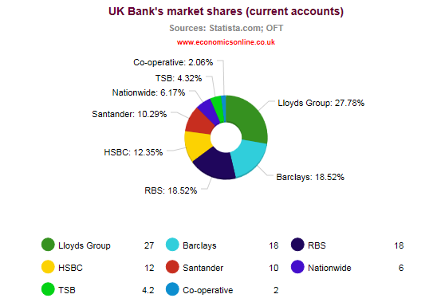

Source :( Economics Online, 2017)

In response to the financial crisis, the British banking industry has undergone an integrated process. In January 2009 HBOS merged with Lloyds TBS to create Lloyds Group, a single banking group. By 2015, the Lloyds Group's market share in personal accounts has risen to 27%.

# 2.5 PESTEL Analysis

Barclays is a British bank with operations in more than 50 countries, including the United States, Japan, India, Europe and many African countries. This is one of the UK's four largest banks, referring to the four major UK banking groups including HSBC, Lloyds and Royal Bank of Scotland. Barclays was founded by James Barclay in 1690 and currently has operations in a variety of consumer and wholesale business segments, including retail, wealth management, corporate loans, credit cards and mortgages. It currently operates its operations through two well-defined divisions - Barclays UK and Barclays International. For the year ended December 31, 2016, the operating profit for the year ended December 31, 2016 for the year ended December 31, 2016 About 220 billion pounds.

Pestle is a business strategy tool for tactics used to analyse these macro environments and determine how trends in the political, economic, social, technological, environmental and legal environments of the future impact individual organizations within the industry. Then, companies study the key drivers of change behind the Pestel factor. The main drivers of these changes are the opportunities and threats in the enterprise's external environment and industry, which can be overcome by concentrating and eliminating weaknesses. That's why Pestle is just a starting point because other frameworks like Porters Five Forces and SWOT must be used together to help companies like Barclays leverage their internal core competencies to capitalize on opportunities and eliminate threats in their industry.

**Porters Five Forces That Shapes Industry Competition**

Barclays is trying to expand its business and services and identify potential and emerging markets. By examining the competition and access conditions in these markets, the bank's sustainability can be determined. Porter's analysis is used to measure the company's ability to perform abroad.

Barclays Bank has gone through a successful climate and is still pursuing more, probably because of their continued focus on sustainability. With the help of strategies link the Porter’s five forces , Barclays will play a leading role in the standard models of other companies.

**SWOT of Barclay Bank UK**

#### Source: SWOT analysis of Barclays Bank (Hitesh Bhasin, 2018)

### Figure2.4

|  |  |
| --- | --- |
| Strength   * Diversity across the world * Strong brand reputation * Leading digital banking in UK | Weakness   * Material legacy conduct issues * Operations in Africa proving to be costly |
| Opportunity   * Barclays is ahead in terms of digital banking especially the use of block chain technology in transaction. | Threat   * Brexit uncertainty in EU financial regulations * Digital disruption is a challenge for the future of Barclays. |

#### Source: SWOT analysis of Barclays Bank (Hitesh Bhasin, 2018)

**Conclusion**

2016 was a challenging political environment for Barclays characterized by a new regulatory capital rule set by the British government and the introduction of a new bank profit surcharge of 8% in January 2016 which helps Significant decision to sell African equity in 2016 and plans to further withdraw in the future. It must also face the uncertainty surrounding Brexit and the economic impact it may have on capital, regulation and EU operations. Nevertheless, the bank remains a strong brand with 400 years of trade history, geographic diversity, leading market leadership in core markets and advanced technological capabilities. Although major remaining issues remain and undermine the issue, the divestment of African operations will raise the core rate of return and make Barclays a smaller and better capitalized and leveraged operating agency to consolidate its U.S. And the UK's core market.

## 2.5Propose Plan for Analysis

## Main Focus

Operations

Technology

HRM

Source: (Hart, 2012).

## Business Models forAnalysis

### Figure 2.6

Source: Author’s Construct

### 2.6 Models for strategic Change

|  |  |
| --- | --- |
| **Leading Change** | **Trait theory**: This theory will give detailed explanation to the types of leadership styles and suggest the best leadership skill Barclays bank can adopt for the day to day administration of the business. |
|  |  |
| **Business Creativity** | **Business Model Canvas**: this model will provide the importance of selecting the best business model for a business and give reason why is the best model to be adopted by the company to change the face of the bank. |
|  |  |
| **IOS** | **Balance score card**is a strategy performance management tool a semi-standard structured report, supported by design methods and automation tools that can be used by managers to keep track of the execution of activities by the staff within their control and to monitor the consequences arising from these actions.  **BCR Matrix**this strategy is easy to perform, helps to understand the strategic positions of business portfolio.  It’s a good starting point for further more thorough analysis.  **VIRO**Is perfect for evaluation of the company’s resources. One you know your resources you can better understand your **competitive advantages**or **weaknesses**. The VRIO considers for each type of the [resource](https://managementmania.com/en/resources-business-resources) the following questions (called evaluation dimension) both for your company and for your competitors. |

Source:

## Other Business Models that can be used for Change

|  |  |
| --- | --- |
| **Recurring Revenue model and loyalty business model** | **This model provides value for customer and a platform for transformation.** |
| **Low Cost Model** | **This is a good technique for competitive pricing.** |
| **Affiliate model** | **Is a perfect model for revenue generation** |
| **Collective business model** | **This model helps pool resources together for industry growth** |

**Source:**

**Recurring Revenue model and loyalty business model**

Many experts will argue that Recurring Revenue Models need to centre on exploiting Customer Lifetime Value, but this is a bottom-line financial formula. To enable true transformational change and be successful, organizations need to shift focus to Customer Lifetime Experience by transforming how customers are viewed and serviced internally. Switching to a Recurring Revenue Model puts a hyper-focus on the customer relationship, the key to enhancing the overall experience of a product. And though the payoffs are significant example revenue becomes more predictable, stable, and perpetual, it’s not easy to do; however, with 80% of consumers demanding a new revenue model, many businesses find themselves without many options (Owen, 2017).

### Figure 4.6

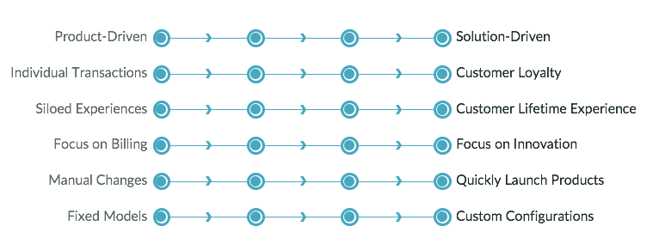

Source: (Owen Ray, 2017)

**Low Cost Model**

This is pricing strategy where companies offer relatively low prices to stimulate demand and gain market share. This is one of three general marketing strategies. This can be used by any company, often with little or no competitive advantage, or economies of scale with higher volumes (Pettit, 2017).

### Figure

**Low Cost Model**

Source:

**Affiliate model**

This is an option that generates revenue from a wide range of revenue sources, including subscriptions, paid ads, and affiliate marketing. An example of affiliate revenue model is based on commissions. In essence, you can resell items from other retailers from your website (Prussakov, 2011).

### ****Figure 4.8****

**Affiliation Model**

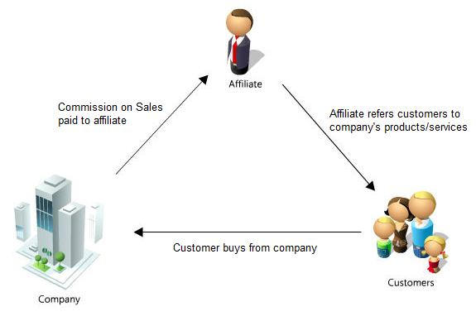

**Source: (Yvonne Cruz, 2015)**

**Collective business model**

The collective business model pools resources from similar businesses or professionals in related fields for the benefit of the group as a whole This is a well-known model patterns which include subscriptions to businesses, industry associations, cooperatives and franchises (Fleisher, 2015).

## Management Strategies

* Corporate and Investment

### Figure 2.7

* Transatlantic Consumer
* Ring- fencing of the bank

Source: Barclaysbank.co.uk (2018)

Transatlantic Consumer

Corporate and Investment

Ring- fencing of the bank

**Summary**

The use of models mentioned above help Barclays bank in the approach to banking methodwhich are often just a timely understanding the productiveness and equipment and provide banking will be suitable for day to day businesses. And is evidenced by, the booming development of people-oriented experiences. But that Barclay’s banks to attract old customers and the need for cultural and organizational transformation this new banking models to attract new customers need to be user-centric focus (Herrington, 2015).

# CHAPTER THREE

## 3.0 Methodology

## 3.1 Introduction

This paper selects qualitative research methods, which means designing a study that involves collecting qualitative data and using interpretation methods for analysis (Collis, J. et al., 2009). Due to the given complexity and limited scope and time frame of the problem being studied, qualitative methods seem to be more appropriate and feasible than quantitative methods involving the collection of quantitative data and statistical analysis (Collis, J. et al., 2009). This method usually uses smaller data sets that are sufficient to achieve reliable results and data collection continues until it reaches saturation (Anthony, 2005).

## 3.2 Research Philosophy

The term research philosophy refers to a system of beliefs and assumptions about the development of knowledge. Although this sounds rather profound, it is precisely what you are doing when embarking on research: developing knowledge in a particular field.The knowledge development embarking upon may not be as dramatic as a new theory of human motivation, but even answering a specific problem in a particular organisation, nonetheless, developing new knowledge (Saunders et al. 2015).

Research philosophy involves the source, nature and development of knowledge. In short, research philosophy is about how information should be collected, analyzed, and used (Creswell et al., 2000)

Observations as a data collection method can be structured or unstructured. In structured or systematic observation, data collection takes a specific variable and follows a predetermined schedule. On the other hand, unstructured observations are conducted in an open and free manner because there are no predetermined variables or goals (Uwe Flick, 2014).

Advantages of the observational data collection method include direct access to the research phenomenon, high degree of flexibility in the application, and the generation of a permanent record of the phenomenon for subsequent reference (Collis et al, 2009).

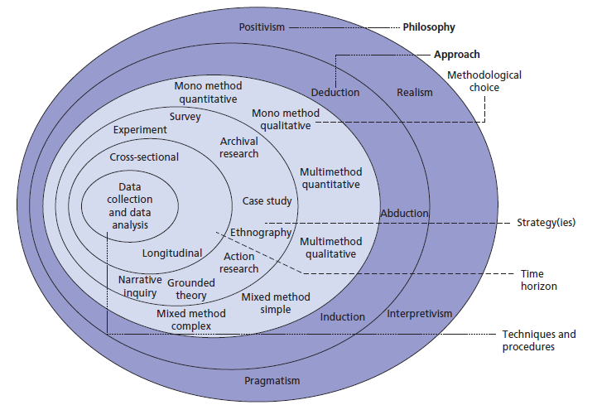

#### Source: Ultimate Guide to Writing a Dissertation in Business Studies(John Dudovskiy, 2016)

**Positivism**

Positivism is a philosophical theory that states that some ("positive") knowledge is based on natural phenomena and their characteristics and relationships. Therefore, the information derived from sensory experience, explained by reason and logic, forms the sole source of all certain knowledge (Howell, 2012).

**Realism**

Realistic research philosophy relies on the realistic independence of human thought. This philosophy is based on the assumption of scientific knowledge development. Realism can be divided into two categories: direct and critical(Mingers, 2014).

Direct realism, also known as naivrealism, can be described as "what you see is what you get." In other words, direct realism depicts the world through personal senses.On the other hand, critical realism maintains that people really experience the real world's feelings and images. In this case study realism will be used to ascertain results, sense this theory is based on assumption of scientific knowledge development (Joseph, 2012).

**Inductive**  
Inductive reasoning is research philosophies which start with observations, and as a result of observations presents the theory at the conclusion of the research process. Induction studies "include the development of the search and interpretation of observed patterns, theories through a series of hypotheses for these patterns. For instance, at the beginning of the study, if there was no theory or hypothesis that could be applied in the induction study this theory will enable a free platform to change the direction of the research once the research process began, hence this will be used in this case study (Feeney et al, 2007).

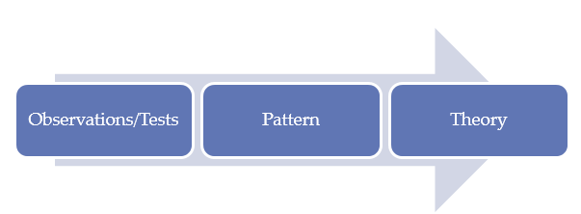

Source: Research-Methodology.net (Dudovskiy, 2017)

It is important to stress that induction does not mean disregarding theory when formulating research questions and goals. This approach aims to generate meaning from the collected data sets in order to identify the theoretical patterns and relationships that are established; however, induction does not prevent the study from applying existing theories to formulate research questions that need to be explored. Inductive reasoning is based on learning from experience. Observe patterns, similarities, and empirical patterns will be used to draw conclusions (Engel et al, 2014).

**Deductive**

A deductive approach is concerned with “developing a hypothesis (or hypotheses) based on existing theory, and then designing a research strategy to test the hypothesis”.

It has been stated that “deductive means reasoning from the particular to the general. If a causal relationship or link seems to be implied by a particular theory or case example, it might be true in many cases. A deductive design might test to see if this relationship or link did obtain on more general circumstances”(Babbie, 2010).

Deductive approach can be explained by the means of hypotheses, which can be derived from the propositions of the theory. In other words, deductive approach is concerned with deducting conclusions from premises or propositions.Deduction begins with an expected pattern “that is tested against observations(Wilson,2010).

**Qualitative**

Qualitative research is a broad methodology that includes many research methods (Brinkmann, 2017).

Source: Author’s construct

The purpose of qualitative research may vary from subject to subject, for example psychologists seek to understand human behavior in depth and manage the causes of such behaviours whereas sociologist views in the perspective of environment with human interactions. Therefore, this study will focus on using qualitative research method for its findings (Ormston et al, 2013).

**Quantitative**

Quantitative research methods describe and measure the level of occurrences on the basis of numbers and calculations. Moreover, the questions of “how many?” and “how often?” are often asked in quantitative studies. Accordingly, quantitative data collection methods are based on numbers and mathematical calculations (Bryman, 2015).

**Ethnography**

Ethnography is a qualitative research study looking at the social interaction of users in a given environment. This research method looks at the social interaction of people in a given environment. It provides the researcher with an understanding of how those users see the world and how they interact with everything around them (Lecompteet al, 2010)

### Ethnography methods include direct observation, diary studies, video recordings, and photography and artefact analysis such as devices that a person uses throughout the day. Observations can be made anywhere from the user’s workplace, their home or while they are out with family and friends. The length of the studies can vary depending on the research that is being conducted(Sarah Pink et al, 2013).

**Case study**

The case study method embraces the full set of procedures needed to do case study research. These tasks include designing a case study, collecting the study's data, analysing the data, and presenting and reporting the results and this is what is the study is based on(Yin, 2009).

**Cross - sectional**

Cross-sectional study design is a type of observational study design. In a cross-sectional study, the investigator measures the outcome and the exposures in the study participants at the same time (Demotal, 2016).

**Longitudinal**

Longitudinal study is an observational study in which data are repeatedly collected on the same subject over a period of time. Longitudinal research projects can last for years or decades. In longitudinal cohort studies, the same individuals were observed during the study (Buckler, 2012).

**Data Analysis and Collection**

Data analysis is a process of examining, cleaning, transforming, and modeling data in order to find useful information, make conclusions, and support decision making. Is also a process of evaluating data using analytical and logical reasoning to examine each component of the data provided? This form of analysis is just one of the many steps that must be completed when doing research (McKinney, 2017)

## 3.3 Research Approach

For this project, inductive method will be used "This is a study in which the theory evolved from empirical observations. Therefore, general inferences are drawn from specific examples (Collis, J. et al., 2000) This method will produce more knowledge because the object of this study is social enterprise, relatively new, with the characteristics of deductive methods cannot be achieved " (Gabbay et al, 2011)

## 3.4 Research Design

The chosen research strategy is a system of data gathering and analysis that is rooted in the theory of grounded theory that attempts to develop a data-based theory (Creswell et al, 2017). "Grounded theory is a method of inductive theory that allows the development of a theoretically general feature topic" (Hakansson, 2013) "This strategy is suitable for the time-limited data of this study"

## 3.5 Data Collection Methods

The data collection method is a case study, which is an in-depth analysis used in conjunction with a case study research method (Hakansson, 2013). This article relies on secondary sources of business models Canvas in the banking sector Comparison and the use of business models and business models, access to knowledge in this area of ​​study, the main source is books, articles, periodicals, websites, (Pawar, 2004).

## 3.6 Data Reliability

Reliability is the process of using audits to judge the validity of conclusions (Myers, 2009) Therefore, the reliability of this study can be considered as low as the findings are based on qualitative information, Severe reliance on researchers for intermittent "limited time may affect research and knowledge to arrive at the right conclusion"(Treiman, 2014)

## 3.7 Data Validity

The validity or credibility of the qualitative study ensures that research is conducted in accordance with existing rules (Bryman & Bell, 2007) "Respondents can verify and confirm that the results are correct" The second source is a reliable sources, this provides a relatively high Effectiveness(Creswell et al., 2000).

Confirmability confirms that the study was conducted in good faith and did not affect the outcome of the individual assessment (Myers, 2009). This study attempts to compare an existing canvas with a business model and a social access model through selection analysis. Potential personal biases are minimized, "so the Confirmability of the study is relatively high. The transferability is to create a rich description that can be used as a database for other researchers (Myers, 2009).

## 3.8 Research Ethics

Research ethics is a set of worldwide principles that govern how research on the interaction of researchers with other human or human-related data is designed, managed and implemented before preparing a research project, the dignity, rights, safety and well-being of human participants must be safeguarded (Wiles, 2013).

Most of the information in this case study is from a different article on Barclays plc.Books, journals, advertisements andreports (Loue, 2002).

## 3.9 Chapter Summary

This chapter gives a detailed account of the research philosophy, strategy and methodology according how this research is conducted. Case study and research approaches, literature describing case studies is valuable in identifying the salient points of the case study methodology, as well as illustrating the weaknesses associated withthe case study research. This includes a substantial literature review and research models.

The banking business is task-focused activities, but also the issue of dealing with people, both are needed to provide management a good ground to ensure strategies that are put in place are workable to give the basic requirements for convenience and psychological comfort.

In this study qualitative method is used to ascertain the specific need for clear task processes, strategies and models that clearly support ready to use of the Banks product and services (Bernard, 2011).

Furthermore, the mission accomplishment method is intuitive and logical using good business models, to ensure clients are possible to gain self-confidence and upturn the use of the bank, thereby increasing the bank's revenue potential. Strategic for service is a simple way to solve the task of banking in comprehensive variety and the majority of beginner client comfort (Neuman, 2003).

# CHAPTER FOUR

## 4.1 Introduction

Banks often compete with each other for client attention and business. In doing so, every Bank tries to track which products or services it is based on, its own internal strengths and weaknesses, what investments are made, what human resource policies are implemented, and which organizational structures are used. As the environment changes, companies may change their vision and goals, structure, business portfolio, market and competitive strategy. Vision, mission, goals and goals are the starting point for strategy development. In this project, the analysiswill look at all aspects of Barclays from a strategic perspective. The project highlights the Barclays strategies.

## Business model forStrategic Analysis

## 4.2 Human Resource Problem

## 4.2.1Balance Scorecard

Based on goal of streamlining banks, Barclays is committed to providing long term, sustainable values to all stakeholders through the strategic move announced on March 1, 2016 and are now improving the performance appraisal methodology to better reflect the way the bank manage and monitor the performance of the Group. This framework incorporates the balance of key financial performance indicators while broadening the approach to strategic non-financial measures and represents the development of a balanced scorecard.

### Figure 4.0

Balance Scorecard Matrix on Barclays Bank

### Source:[Managing Reputation in the Banking Industry:Theory and Practice](https://books.google.co.uk/books?id=QKIFDAAAQBAJ&pg=PA70&dq=applying++balanced+scorecard++on+barclays+bank+uk&hl=en&sa=X&ved=0ahUKEwibu_Dlk7nZAhVnBsAKHTb3B7YQ6AEIKTAA)(Dell’Atti et al, 2017)

### Table 4.1

Balance Scorecard Matrix on Barclays Bank

|  |  |
| --- | --- |
| **Customer & Client** | The use of technology to improve the customer and customer experience and respond to their changing needs, such as through Mobile Banking on all phones adds Barx, Pay Tag, and Barclays.Net and adds for businesses and organizations.    Furthermore, as simple and quick as possible to interact with our most important customers and users of the apps to put power in their hands so that it is assessable anytime irrespective of when and where they trade from.  And simplifying products and services and improving the service models to provide the needs of customer. |
| **Colleague** | There should be an introduction of the company’s philosophy and values ​​and incorporated into all human resources processes including recruitment, promotion and performance management. This will put Barclays Leadership Institute, Barclays Global curriculum development and training on the ladder. Again driving a coherent global diversification and inclusive program to create a more visible and diversified talent pipeline. |
| **Citizenship** | Ensuring that the way things are done in the company or business reflects a wider range of social and environmental considerations  By contributing to growth by financing, supporting businesses and ensuring that products and services support sustainable development.  Providing support for community by helping young people develop business, employability and financial skills |
| **Conduct** | Having a follow rigorous and transparent behavioral risk reporting and management frameworks  Using material behavior risk assessment to effectively identify, assess and manage behavioral risk  Exercising the right judgment to avoid compromising the integrity of customers, clients and counterparties or markets |
| **Company** | As a company by proposing initiatives across strategic quadrants: investment and growth, relocation, restructuring and exit are managing costs (rights, industrialization, innovation) and provide leverage and capital commitments are improving controls by introducing the Barclays Guide, which covers how things are organize, manage and govern and includes a new risk management framework |

### Source:[Managing Reputation in the Banking Industry:Theory and Practice](https://books.google.co.uk/books?id=QKIFDAAAQBAJ&pg=PA70&dq=applying++balanced+scorecard++on+barclays+bank+uk&hl=en&sa=X&ved=0ahUKEwibu_Dlk7nZAhVnBsAKHTb3B7YQ6AEIKTAA) (Dell’Atti et al, 2017)

The methodology maintains a similar focus on achieving positive results for key stakeholders. However, the revised approach does not measure the banks performance against a few narrowly defined goals, but rather more fully and better reflects the progress towards achieving the strategic goals of the organization. As illustrated above.

**4.2.2BCG MATRIX Analysis on Barclays Bank**

Barclays has used various strategies to achieve what he has achieved to date. First, to get the company aware of the resources it owns and how much it generates, in other words, to keep them informed of their position in the financial industry and their markets, Barclays uses the famous Boston Consulting Group (BCG) Matrix Analysis (Johnson et al, 2002). This strategic analysis tool is basically based on two dimensions of its market share, that is, the number or share of customers who use their products or services, placing any company or organization in a particular industry in one place; and its market growth, which This means that the industry's business growth, and even the business in the industry's position (Johnson et al, 2002).

**Applying BCG matrix**

This method is based on the product life cycle theory that can be used to determine what priorities should be given in the product portfolio of a business unit. To ensure long-term value creation, a Barclays Bank should have a portfolio of products that contains both high-growth products in need of cash inputs and low-growth products that generate a lot of cash for shareholders. It has two dimensions: market share and market growth. The basic idea behind it is that the bigger the market share a product has or the faster the product's market grows the better it is for the company investors and the customers(Chuck Williams, 2017).

### Figure 4.2

BCG Matrix on Barclays Bank

# Source:MGMT (Chuck Williams, 2017)

Based on the company’s cash generation, market share and industry growth, the stage in which it operates, and wherever it is based, Barclays Financial Services Group has put forward various strategies to ensure that it retains the entire market location. At present, the bank can say that this company is in its mature stage mainly because it went abroad a few years ago and the industry has not become bigger. In addition, according to the expertise of the services provided by the company, it can be said that they are in the cash cow stage.

(Minzberg et al,(2005), Strategy Safari)

**4.2.3VIRO Model Analysis on Barclays Bank**

According to the VRIO framework, a supportive answer to each of these questions relative to Barclays Bank is being analysed and indicate that the firm can sustain a competitive advantage using this model and the likely outcome for the Barclays Bank under varying circumstances(Barney et al, 2006).

**Applying the VRIO Framework on Barclays Bank**

### Figure 4.3

VIRO Chart

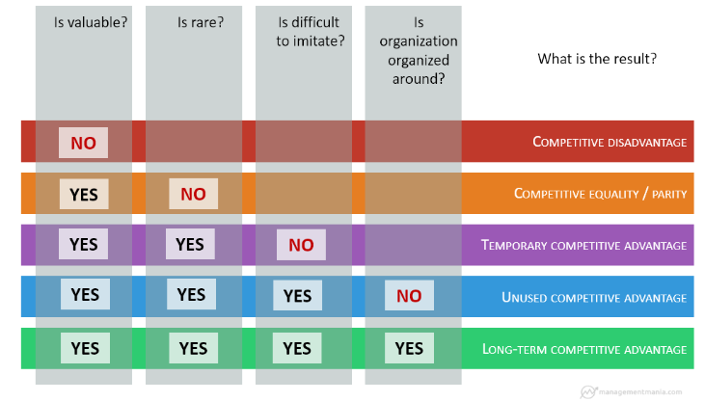

Source: VRIO Analysis is an analytical technique (Barney & Hesterly 2006)

However, if there are high costs of imitation, the Barclays Bank may enjoy a period of sustained competitive advantage. Costs of imitation increase due to some combination of the Unique Historical Conditions thus, path dependence; first mover advantages, Causal Ambiguity, Social Complexity including social relationships not replicable, and Patents. All of these will are some of the competitive advantage that Barclays Bank will benefit from by applying this Model (Barney et al, 2006).

Again, this model will ensure Barclays Bank is properly organised in terms of dealing with the firm’s structure and control thus, governance mechanisms, compensation, reporting structures, management controls, and relationships (Barney et al, 2006).

### 4.2.4Business Model Canvas

A humble way to understand the needs of customers, is to design product and service that meets the needs and to their expectations. It also works in combination with the Business Model Canvas and strategic plan and performance of the necessary tools needed for Barclays bank’s processes (Amit, 2012).

Barclays Limited is a global financial services holding company. The company is engaged in retail banking, credit cards, wholesale banking, investment banking, wealth management and investment management services. The company's divisions include Barclays UK and Barclays Corporate and International. Barclays UK divisions include British individuals, small British businesses, British Fortune businesses and Barclaycard UK consumer credit card business. Barclays has merged its investment banking division with international agencies; large British companies, international business and wealth businesses, and Barclaycard Business International (including consumer credit card businesses in the U.S., Germany and Northern Europe) and Barclaycard Business Solutions including merchant acquisitions (Westerlund, 2015).

In every organization there are strengths and weaknesses, opportunities and threat (Chesbrough, 2010). To highlight the previous whereas reducing the latter, business often dedicate significant capitals to their company stratagems example creating a perfect strategy to outwit the opposition in a developing markets. And at same time businesses may give a direct assessment to the necessary target in defining the exact kind of strategy needed for product innovation (Amit, 2012).

Developing new products entails an examination across a particular industry and coming up with an innovative product to compete with the market. For a company like Barclays Bank that can contend on its proficient industrialized and excellent supply-chain supervision, avoiding the rough peaks and instead pass through the sloppy hill is an effective strategy. (Mitchell, 2003).

**4.2.5Theories for Analyzing the Leadership of the Bank**

## Traits Theories

Leadership is also the ability to attain result and also impacting positively to followers, according to Trait theorist Robbins et al. a leader should have a drive, desire to lead, honest, integrity, self-confidence, intelligent and extraversion(Robbins et al. 2003) .

### Figure 4.4

**Trait Theory**

Source: *Source: Academy of management executive (2016)*

**Jes Staley Leadership Traits**

**Drive:** As a leader, he exhibits a higher effort level. Jes Staley has a relatively high desire for achievement, he is ambitious, and has a lot of energy, and tirelessly persistent in his activities and also shows initiative in his line of business.

**Desire to Lead:** He has a strong desire to influence and lead othersand demonstrated the willingness to take responsibility. Mr Staley’s appointment was as a result of his desire to lead which the Board of Barclays Bank identified which had it approved by regulators to revive Barclays from its declined stage.

**Honesty and Integrity:** Staley built trusting relationship between himself and followers by being truthful or no deceitful and by showing high consistency between word and deed.

**Self-confidence:** Followers look to him for an absence of self-doubt, and had the need to show self-confidence in order to convince followers of goals’ and take bold decisions. His ability to attain and impact positively to followers and the team, enabled the efficiently achieves structural goals for Barclays come back after the trench period (Tosi, 2013). According to Northhouse.PG, (2001) Leadership is a process, which implies that it is not a quality or distinguishing factor that resides in the leader, but is a transactional happening that arises between the leader and his or her followers. Leadership establishes direction through vision and clear set strategies.

**Intelligence:** Jes Staley is intelligent enough to gather synthesize and interpret large amounts of information and to be able to create visions solve problems and make correct decisions.As a leader, he believed that enabling true gender equality is a responsibility we all share. At Barclays, our partnership with the UN and support for he or she are indicative of the strength of our commitment to ensuring women can contribute fully to society, to industry and global economies.

**Job Relevant Knowledge:** Jes Staley had a high degree of knowledge about the company (Barclays Bank), the banking industry and technical matters. He has In-depth knowledge made well-informed decisions and to understand the implications of those decisions.

**4.2.6 Bloom’s Taxonomy Theory**

This theory provides a hierarchical structure with which to think about the cognitive levels of the learning activities that Barclays to undertake to encourage detail understanding of the company’s products and services in order to best represent the Bank (Anderson et al, 2001).

### Figure 4.5

**Taxonomy Theory**

Source: Vanderbilt University Centre for Teaching (Patricia Armstrong, 2001)

Barclays Bank can retrieve relevant information from their long-term memory to determine the meaning of instructional messages, including oral, written and graphic communication and carry out or use a procedure in a given situation that can break material into its constituent parts and detect how the parts relate to one another and to an overall structure or purpose of which the bank use for its judgment based on criteria and standards of the bank.Barclays Bank can also put the elements seen in this theory together to form a baseline to service delivery(Anderson et al, 2001).

**Conceptual Skills of Jes Staley**Jes Staleyhas the mental skills to analyse and diagnose complex situations. These tasks require conceptual skills. For example, decisions require first spotting of the problems, develop alternative solutions to correct them, evaluate these alternative solutions, and choose the best solution (Peter Northhouse, 2007) And a plan of action to be able to develop and implement the ability to combine new ideas with existing processes and innovate at work is also a crucial conceptual skill for today's leaders which he exhibited (Linda Seligman.2004).

**Technical skills of Jes Staley**

Jes Staley has the ability to apply specialized knowledge. The skills of a professional or a leader isusually focused on the technical skills they acquire through a wide range of formal education (Scott Beardsley, 2017). Of course, professionals do not monopolize technical skills, nor do all technical skills have to be learned in school or other formal training programs. All work requires some expertise and many people develop their technical skills at work. Barclays saw such skill in him which he exhibited by showing an in-depth knowledge of the industry (Philip Coggan, 2008).

**Proactive Personality**

Staley has a positive personality to take initiative that can find opportunities, take action, persevere until meaningful changes occur, compared with others passively responding to the situation. Creating environment that has changedBarclays, be it limited or disregarded obstacle (Andrew DuBrin, 2013). Not surprisingly, he hasmany organizational needs covet. Staleyis more likely to be satisfied with their work and helping others accomplish more, mainly because he has built more relationships with others.

He challenges the status quo or to express their thoughts when the situation does not meet their preferences, they are not satisfied. However, he is more likely to leave an organization to start his own business. As individuals, who has worked in the industry for sometimes he is more likely than others to achieve careers he choose to create and influence the working environment that benefits him. The identify work and organize information, communicate at the top, participate in career planning, showing his career persistence obstacle (Kilian Wawoe, 2010).

**Transformational Leadership**

Jes Staley executed appropriate leadership talent and wide-ranging experience to deliver shareholder value and to take the group forward strategically, Barclays bank therefore completed the cultural transformation of the group of which there can be no retreat from becoming a value driven organisation which conducts itself with integrity at all times "In particular, he also understands corporate and investment banking well enough to the re-positioning of which is one of the bank’s major priorities"(McFarlane, 2015).

**Skill set of Antony Jenkins**

**Human skills Antony Jenkins**

Antony Jenkins ability to understand, communicate, motivate and support others, be they individuals or groups, define one's skills. He is technically proficient but is poorly obedient, unable to understand the needs of others or weak at dealing with conflicts. Jenkins get things done things through others approval, he has good interpersonal skills and common thread runs through functions, roles, skills, activities, and management approaches , He is in terms "people skills" Frank (Stopa, 2011)

**Task Performance.**

Mission Performance, the combination of efficiency in performing the core tasks reflects mission performance level.Which he exhibited the desire to achieve and move the company forward which gained an applaud from the board recognising that contribution Mr Jenkins had made over the past three years, and was “extremely grateful to him for bringing the company to a much stronger position” (Rod Ellis , 2005).

His performance can be measured in terms of the quantity and quality of products produced. The performance of tasks will be the level of education that followers receive. The task performance which is measured by timeliness and quality of the presentations they provide to the client and shareholders of the company. All of these types of performance are related to the core responsibilities and responsibilities of the job, and are often directly related to the functions listed in the formal job description. Obviously, task performance is the most important human factor in contributing to organizational effectiveness, which Jenkins exhibited (Locke et al, 2013).

**Bureaucratic Leadership**

Bureaucratic leaders rely on rules and regulations and clearly defined positions within organizations. Jenkinstends to be people who are well organized. People in bureaucratic leadership are likely to report only to their immediate supervisor or, in the case of a president or CEO of a company, to the board of directors. Stepping out of the organizational role they play is difficult for them (Larry Terry, 2015).

Jenkins exhibited strict hierarchy that is formalized by the leadership and strictly adhered to,the organization is controlled by immutable rules, regulations, or laws .The organization is structured along the lines of specialties. The organization has one of two missions:, Up-focus,” meaning it focuses on the board of directors or stockholders, “In-focus,” which means the organization serves a product-oriented goal such as increasing profits market share(Pamela Spahr, 2015).

## 4.2 Assessment of Barclays Bank Current position

**Risk and business strategy**

The risk function plays a significant role in review and challenge of risks inherent within business plans and strategy by verifying that they fall within financial volatility risk appetite and incur a level of risk that is individually and in aggregate acceptable to the Board, or be modified accordingly. The Group-wide stress testing process is similarly linked to the medium term planning process and also supports strategic planning and capital adequacy. Barclays manages human rights risk via our environmental and social risk procedures and guidance and our reputational risk framework and continues to work collaboratively with others in our sector on integration of human rights issues into business decision making. Risk management responsibilities are laid out, which covers the categories of risk in which Barclays has its most significant actual or potential risk exposures, which are known as Principal Risks

Jes Staley tries to get rid of Risk Weighted Assets since the current situation of the bank, He is withdrawing from Asia and Africa, and reluctant to take higher risks and higher returns, but because he wants to get good result to growth the bank again.

"The heart of the Barclays strategy is the consolidation of our strength as a transatlantic consumer, business and investment bank in the two largest financial centres in the world, London and New York(Gale, 2017).

This will be one of the two new divisions within Barclays, the other being its ring-fenced UK retail bank, but there’s little doubt where Staley sees the profits coming from. The first stage of his plan is similar to Jenkins’ out of sheer necessity. Barclays has little choice after all but to ride out the ‘legacy headwinds’ of regulatory charges (it set aside another £4bn for PPI mis-selling, forex fixing and other litigation in 2015) and imposed capital ratios.  
Selling down its stake in its African bank and, indeed and cutting its 2016 and 2017 dividends by 54% have both helped Barclays. But the legacy storm won’t rage forever. Once the painful battering of regulatory pay-outs ends, Staley has promised that his ‘dramatically simplified’ bank will ‘pay out a significant proportion of earnings in dividends to shareholders over time’ (Gale, 2017).

**Management of the Bank**

The strategic management model is the method manager’s use in developing and implementing a strategy. This approach addresses the issue of who has a significant impact in the strategic management process and how to implement the process. Managers usually adopt one of three main strategic management methods. Entrepreneurs, Adaptability and Planning (Mintzberg, 2005)

Today's success organizations must promote innovation and master the art of change, or they will become extinct candidates. Victory will continue to maintain the flexibility of the organization, continuously improve the quality and through the continuous innovation of products and services to defeat the market competition. Domino dominated the small pizzeria and managers think they can keep doing what they've been doing for years. Amazon.com closed many independent bookstores because it proves that you can successfully sell books (and anything else) from the site. After years of sluggish performance, Boeing is aware of the need to change its business model. The result is its 787 Dreamliner, which has once again become the world's largest aircraft manufacturer. An organization's employees may be the driving force for innovation and change, or they may be a major stumbling block. Managers are challenged to stimulate employee creativity and tolerance of change. The areas of OB provide a wealth of ideas and techniques to help achieve these goals.

The main purpose of management, as described by Fayol is planning, organizing, staffing and controlling.

**Shareholders of Barclays Bank**

Under the new management, this core is beginning to shift slightly. McFarland believes Britain and South Africa are the two most powerful weapons for banks. But even in the UK, he also thinks there's more to be done - whether it's getting a mortgage pricing closer or paying more attention to "clients," he feels he's rarely used by 132,000 of his colleagues. In Britain and South Africa, he tries to inject what he calls "accelerated business."(James Quinn,2015).

Stakeholder analysis is very important for developing knowledge and understanding of other organizations in the company's environment. The first step is to list all the stakeholders and put them on the stakeholder map. This shows the main relationship and interdependence between stakeholders.

These maps are not only directly related to stakeholders, but include all the maps that indirectly help your business achieve its goals. You can then evaluate the likely impact of any proposed strategy on these different groups that is, support or resistance (James Quinn, 2015).

.

**Analysis of Barclays Banks Operations**

## Swot Analysis of Barclays Bank

### Figure 4.9

**Swot Analysis of Barclays Bank**

**Strength of the Bank**

During 2016, Barclays sought to minimize the impact of many of the macro challenges and threats analysed by pestle such as Brexit and regulatory pressures in the UK, while also benefiting from existing opportunities such as becoming a minority bank one of them has started to process deals based on blockchain technology. As a result, the bank is now smaller, has a higher capital adequacy ratio, lower leverage, and is geographically closer to the core markets of Britain and the United States. Barclays is renowned for its brand reputation and stems in part from more than 400 years of service history, enabling it to build strong brands across multiple countries and territories. This diverse location is one of Barclays's core strengths.

The company has a strong presence in the UK market, taking the lead in several key products and services such as the Barclaycard payment solution. In this digital era, Barclays has the technical capabilities as its core strengths and was named the UK digital banking leader. As part of making technology a core competency, the bank has opened a new Operations and Technology Centre in Ladbroke, Northampton and Glasgow (FT, 2017).

**Analysis of Barclays Weakness**

Major traditional behavioural issues still cause Barclays to place special emphasis on its technology and operations infrastructure that needs to be modernized and network responsive (The Financial Times, 2017).

Barclays Bank's core business, especially the U.S. corporate and investment banking business, still lacks the bank's needs. As a result, the Group still has a 40% discount to its book value despite the substantial increase in market value in 2016 as a result of the restructuring (FT 2017).

Barclays Bank agreed to pay $ 972 million to its African subsidiary, Barclays Africa Group Ltd. (BAGL), as part of its separation agreement (Cashen, 2017), which has proved time-consuming and costly to divest.

**Opportunities Available to the Bank**

The strategic withdrawal of Barclays Africa Group Ltd (BAGL) equity stake as part of its largest restructuring plan in history will exit more than 30 countries, raising core rewards and eliminating drag on further resolution of annual reports on historical behaviour 2016. Barclays is ahead of many traditional banks in benefiting from the growth of digital banking, as one of the few banks to begin processing deals based on block chain technology (Binham, 2017).

**Internal and External Threat of the Bank**

Uncertainty about Brexit is bad for many British companies, including Barclays. If the Brexit negotiations (FT 2017) call for such a move, management has proposed a contingency plan to strengthen the EU's internal handling of the EU's activities in Europe. Regulatory pressure includes new capital requirements.

The British government introduced a new 8% bank profit surcharge in January 2016.

The Serious Fraudulent Office (SFO) filed a lawsuit about banks' transactions with Qatar during the height of the financial crisis (Treanor, 2017).

## Pestle Analysis of Barclays Bank UK

Barclays Bank identified the sustainability as a means of recognizing and managing the economic, social, and environmental issues across the Group, and at the same time, contributing to the wellness of the society. Pest analysis is created to identify the factors that might affect the sustainability of the organization (Rashain Perera, 2017).

**PoliticalAnalysis of the Bank**

Barclay’s 2016 was a challenging political environment for Barclays characterized by a new regulatory capital rule set by the British government and the introduction of an 8% bank profit surcharge in January 2016. If the bank has overseas affiliates, that's why it affects 62% to 50% of Barclays' foreign affiliate in Africa (Barclays Africa Group Ltd.) contributed 62-50% of the major share-based decision to sell its equity stake in 2016 and plans Further exit in the future (2016 Annual Report).

However, the biggest impact was the Brexit, which Britain voted in June 2016 to leave the EU. The move is not only expected to trigger the political and economic turmoil in British businesses but will also affect the UK economy, at least for the short term (Douglas et al, 2016).

**Economic Analysis of the Bank**

The economic risks and uncertainties that the British exit from Europe pose a significant challenge to many banks, including Barclays. According to the final international agreement between the UK and other EU member states, the potential impact of leaving the EU is substantial, as can be seen from the subsequent decline in the value of sterling against the major currencies such as the U.S. dollar and the euro. If Britain eventually left the EU in 2020 (Davis 2017), things could get worse. For Barclays Bank, the possible impact of Brexit on capital, operations and regulation, as well as its impact on its employees, customers and customers (2016 Annual Report).

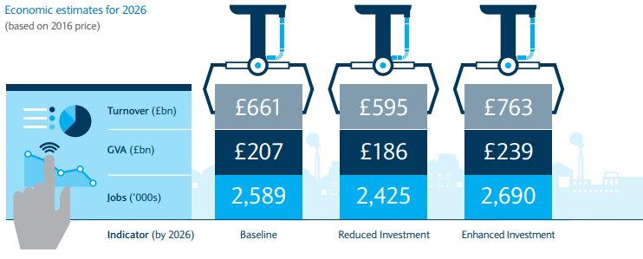

Source: Barclayscorporate.com (Mike,2016)

**Social Analysis of the Bank**

The social environment includes demographics, lifestyle or fashion, changes in labour and social mobility. In general, social change may pose a threat or opportunity to banks such as Barclays. One of the demographic shifts that currently affect Barclays in the development of its core markets in the United Kingdom and the United States is the aging of the population and the implications of future product and service delivery. According to the National Bureau of Statistics (ONS), the median age in Britain increased from 33 years in 1974 to 40 years in 2014 (ONS, 2015). It is estimated that by 2019, the UK population aged 55-64 will achieve double-digit growth. As aging retirees have more revenue and higher disposable income, an aging population will create business opportunities for Barclays. For Barclays and other banks, this shift means promoting savings, investment and wealth management as a basic service to meet the needs of retirement-age clients as well as credit and consumer services (PwC 2016).

**Technological Analysis of the Bank**

As far as the technology environment is concerned, the banking industry has reached a turning point. The digitalization capability is accelerating the development of the banking industry. Therefore, all aspects of the banking industry can now be completed online. The current financial innovations have the potential to revolutionize finance and change the international monetary ecosystem, including the rise of blockchain, biometrics, robotics and financial technology companies (Lonergan 2016; Cap Gemini 2016). Financial technology companies, agile digital companies, the use of technology to access financial markets, and the emergence of simple, easy-to-use, convenient and cost-effective products and services to their customers have had a significant impact on banking in particular. The disruptive technology (Gemini 2016).

**Legal Analysis of the Bank**

In June 2017, Barclays and four former senior executives were accused of Fraudulent Offices (SFO) fraud at the bank's deal with Qatar during the height of the financial crisis (Binham, 2017; Treanor, 2017). The investigation involved Barclays' emergency fundraising and follow-up funding from Qatar's holding group, Qatar's sovereign wealth fund (Binham, 2017). The bank raised a total of 11.8 billion pounds from numerous investors, including Qatar holding companies, and other investors in Abu Dhabi. The investigation, which has been in place since August 2012, culminated in criminal charges, the first to target British high street banks and former senior management during the financial crisis (Treanor, 2017).

If convicted, Barclays faces a fine and may further damage the reputation of Barclays Bank, which has hit hard since the financial crisis, such as the 2012 libor scandal that CFTC fined $ 200 million CFTC 2012) .The Financial Conduct Authority also filed a $ 1 billion lawsuit against Barclays and filed a report.

**Environmental Analysis of the Bank**

Barclays PLC also recognizes the current trends of consumers and governments that require businesses to reduce their carbon footprint. In its 2015 Citizenship Program, the bank is committed to reducing its own carbon footprint by reducing energy consumption, primarily through the annual report on sustainable development finance and carbon offsets initiatives 2017).

## 4.3 Analysis of the Assessment

The concept of Leadership gives a different definition to leading people including that of getting people to do things they have never thought of doing, do not believe are possible or that they do not want to do. With reference to an organization, he defined leadership as “the action of committing employees to contribute their best to the purpose of the organization”. While on a complex and more accurate view, he explains that you only know leadership by its consequences from the fact that individuals or a group of people start to behave in a particular way as a result of the actions of someone else (Taffinder, 2006).

Leadership according to Johnson and Scholes (2004) is the process of influencing an organization (or group within an organization) in its efforts towards achieving an aim or goal. However, required in today’s complex operating environment is transformational leadership, which is leadership that inspires organizational success by profoundly affecting followers’ beliefs in what an organization should be, as well as their values, justice and integrity (Certo, 2000). This is referred to as transformational leadership (Johnson et al, 2004).

## Proposed Strategies for Growth

## 4.4 Selected Strategies

Strategies are the long-term direction and scope of the organization: achieving the organization's strengths by deploying resources in a challenging environment, meeting market demand and achieving stakeholder expectations (Scholes, 2015). Thinking strategically is what separates managers and leaders. Learn the fundamentals about how to create winning strategy and lead your team to deliver it. From understanding what strategy can do for you, through to creating a strategy and engaging others with strategy (Max Mckeown, 2015)

Barclays Bank Business Strategy  
The banking sector strategy is more concerned with how banks compete in specific markets. It includes planned decision about products selection, which meets customer’s needs, acquisition of competitor advantage and bringing on board new ideas(Sull, 2001). Again the banks operational strategy focus on how each part of the industry is organized to achieve the strategic direction of the every level. As a result, the focus of the bank’s strategies on resources, processes and personnel issues(Grant, 2013).

### Figure 4.10

### Corporation Strategy

The strategy of Barclays PLC Group is to consolidate our strength as a transatlantic consumer, business and investment bank, and build on the two largest home market in the United Kingdom and the United States globally.

Our two well-defined divisions, Barclays UK and Barclays International, offer diversification through lines of business, geography and customers to increase financial flexibility and help deliver a consistent return for the entire business cycle. We have a strong core business and we have exciting prospects to provide long-term shareholder value (Rothaermel, 2012).

In line with our goal of long-term sustainable value for all stakeholders, we have formulated a "vision of shared growth" - our citizenship and the sustainability of the business models we operate. The goal is to make decisions and do business to provide a prosperous future for our customers and customers, and for the communities we serve.

The implementation of our strategy Thanks to the energy, commitment and passion of our employees, we clearly expressed our common goal of helping people achieve their goals in the right way. Our common values ​​tell us how we work and how we behave, guiding our everyday choices(Johnson et al, 2008).

### Cultural Strategy

Barclays has undergone major changes in all of the areas we are targeting, especially its culture. Its targeted positive behaviours includea three-year citizenship program that focuses on issues such as productionbroader financial products and wider access to peopleSustainable investment. It also strives to improve diversitythe workforce has been shown to improve overall performancethe business world, through mentoring, thought leadership programs. And strategic headhuntingdespite this positive progress, we believe Barclays remains the samethere are many things to do. Its cultural transformation continues

Past behavioral problems and the cost or income ratio in themInvestment banks are still far above their peers. However, the bank's senior executives said they are motivated to correct the problemsThings, and have improved our investmentcase. As a credit investor, the bank believe in some of the bank's advantagesto be covered by the challenge. By cutting their dividendsto fund the restructuring, Barclays is defending its balance sheetis a credit-friendly move. It is dedicated to solving employee problemsBehaviors, corporate governance and other environmental, social and governance issues make it one, it is in our interest to have a more attractive credit issueras a credit investor (Jurevicius, 2013).

### ****Product Development Strategy****

The Product Development strategy is a global strategy used by many firm to sustain their businesses, for product development in terms of upgrade or new introduction of product into the market. The aim is to improve the efficiency of workers and the organization in product development and to provide consumers the satisfaction they want. This is achieved through the provision of earnings for skill development, data, partnership and advertising of new product improvement and administration(Mina Tajvidi, 2016).

### ****Market Penetration Strategy****

The always take into account all the good things of the industry, our competitors, the market, the organization's ability, and the classic strategy to teach us how to do it, but it's all for the big ideas, the groundbreaking experience and what they find in space and We have to play after the opportunity to use it(Triant G. Flouris, 2016). The company experience value creation and growth of the great breakthrough when you take this creative way, rather than the more traditional analysis method. (Morey, 2017).

A Suggested Structure for Growth

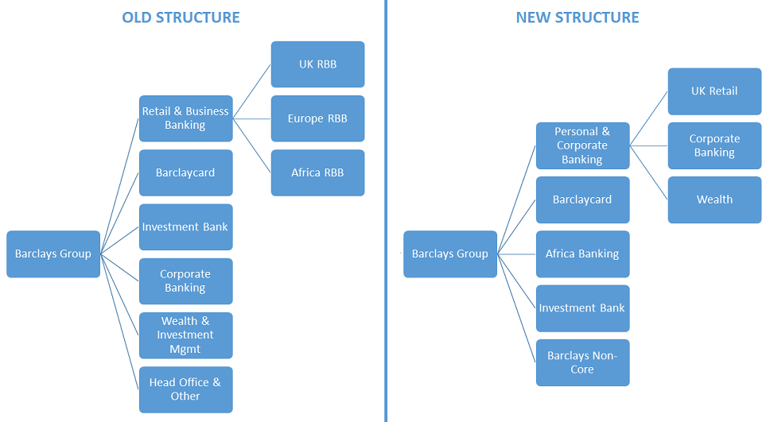

# Source: A Look at Barclays' Revamped Strategy and Its Impact on the Bank's Share (Trefis, 2015)

Barclays’ intentions with the reorganization are evident from the proposed changes to its business model. The new model marks a considerable change from the current operating structure, and consists of five divisions as compared to the older structure, which had six divisions. Things that stand out are the bank’s clear decision to focus on retail operations in the U.K. and Africa, which means that the bank will likely no longer pursue retail banking growth in other parts of [Europe](http://www.forbes.com/europe-news/) and Asia (Trefis, 2015)

### Product Differentiation Strategy

Product differentiation is a viable business strategy, which every business use to try and gain a reasonable advantage by growing and improving the quality, standard and value of the product and service through perceive value relative to other companies' products and services. In terms of demand, the key is insight into the customer and its needs and preferences. These three aspects constitute the main content of Barclay’s analysis, that is, tangible, invisible and human differentiation(Stuyck, 2017).

**Cost leadership strategy**

This is one of Potter's general strategies known as cost leadership (Malburg, 2000). This strategy focuses on gaining a competitive advantage by having the lowest cost industry(Porter, 1999). In order to achieve low-cost advantage,organizations must have low-cost leadership strategies, low-cost manufacturing and a

Workforce dedicated to low-cost strategy (Malburg, 2000). The organization must be

Willing to stop any activity they have no cost advantageCost-benefit outsourcing activities should be considered in other organizations(Malburg, 2000).

For an effective cost leadership strategy, a company must have a big oneMarket Share (Hyatt, 2001). There are many areas to achieve cost leadership, such as qualityProduction, Quality Assignment, Economies of Scale, Technology, Product Design, Input Costs,Utilization of resources and access to raw materials (Malburg, 2000).And again claims that companies with only one industry can become cost leaders .If this is the only difference between company and competitor, then the best strategic choice isLow-cost leadership). Reduce costs and cost advantagesfrom process innovation, learning curve benefits and economies of scale, productsDesign and redesign activities that reduce manufacturing time and costs.

Low costor cost leadership strategy effectively implemented in business design (Sy, 2002).

Produce and sell comparable products that are more effective than their competitors. This

Companies may get raw materials or superior know-how that helpscut costs. Cost leadership strategy seeks to achieve above average returnscompetitors push down the components of all activities through low pricescost. In order to obtain such a relative cost advantage, the company must invest considerable effortcontrol and production costs, improve capacity utilization, controlMaterial supply or product distribution, and minimize other costs, including research and development and salesadvertising(Malburg, 2000).

**Focus Market Strategy**  
The competitive advantage of market focus is based on the competitive advantage of competitors or the ability of competitors to differentiate themselves from their competitors. The focus is on choosing a market that has unique preferences for buyers. Thus, defined by geographic uniqueness, the specific requirements of the product used, or the special attributes that attract clients (Stone, 1995).

The key strategy based on low cost depends on the existence of a buyer's segment whose costs are lower than those of other markets. On the other hand, the differentiated focus strategy depends on the presence of buyer segments that require unique products attributes. In the key strategy, a company is targeting a particular market segment (Porter, 1996). Companies can choose to focus on a specific customer base, product range, geographic area, or service line for example, some service companies only focus on serving customers (Stone, 1995).

The point is also to take a narrow area of ​​competition within an industry. The goal is to gain market share by operating in a niche market, either in an unattractive market or in markets that are overlooked by larger competitors. These niches come from many factors, including geographical location, buyer characteristics, and product specifications or requirements. A successful focus strategy (Porter, 1980) depends on a sufficiently large industry with good growth potential but not on the other major competitors. Market penetration or market development may be an important focus strategy. Mid-sized and large enterprises use focus-based strategies, but only with a common strategy of differentiation or cost leadership. However, the key strategy is most effective when consumers have different preferences and competitors do not pursue niche (David 2000).

## 4.5 Findings

The study shows that Barclays Bank has largely been adoptedCost leadership strategy and ring fencing strategy to cope with the resulting competitionin the banking industry.

The research shows that Barclays Bank Limitedensure that it maintains a low cost leadership strategy, low cost manufacturing and aCommitted to low-cost strategy of the workforce. In order to achieve results.

Barclays Bank is always willing to stop any activitiesit has no cost advantage and consider outsourcing activities.Other banks have cost advantages.

Barclays Bank Ltd. has been able touse a cost-leadership strategy to achieve above-average returns

However, competitors provide services through inexpensive services. In order to achieve such a relative costBarclays Bank Limited has made considerable efforts to reduce itthe cost of providing services.

## 4.6 Suggested Solutions

Based on the findings, the study concluded that Barclays Bank the competition can be overcome by maintaining low costs Leadership strategy, low cost manufacturing and commitment to a low-cost workforce strategy. The study shows that Barclays Bank Limited has introduced a different a wide range of services are provided for the competition of in the UK baking banking industry. Therefore, the study concludes by providing unique services Competitor, an organization can stand by its existing advantage Customers and attract new customers. The study came to a conclusion that Barclays Bank Limited can make Overcoming competition by strategically implementing its sets of strategies. This will make it possible for Barclays Bank to maintain a wide range of customer development.

## Summary

Effective leaders rely on emotional appeals to help communicate their message. In fact, expressing emotion in a speech is often the key factor let us accept or reject the leader's message. "When leaders feel excited, passionate, positive, they may be more likely to inspire their subordinates and communicate an effective, compelling, optimistic and fun feeling. As an example, they learned to show enthusiasm when talking about themEven polls show other things, they may win the election.Business executives know the emotional content is vital if the employee wants itBuy what they think about the future of the company and accept the change. When higher providing new visions, especially ambiguous or distant goals, is often difficultEmployees accept the changes they will bring. By arousing emotions and connectionsThey have an attractive vision and leaders have increased the possibility of managersLike the staff will accept the change. are dedicated to inspiring leadersGoals also lead to greater optimism and enthusiasm for employees more active social interaction with colleagues and clients.

# CHAPTER FIVE

### Introduction

The problem that Barclays may face in the future is that the continuing economic conditions in the UK, Europe and the United States have led to increased uncertainty within retail consumers and a shortage of credit in the market. This, in turn, places a growing emphasis on companies' ability to make up for the shortfall in the UK domestic market through advances in emerging markets, thereby boosting the company's overall profitability and profitability. All companies, including Barclays, are forced to re-examine the retail aspects of their business, hoping to stay competitive in the high streets and cut back when necessary. In the current financial environment, banks are reluctant to finance each other and the UK market is on the verge of a severe recession. Any retail factor that may affect the competitiveness of Barclays High Street will depend to a large extent on the Bank of England and the Treasury seeking to regenerate and strengthen Decline in the stock market confidence, as we have seen in other financial institutions, a sharp decline in market value and speculation can lead to disastrous consequences(Stuyck, 2017).

### Conclusion

### Action Plan

Key to Barclays' success is the three hundred years of history and expertise in banking that Barclays has seen and won as a trusted and reliable bank and investment institution. This reputation has grown to more than 50 countries and becomes a truly universal bank, providing loans, investing and securing funds to more than 42 million customers and customers around the world. Another reason Barclays succeeds is that it follows a simple strategic premise: "anticipating the needs of customers and customers and serving them by helping them achieve their goals." The recent success of Barclays is that they have the ability to target and recognize Upcoming emerging markets, such as parts of India, Asia and Africa, namely South Africa, have expanded the availability of their retail networks and ATMs. Although from basic banking accounts to funded government projects is a truly global company, Barclays has focused on meeting the needs of individual clients(Trefis, 2015).

Speed is not the only priority; it also has an innovative reputation. The broker community is the bank's number one in the latest models, including the world's first ATM and the first UK debit card. As a leading bank the charge for digital and trying to ensure that the communities are not behind. The community platform will help the bank bring brokers to the same digital journey. With the new platform, brokers get instant access to information, whether they are using smartphones on a train or laptop at a customer conference (Financial Time, 2017).

**Resources**

Barclays' basic resources include its own physical and human resources. These two resources are acquired and evolving so that their capabilities can be fully realized by the company. Barclays' unique resources include the company's intangible resources. Such resources are not readily available directly and may take years to fully utilize these resources.

**Financials**

Corporate funds come from other sources such as parent companies or investors. The money is used to pay for the different costs of the company. Barclays wants to focus on price-based strategies, with the main goal being to make more money without sacrificing anything else. The company has a number of priorities in its budget priorities. The company is in good financial standing but still wants to maintain its financial position at a lower cost and profitability by providing efficient and efficient service.

**Human**  
In providing quality service to customers, companies need a loyal staff who perform well and know that the services they provide to their clients can help the company get a positive or negative image. Well-trained staffs to ensure that customers provide the best service. The company ensures hiring promising people to help the company achieve its goals. These people are well-trained by the company, so every employee will play an important role in the company. The company offers a variety of financial and compensation programs for employees. This ensures that every effective service for employees, they have made a huge return. The company also recognizes and awards employee rewards for implementing the above standards.

**Skills**

Barclay’s employees excel at serving clients. The company ensures they hire people who specialize in management, banking and finance. The company also looks for activities to help employees improve their skills.

**Organisational Processes**

Barclays' organizational processes are well thought out and designed to meet the needs of the environment. Every organizational process associated with production, marketing or sales has a specific goal that contributes to the company's success. Barclays' process was rigorously analyzed. The management team ensures that they choose the process they will be using.

Barclays Financial Group is known by many as Barclays Bank mainly because it does not know the extent of their business operations. Barclays is not only known for its business operations (current accounts, savings accounts, insurance, bankruptcy, etc.) as well as wealth management and stockbrokers for British and international clients. Both of these options are for use by highly networked people.

Barclays wealth management, including offshore banking, stock brokerage business, private banking and so on. The availability of these business operations ensures that every part of every market is cared for, worked-class or otherwise. Barclays Bank adopted this strategy is essential and effective, because everyone has this strategy. Everyone takes care of this company, whether they are looking for savings accounts or financial advice for a new or ongoing business (Rao V S P., Hari Krishna V (2008): Strategic Management).

### Limitation of the study

Qualitative case studies are also limited by the sensitivity and completeness of the researcher. Research are the main tools for data collection and analysis. This has its benefits. However, it is not easy to observe and interview for aspiring case studies research. There are no guidelines when writing the final report. Throughout the research work, investigators rely on their own instincts and abilities (Brinkmann, 2017).

Although there is a lot of information about marketing techniques, the goal of the research is simply to gather information about the service industry. Some limitations have been considered when collecting data:

Most of the information research used are collected from books, questionnaires and the internet and journals. This research focused on using readily available and reliable secondhand data for projects, but there are some problems with secondary data:Outdated data and incomplete data

Incompatible format comparison of peer information, data not accessible and not presented in useful form. Sometimes, information about current marketing techniques that are highly sensitive to any company is not readily available and it seems difficult to schedule meetings with company management.

Sometimes, because of human error, some of the information may be characterized as being overlooked, which not produce the desired may result in the collection of information.

Some information requires professional knowledge to understand, and may be difficult for the public to understand.

### Recommendations

Barclays brand builds on its extensive operations across multiple continents, serving 20 million customers and deeply engaging with these customers. Its built over 300 years of experience makes it seem easy to make the complex look simple. This breadth and depth of experience and the benefits it offers as a banking-leading financial expert are key to the positioning of its "financially viable" brand.

Barclays Bank's ambition is to become the world's leading provider of financial services to all universal banks. The adoption of this declaration means providing a wide range of retail and business services to consumers worldwide(EL-Achkar, 2016).

Barclay Bank should strategy follows a simple principle to meet customer needs by providing quality customer service and helping them achieve their goals.

Barclays Bank has a clear overview of the sources of growth in the financial services industry, hence, enabling it to capitalize on the opportunities offered by investment trends will help the growth of the bank.

At the same time, at the heart of the Barclays brand is the company's desire to become one of the most respected financial services organizations in the world and is recognized as an innovative, customer-focused company that offers world-class products and services to ensure that employees are provided Excellent career and positive contribution to the community.

### Summary

Barclays Bank is one of the UK's leading banks, with its long history, placing it on top of many other banks. The company has experience in doing its job. Although there are many competitors, but see this company is still far ahead. It is still far ahead as it employs a variety of effective tactics and will continue to function effectively. One of Barclays Bank's main goals is to set up the best bank in the UK and you can see that it is working hard to achieve this based on the measures it has taken, trainers, technicians and even the path to globalization aims.

The basic principle of Barclays philosophy is to bring the interests of all shareholders from customers, employees, shareholders and the wider community into a value and prosperous environment where satisfied stakeholders are provided.

Barclays can not only analyze whether these goals can be achieved through external analysis, but also from the internal perspective. The difference is that the external analysis is related to the content of the company's external discussions, competitors, customers, politics, environment, social technology, and so on. So Barclays can look at itself to pinpoint where they get the most business and try to get the most out of it. On the other hand, their companies can see where they are losing money and try to devise strategies to strengthen them.

# Reference

# John Dudovskiy,2016the Ultimate Guide to Writing a Dissertation in Business Studies: A Step-by-Step Assistance.

Uwe Flick, 2014. Introduction to Qualitative Research, 5th Edition.

Onwuegbuzie, Anthony J 2005. International Journal of Social Research Methodology: On Becoming a Pragmatic Researcher: The Importance of Combining Quantitative and Qualitative Research Methodologies.

Creswell, John W. et al . 2000. Theory Into Practice :Determining Validity in Qualitative Inquiry

Saunders, M., Lewis, P. & Thornhill, A. (2012) “Research Methods for Business Students” 6th edition, Pearson Education Limited

# Joseph A. Maxwell, 2012. : A Realist Approach for Qualitative Research.

John Mingers, 2014.Systems Thinking, Critical Realism and Philosophy: A Confluence of Ideas.

Aidan Feeney et al, 2007. Inductive Reasoning: Experimental, Developmental, and Computational Approaches.

# Rafael J. Engel, Russell K. Schutt, 2014. The Practice of Research in Social Work

Svend Brinkmann, 2017.Philosophies of Qualitative Research

Kerry E Howell, 2012. An Introduction to the Philosophy of Methodology

Justin Pettit, 2017. The Final Frontier: E&P's Low-Cost Operating Model

Bradley, L. and Stewart, K., University of Ulster, (2002) The Future of Internet Banking: what the international experts say (need clearance from authors before publication) Li, F. (2002) Internet banking, some emerging tendencies in the UK,51 'Giving Europeans an on-line push', Bughin, J.R., McKinsey Quarterly, 2001.

Craig S. Fleisher, Babette E. Bensoussan , 2015. Business and Competitive Analysis: Effective Application of New and Classic.

# EvgeniiPrussakov , 2011.Affiliate Program Management: An Hour a Day

Shahin W. & EL-Achkar, E., 2016. In: Banking and Monetary Policies in a Changing Financial Environment. S.I Routldge. Page32.

Smith, R.F., 2010. In: Business Process Management and the balance scorecard: using processes as strategic drivers. New Jersey. John Wiley and Sons.

Wallace, T, 2016. The Telegraph, page1.

John W. Creswell, J. David Creswell 2017. Research Design: Qualitative, Quantitative, and Mixed Methods Approaches

Abraham, S., 2013. Will business model innovation replace strategic analysis? *Strategy & Leadership*, *41*(2), pp.31-38.

Donald J. Treiman, 2014. Quantitative Data Analysis: Doing Social Research to Test Ideas

Amit, R. and Zott, C., 2012. Creating value through business model innovation. *MIT Sloan Management Review*, *53*(3), p.41.

Chesbrough, H., 2010. Business model innovation: opportunities and barriers. *Long range planning*, *43*(2), pp.354-363.

Comes, S. and Berniker, L., 2008. Business model innovation. *From strategy to execution*, pp.65-86.

De Bono, E., 2010. *Lateral thinking: a textbook of creativity*. Penguin UK.

|  |
| --- |
| De Bono, E. and Zimbalist, E., 2010. *Lateral thinking*. Viking. Sana Loue, 2002. Textbook of Research Ethics: Theory and PracticeManohar S. Pawar 2004. Data Collecting Methods and Experiences: A Guide for Social Researchers |
|  |

Euchner, J. and Ganguly, A., 2014. Business model innovation in practice. *Research-Technology Management*

Fodness, D., 2005. Rethinking strategic marketing: achieving breakthrough results. *Journal of Business Strategy*, *26*(3), pp.20-34.

Giesen, E., Berman, S.J., Bell, R. and Blitz, A., 2007. Three ways to successfully innovate your business model. *Strategy & leadership*, *35*(6), pp.27-33.

Huston, L. and Sakkab, N., 2006. Connect and develop. *Harvard business review*, *84*(3), pp.58-66.

Dov M. Gabbay et al, 2011 .Inductive Logic

Kaplan, S., 2012. *The business model innovation factory: How to stay relevant when the world is changing*. John Wiley & Sons.

Rachel Ormston et al, 2013. The Foundations Of Qualitative Research

Gottfredson, R. K. Aguinis H. (2016). Leadership behaviour and follower performance: Deductive and inductive examination of theoretical rationales and underlying mechanisms: Journal of Organizational Behaviour.

Howell, J.P., 2013. ‘Snapshots of Great Leadership’. New York: Routledge Taylor & Francis

Group

Lindgardt, Z., Reeves, M., Stalk, G. and Deimler, M.S., 2009. Business model innovation. When the Game Gets Tough, Change the Game, The Boston Consulting Group, Boston, MA.

Massa, L. and Tucci, C.L., 2013. Business model innovation. The Oxford handbook of innovation management

Massa, L. and Tucci, C.L., 2013. Business model innovation. The Oxford handbook of innovation management, 20, p.18.Slaughter, E.S., 1998. Models of construction innovation. Journal of Construction Engineering and management, 124(3), pp.226-231.

Mitchell, D. and Coles, C., 2003. The ultimate competitive advantage of continuing business model innovation. Journal of Business Strategy, 24(5), pp.15-21.

Osterwalder, A. and Pigneur, Y., 2010. Business model generation: a handbook for visionaries, game changers, and challengers. John Wiley & Sons.

Rothwell, R., 1992. Successful industrial innovation: critical factors for the 1990s. R&d Management, 22(3), pp.221-240.

Henrion Ludlow Schmit’s research suggests that only one in five of consumers trusted online-only brands more than establish high street banking brands. Sources: New Media Age and Design Week, both 21 November 2002

Porter, M.E (1980) Competitive Strategy, New York: The Free Press.

Timmers, P. (1998) Business models for electronic markets. Focus theme EM, Electronic Markets, Volume8, No.2.

Timmers, P. (1999) Electronic Commerce: Strategies and models for Business to Business Trading, John Wiley and Sons Ltd

Aroon Manoharan, James Melitski, Daniel Bromberg, State strategic information system plans, International Journal of Public Sector Management, 2015, 28, 3, 240

Raili Pollanen, Ahmed Abdel-Maksoud, Said Elbanna, Habib Mahama, (2017) Relationships between strategic performance measures, strategic decision-making, and organizational performance: empirical evidence from Canadian public organizations, Public Management Review,19, 5, 725

Berry, Frances Stokes, and Barton Wechsler, 2017 “State Agencies' Experience with Strategic Planning: Findings from a National Survey.” Public Administration Review, vol. 55, no. 2, 1995, pp. 159–168. State Agencies' Experience with Strategic Planning: Findings from a National Survey. Public Administration Review, 55(2), 159-168.

Herrington J. Bryce (2015) Financial and Strategic Management for Non-profit Organizations, Fourth EditionDouglas C. Eadie Public Administration Review. Vol. 43, No. 5 (Sep. - Oct., 1983), pp. 447-452

Bernard, H.R. (2011) “Research Methods in Anthropology” 5th edition, Altamira Press, p.7

 Saunders, M., Lewis, P. & Thornhill, A. (2012) “Research Methods for Business Students” 6th edition, Pearson Education Limited

 Neuman, W.L. (2003) “Social Research Methods: Qualitative and Quantitative Approaches” Allyn and Bacon

Lodico, M.G., Spaulding, D.T and Voegtle, K.H. (2010) “Methods in Educational Research: From Theory to Practice” John Wiley & Sons, p.10

Alexandiris, K.T. (2006) “Exploring Complex Dynamics in Multi Agent-Based Intelligent Systems” Pro Quest

Goddard, W. & Melville, S. (2004) “Research Methodology: An Introduction” 2nd edition, Blackwell Publishing

Monette, D.R., Gullivan, T.J. &DeJong, C.R. (2011) “Applied Social Research: A Tool for the Human Resources” 8th edition, Cengage Learning p.30

Zikmund, W.G., Babin, J., Carr, J. & Griffin, M. (2012) “Business Research Methods: with Qualtrics Printed Access Card” Cengage Learning  p.3.

Kothari, C. R. (2004). Research methodology: methods and techniques. New Delhi: New Age International.

May, T. (2011). Social research: Issues, methods and research. London: McGraw-Hill International.

Monette, D.R., Sullivan, T. J., & DeJong, C. R. (2005). Applied Social Research: A Tool for the Human Services, (6th ed.), London: Brooks Publishing.

Neuman, W. L. (2003). Social Research Methods: Qualitative and Quantitative Approaches, London: Allyn & Bacon.

Newman, I. (1998). Qualitative-quantitative research methodology: Exploring the interactive continuum. Carbondale: Southern Illinois University Press.

Ãstlund, U,Kidd L., WengstrÃm, Y., & Rowa-Dewar, N. (2011). Combining qualitative and quantitative research within mixed method research designs: a methodological review. International Journal of Nursing Studies, 48(3), pp. 369-383.

Podsakoff, P. M., MacKenzie, S. B., & Podsakoff, N. P. (2012). Sources of method bias in social science research and recommendations on how to control it. Annual Review of Psychology, 63, pp.539-569.

Rowley, J. (2012). Conducting researchI nterviews. Management Research Review, 35(3), pp.260-271.

Saunders, M., Lewis, P., & Thornhill, A. (2007). Research Methods for Business Students, (6thed.) London: Pearson.

Silverman, D. (2013). Doing Qualitative Research: A practical handbook. London: Sage.

Snieder R. & Larner, K. (2009). The Art of Being a Scientist: A Guide for Graduate Students and their Mentors, Cambridge: Cambridge University Press.

Wiles, R., Crow, G., & Pain, H. (2011). Innovation in qualitative research methods: a narrative review. Qualitative Research, 11(5), pp.587-604.

Zott, C. et al. The business model: Recent developments and future research. *Journal of Management 37*, 4 (2011), 1019--1042.

tone, Phil. (2001) Develop a winning marketing plan, Oldroyd, Mike 2006 Marketing environment Drummond, G. Ensor, J. & Ashford, R. 2008. Strategic Marketing: planning and control. 3rd edition. Amsterdam ; London: Butterworth-Heinemann Blythe, J. 2008 Essentials of Marketing 4th edition. Kotler, P. & Armstrong, G. 2004 Principles of Marketing 10th edition. International edition.

Bajpai, N. (2011) “Business Research Methods” Pearson Education India

 Source: Saunders, M., Lewis, P. & Thornhill, A. (2012) “Research Methods for Business Students” 6th edition, Pearson Education Limited

 Table adapted from Saunders, M., Lewis, P. & Thornhill, A. (2012) “Research Methods for Business Students” 6th edition, Pearson Education Limited

Aaltonen, P., and Ikavalko, H. (2002), Implementing strategies successfully, Integrated Manufacturing Systems, Vol. 13 No.6, pp.415-18

Bourgeois, L.J., Brodwin, D.R. (2004), Strategic implementation: five approaches to an elusive phenomenon, Strategic Management Journal, Vol. 5 pp.241-64.

Dubrin Andrew J. (2007) Leadership research findings, practice, and skills 5th edition, Houghton Mifflin Company

Bryman, A. & Bell, E. (2015) “Business Research Methods” 4th edition, p.160

### Sarah Pink, ‎Dylan Tutt, ‎Andrew Dainty – 2013 [Ethnographic Research in the Construction Industry](https://books.google.co.uk/books?id=hE5BqfZF8hgC&printsec=frontcover&dq=ethnographic+research&hl=en&sa=X&ved=0ahUKEwipzevhqJHZAhWKCMAKHY9ADF0Q6AEINjAC)

### [John M.H. Buckler](https://www.google.co.uk/search?sa=X&biw=1366&bih=662&tbm=bks&tbm=bks&q=inauthor:%22John+M.H.+Buckler%22&ved=0ahUKEwjQ0P-4sJHZAhVIBsAKHeEKAB4Q9AgINTAC) – 2012 [A Longitudinal Study of Adolescent Growth](https://books.google.co.uk/books?id=pcPgBwAAQBAJ&printsec=frontcover&dq=longitudinal+study&hl=en&sa=X&ved=0ahUKEwjQ0P-4sJHZAhVIBsAKHeEKAB4Q6AEIMzAC)

# Pamela Spahr, 2015. What is Bureaucratic Leadership? How Rules Can Guide People

https://www.fool.com/investing/general/2016/04/21/the-biggest-problem-with-barclays-plc-stock.aspx

<https://www.home.barclays/about-barclays/business-structure.html>

[**https://www.home.barclays/content/dam/barclayspublic/docs/Citizenship/Reports-Publications/sustainability-review-2007.pdf**](https://www.home.barclays/content/dam/barclayspublic/docs/Citizenship/Reports-Publications/sustainability-review-2007.pdf)

[**http://www.essay.uk.com/guides/case-studies/barclays-case-study.php**](http://www.essay.uk.com/guides/case-studies/barclays-case-study.php)

# Management Of Banking And Financial Services, 2/E

By Suresh Padmalatha 2011