What is Coleman Fuel and What Things Do I Have to Know in Using It?
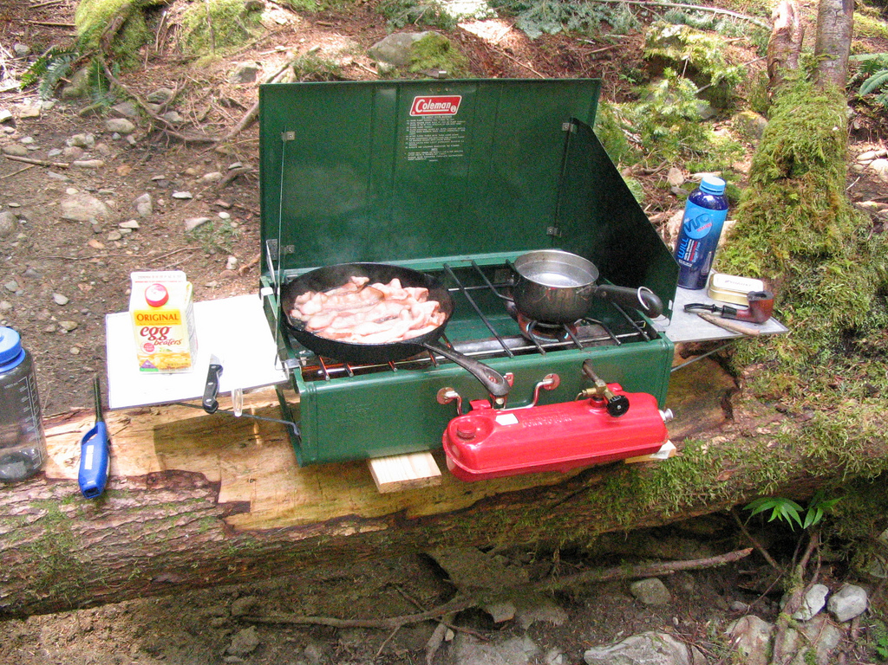
Many people love camping and lantern viewing. Cooking while in the camp and joining lantern festivals is truly enjoyable and gives a great hangout time. Using camp stoves is ideal when the camp site is not a great risk of fire. Great hazards come when you are not aware of the substance you are using during a supposed-to-be “fun time”. It is important to know the exact materials you need before you purchase them to avoid fire and any danger.
So what exactly is Coleman Fuel?
Coleman fuel, popularly known as naphtha or “white gas” (other names include: petroleum ether, petroleum naphtha, Amsol 10, Kensol 10, VM&P (varnish makers & painters) naphtha, and petroleum benzin) is a 100% hydrotreated distillate liquid petroleum fuel that is colorless and odorless and is used primarily in camp stoves and lanterns. This type of fuel contains up to 25% n-hexane, 15% cyclohexane, and less than 0.001% benzene by weight. It was originally been sold in cans and was the same as the “drip gas” or natural-gas condensate. This fuel is very popular in North America during the 1950s and almost every house owns at least one can of it. To this day, Coleman Fuel is still used in camp stoves, lanterns, and even fire dancing.
Tips for Safe Usage of Camping Stoves:
Check the stove before using. Look for any damages or leaks of the valve, fuel lines, and the fuel container before lighting the stove.
Never use any stove inside the tent. Tents are highly combustible so they are more likely to catch fire. If you are cooking inside the enclosed tent using a stove, this can also cause carbon monoxide poisoning and suffocation.
Always carry a match with you. When piezo-igniter fails, a match can be helpful for the stove to start a fire. Always keep you face and body be at a safe distance while lighting a match or turning the stove on.
Place the stove on a flat surface before using. Be sure that your stove’s base balances the level of the surface to avoid the risk of spilling of hot liquids while cooking. If you are on a sandy area, use an excess ply wood or any flat objects that you could place your stove on.
Always bring tools for repairs. Never forget to bring tools while using a camp stove in case of any necessary repairs. However, be sure that you are knowledgeable enough to repair the damage to avoid the risks of danger.
What are the tips in Using Coleman Stoves that I should know?
- In priming Coleman-fueled stoves, you can use alcohol to lessen the soot produced.
- When using the stove, use a windbreak if necessary to shield off the wind against the burners.
- Do not store your tank for a long period of time without emptying and cleaning it beforehand. Otherwise, sediments might form inside the tank, making it unusable in the future.
- Leave room for the air to breathe inside the tank so fueling it fully is not advisable. Leaving enough space in the tank will make it easy to pump and pressurize it.
What are the tips I can use in cleaning Coleman-fueled stove?
Coleman fuel produces very less impurities and dirt so the stove could almost comes clean after use. However, you still need to clean it regularly to maintain its performance and fuel-efficiency and lessens its odds for damages, corrosion, and sediments buildup.
- Cleaning the stove when it becomes dirty or every after a boil-over is recommended. Remove the burner from the stove and use a soap and warm water to wipe off the dirt from its surfaces. Never forget to dry the stove before using.
- If inside the case has a large amount of grease and dirt, you can use a high pressure hose to clean the area around it and turn the stove upside down to dry. Make sure that all the waters inside the manifold are removed to prevent it from rusting.
- When you store the stove to be used on the next camp season, put it inside a tight plastic bag and make sure that no insects or dust can clog the fuel lines.
- When using it again, oil the pump cup on the tank’s pump plunger to let it work smoothly and pumps air evenly.
What are the dangers of Coleman Fuel that I should be aware of?
Coleman fuel is an acute irritant that cause minor irritations, burns, and swelling of body tissues upon contact. So it is necessary to be cautious in transferring the liquid in the stove or another container so as not to spill any of it on your skin.
Dermal exposure. Upon contact to the skin for a short time, coleman fuel may cause minor irritation whereas long-term contact causes persistent dermal problems and redness of the skin.
Intake. This fuel, just like any other petroleum distillates, when ingested can cause itchiness and burning of the mouth, esophagus, and intestines.
Inhalation. This fuel, when inhaled, may cause respiratory tract infection, fluid buildup, loss of consciousness, and suffocation.
Prolonged exposure of Coleman Fuel may damage the motor and nerve cells and deteriorates some body organs like kidney, liver, and respiratory system.
If you experience a problem after newly exposed to Coleman fuel or other petroleum distillates, prepare the Coleman first-aid kits and emergency basics. (https://www.youtube.com/watch?v=sclzHElwOcA)

