VIRAL NOW! A MOM WAS CAUGHT EATING HER CHILD INSIDE A HOSPITAL IN CHINA!
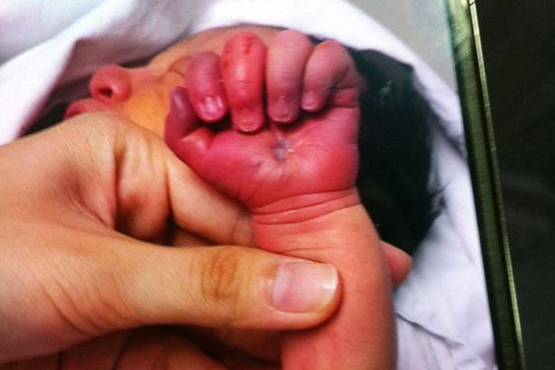
We’ve all seen or heard some weird things in the world that truly surprise us or left us in wonder. If you think you’ve seen enough, wait until you read this news from a hospital in Shenzhen, CHINA …
LI ZHENGHUA, a 24-year old woman who just gave birth to a baby boy, was caught gorging on his son’s arm before she was stopped by the nurses. A nurse force the woman to get rid of her son’s arm, but the woman wouldn’t let go but force her teeth on the child instead. Finding out that force was of no avail, the woman was given sedatives and put her to sleep. The doctors then pulled her jaws apart and place a mouth guard in her mouth.
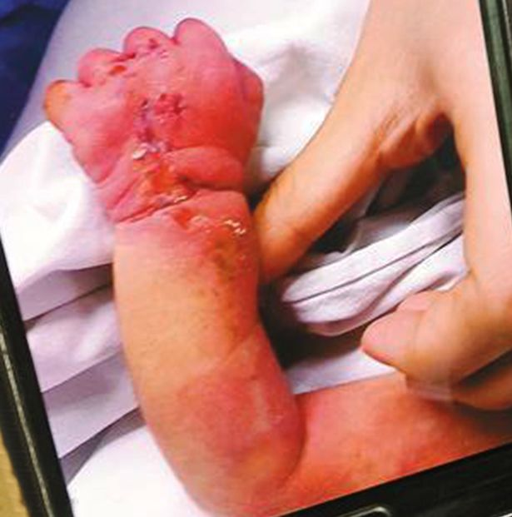
The infant obtained heavy bruises and massive bleeding resulting from the mother’s bites. He was taken care of by the hospital staff and the social workers who are still discussing if they would return the child custody to the mother.
The mother was kicked off by her mother-in-laws place when she was still pregnant so she was forced to live and starve on the streets. People accused her of cannibalism, and this story may have something to do with that alleged behavior.
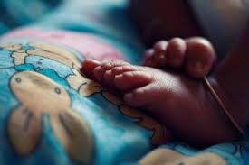
The people who saw the events on the hospital took the photos and posted it online. This has earned many comments such as “disgusting”, “shocking”,” terrible”, while others condemned the mother for that act saying she shouldn’t have blessed with a child. Others empathize with the mother, claiming that she has some sort of mental problem caused by her horrible state before giving birth.
In your own opinion, should the mother be judged dreadfully and denounce protection of her child?

