4 SHOCKING WEIGHT LOSS METHODS: ARE YOU BRAVE ENOUGH TO TRY THEM?
All of us want to get good curves and lose weight without a single lick of exercise. With this fact, business firms are creating new ideas to get good profits with those who are really in need to change their body size. Now, women on the internet are sharing these seemingly absurd methods that help them reduce their weight--- and some are really ridiculous you can even question them. But science has a say to these:

- TOUNGE PATCH

This tongue patch is made by plastic surgeon Nicholas Sugay and it is aimed to be sewed on your tongue so that it will be difficult for you to eat solid food. Of course, if you only eat liquid food, your intake of high calorie foods will decrease. People who have tried this method reportedly lost 20 pounds in average for one month. The only problem is that, getting rid of the patch after may cause you to want to eat again…unless you’re motivated to continue your diet.

- NASAL DRIP

If your body doesn’t have carbohydrates and glucose to use as energy, your fat will usually burn off and will convert to energy, a process called ketosis. This weight loss method developed by Dr. Oliver Di Pietro is known as KE diet which guarantees you to shed 10 pounds for ten days. You just have to insert a small tube in your nose through your stomach and constantly drip low-calorie, protein and fat-rich solution directly in your stomach and if you stick on not eating beyond that, a little tube and a bag of nutrients are just a little sacrifice for an awesome body later.

- URINE INJECTION

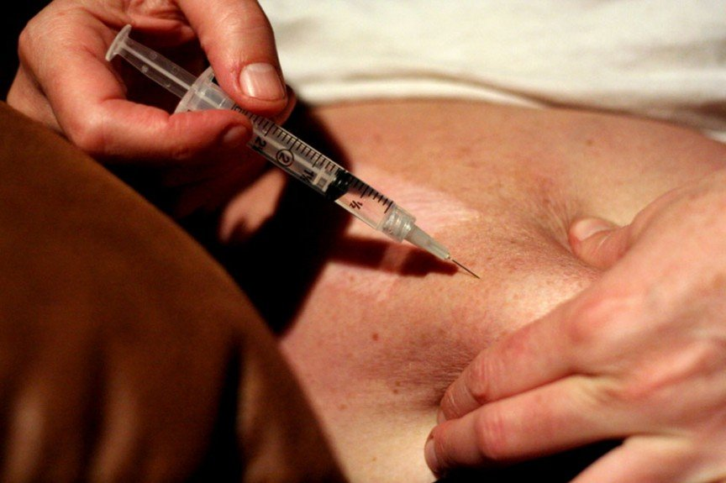
A woman named Sheyl Peloni once reported to have lost weight after injecting herself urine of pregnant women once a day. The hormone human chorionic gonadotrophin of a pregnant’s urine can trick the body to metabolize faster believing that the body is pregnant.

- THE TAPEWORM DIET

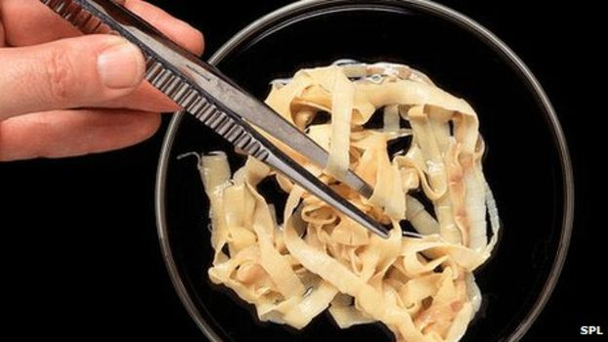
One woman once told her doctor that she bought a tapeworm and ingested it hoping to make it help her burn her fat. Yes, you can actually get thin having a parasite inside your body, but it can also take away your nutrients that your body needs to function causing anemia, malnutrition, or worse, death.

