5 Foods You Need to Watch Out for When You’re in China
China is widely known for its fake products--- from fake gadgets, clothes, cosmetics, medicines, furniture, wares, and just almost any product that you can think of, they can fake it. Now, even foods are forged illegally. A lot of All of this counterfeit goods are easy to spot because they are generally cheaper than the original product, and a lot of business-minded individuals are going to this business because they can double (or even triple) their profit even when they are putting other lives at stake. Surely, China has a lot of good foods to offer, but there are also foods that you need to watch out for when you’re visiting the country.
- FAKE RICE

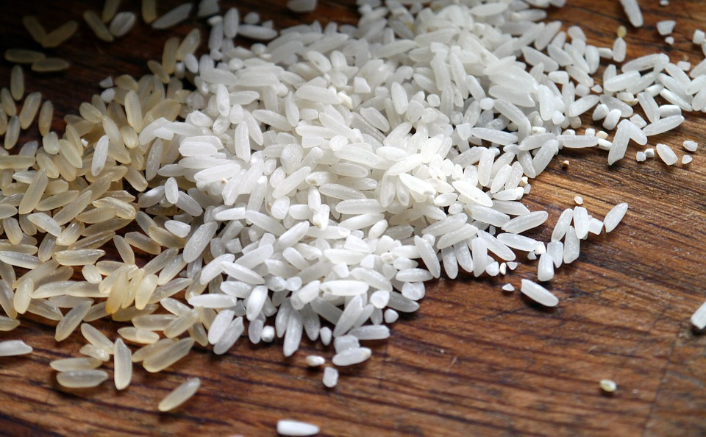

As a part of Asian cuisine, Rice is widely eaten in China, and you need to avoid this synthetic rice that tastes like plastic. Many countries have been receiving this rice, and people have been complaining how it caused them stomach problems as it was very hard to digest even when cooked at a great period of time.

- PORK DISGUISES AS BEEF

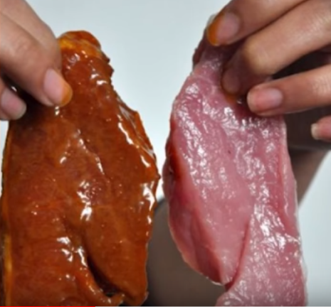

Pork is much cheaper than beef. Some restaurants have been modifying pork meat to make it look and taste like beef. By soaking the pork meat into the beef extract for thirty minutes, the pork turns reddish in color. Boiling the meat and putting a mixture of caramel and beef powder can make it look brown like beef and even smell like real beef.

- FAKE EGGS

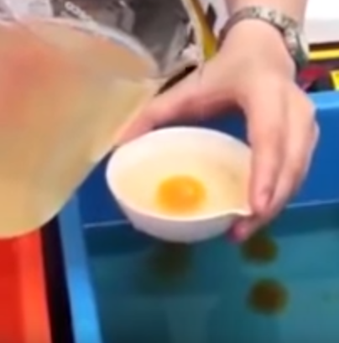

These fake eggs are made of gelatin, resin, coagulants, and starch, mold and shaped like real eggs. If you eat these too often, it may cause memory problems and even cancer.

- FAKE HONEY
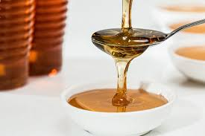

Mixed with rice syrup or sugar syrup, fake honey is almost as unrecognizable as the real ones.

- FAKE STEAMED BUNS

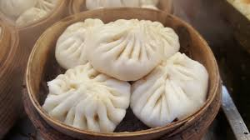

You can see several stalls in the streets that sell steamed buns. But watch out, because some of these “pork” steamed buns may actually have cardboard filling. The used cardboards are immersed in water to moisten and added with caustic soda, cooked, and seasoned as the pork filling.

These foods are as deadly as they’re gross, and being very cautious might save you from unwanted diseases caused by these insane products.

