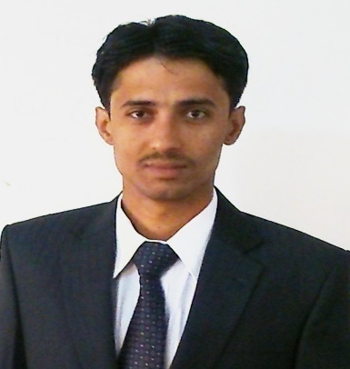
CURRICULUM VITAE

FAKHRUDDIN KOLACHI
Mobile #: +92333-7238897
Email: fakhruddinkolachi8@gmail.com
Postal Address: IBA Hotest # 16, Akhuwat Nagar, Near Goal Masjid, Airport road,
Sukkur.

Objective:

To work in learning and challenging environment, utilizing my skill and knowledge to be the best of my abilities and contribute positively to my personal growth as well as growth of the organization.

Academic Qualification:

DEGREE | INSTITUTE | DURATION | DIV/GRADE/ CGPA
MBA (Finance)  (2 year) | University of Sindh, Jamshoro | Jan 2013-Dec 2014 | C.G.P.A: 3.34  (79%)
B.Sc. (G. Science)  (Finance)  (2 year) | Shah Abdul Latif University, Khairpur | Aug 2009 - Dec 2011 | (1st Division)  Grade (‘B’)  61%
Intermediate  (Computer Science) | F.G College H-9 For Men, Islamabad | Aug 2007 - Apr2009 | (2nd Division)  Grade (‘C’)  53%
Matriculation  (G. Science) | B.I.S.E Sukkur | Aug 2004 – Apr 2006 | Grade (‘A’)  78%

Skills & Interests:
- Computer literate with excellent skills of MS Office especially MS Excel.
- Strong verbal/written communication.
- Fluent in English, Urdu and Sindhi.
- Strong work ethics, work well with others.

Achievements and Awards:

- Certificate of one day Finance Manager Training Workshop by Sir Saleem at University of Sindh.
- Certificate of one day Entrepreneurship Workshop by Sir Saleem at University of Sindh.

Internship and Class Project:

Place / Organization | Date | Supervisor | Description
Stock Exchange Hyderabad | 14 Oct 2014 | Asst: Prof Abdul Sattar Shah | Visited stock exchange where we observed the working of stock exchange and how their rate fluctuates
Business Research Management (BRM) | 7 Feb 2014 | Asst: Prof Vishnu Parmar | We had given a project in which we wrote a business plan about hotel business. We did industry analysis, analyzed our competitors, and prepared estimated financial statements.

Personal Information:

- Name: Fakhruddin
- Surname: Kolachi
- Date Of Birth: 4th January, 1991
- NIC No: 45102-4950879-1
- Religion: Islam
- Marital Status: Single
- Domicile: Ghotki ® Sindh
- Nationality: Pakistani
- Permanent Address: Kolachi Tent Service, near anti-corruption Police Station, Ghotki

Reference:

- Will be furnished upon request.

