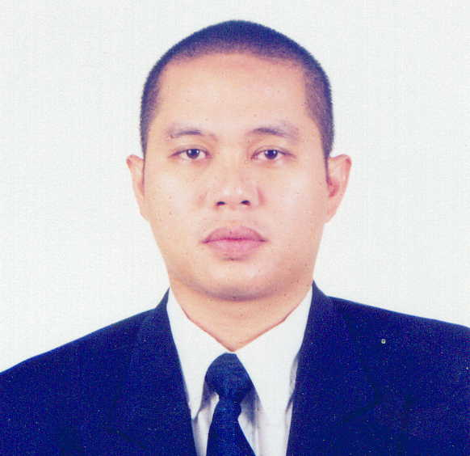

RICHARD G. BONIFACIO
Unit 6355 Flora Vista, 345 Peacock Street
East Fairview, Quezon City 1118
E-mail : richard.g.bonifacio@gmail.com
Skype ID : richard.g.bonifacio
Home Phone : +63 961-8534
Mobile Phone : +63 9425092412

__________________________________________________________________________________________

WORK EXPERIENCES

BALSAM INTERNATIONAL

Online Reputation Management – Senior Analyst August 2015 to Present

- Provide support to the manager in supervising the team to ensure that all tasks, deliverables and targets are met.

- Monitoring online reviews outside of brand, including the Better Business Bureau, Yelp, Complaints Board and others

- Improving and keeping a high brand reputation rating

CHOXI.COM INC (formerly Nomorerack.com)

Social Media and Online Reputation Manager (Freelancer) November 2012 to August 2015

- Manages and monitors Social Media accounts such as Facebook, Twitter, Instagram and Youtube.

- Monitors performance of agents to ensure that quality customer service thru various social media accounts, email and online chat is given

- Handles complex customer complaints such as Better Business Bureau (BBB), Attorney General, Federal Trade Commission

DISTRIBUTED WEBSITE CORPORATION

Account Manager (Independent Contractor) February 2012 to July 2012

- Provide quality online customer support to institutional clients all over the U.S.

- Ensure that new and existing clients are satisfied with the program they purchased

NCR SINGAPORE PTE LTD

Incident Management Officer November 2010 to March 2011

- Allocates work order to field engineers to ensure service level agreement with corporate clients are met

- Liaise with other departments and third party contractors to ensure clients’ operations are not compromised

ADECCO PERSONNEL PTE LTD (Singapore)

Phone Banking Officer for ANZ Bank September 2009 to October 2010

- Handles client enquiries and requests pertaining to their bank accounts and other products & services offered by the bank

- Coordinate with other department heads for approval of special handling requests of bank clients

- Ensured knowledge is up-to-date by participating in individual and team trainings and meetings and reading the information posted in the Call Centre’s Knowledge Management System (KMS)

- Assisted Phone Banking Centre by reporting issues found in our Customer Relationship Management (CRM) Software and other bank systems

UNITED OVERSEAS BANK LTD (Singapore)

Customer Service – Senior Officer October 2007 to June 2009

- Resolved customer complaints and problems to the satisfaction of the customer

- Used customer service and sales skills to optimize the opportunity of each customer contact

- Configured bank softwares such as CARDPAC and AS400 for team mates

- Assisted clients in navigating bank’s internet banking website and setting up their personal internet banking accounts

- Entered customer data and other relevant information into the Customer Relationship Management Software (CRMS)

ACCENTURE INC. (Philippines)

Technical Support-Helpdesk October 2006 to October 2007

- Assisted clients on all DSL and internet connectivity problems

- Provided customers assistance in setting up Wi-Fi Networks for home or small offices

- Troubleshoot customers’ PC, from hardware to software problems

- Helped clients configure email accounts

ONE GLOBAL CONTACT CENTER

Fulfillment Team Leader June 2001 to September 2006

- Conducts daily monitoring of the tasks delegated to each Fulfillment Officer on duty

- Prepares agenda for team meetings and weekly schedule of the entire department

- Conducts quarterly evaluation and monitoring of performance of team members

- Seeks adequate information and total support solutions to external and internal customers

- Performs more on decision-making and track orders from the initial placement to supplier, to warehouse and to deliveries

SPECTRUM ELECTRONIC APPLICATION CORPORATION

Accounts Manager April 1999 to August 1999

- Achieve a sales target of Php 5.4 million per quarter. Conduct at least 25 client calls per week.

- Prepare, analyze, and negotiate proposals with the company to come up with the best offer that will suit client needs.

- Submit a minimum of 100 fully accomplished database report per week with the name of key persons, the present system used, and other strategic information needed by the company.

PHILCOPY CORPORATION

Account Executive June 1998 to February 1999

- Achieve sales target in relation to budget given by top management

- Conduct a minimum of 120 personal client calls/visits per month with a minimum target of 20 full presentations with prospective clients per week with the end in view of achieving 300 points per month

- Ensure broad and extensive coverage and penetration of the market by systematically calling on all companies as assigned in the hit list and by conducting presentation to various user groups

PHILIPPINE WIRELESS, INC. (Pocketbell)

Field Sales Executive-Direct Marketing December 1997 to June 1998

- Recommends on a continuing basis improved strategies and techniques of sales and promotions

- Investigates and provides information on competitive activities encountered either directly or indirectly in the marketplace

- Utilizes personal effectiveness and professional confidence in developing strong business relationships with the market

EDUCATIONAL BACKGROUND

College:

1997 Bachelor of Science in Business Administration, Major in Marketing

Philippine School of Business Administration
Aurora Boulevard Cubao, Quezon City

Short Courses Taken:

2002 Computer Systems Design and Programming
AMA Computer Learning Center
Aurora Boulevard corner EDSA Cubao, Quezon City

2000 Certified Internet Professional Program
Informatics
SM Southmall Las Pinas City

TRAININGS AND SEMINARS ATTENDED:

Supervisory Workshop
E-Pacific Global Contact Center
May 2005

Foundation Coaching Program
United Overseas Bank of Singapore
November 22 to December 12, 2007

Negosyo Basics Program
Philippine Center for Entrepreneurship
July 29, 2011

