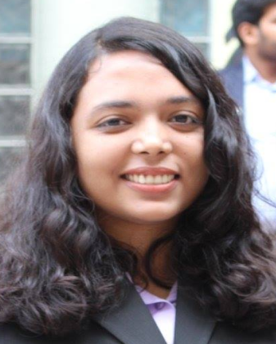
Tashnuva Sumaiya Islam
House-8, Road-4, Sector-4, Uttara, Dhaka-1230, Bangladesh
16th July 1993 01882651954 tashnuvasumaiya.i@gmail.com
“Ambition, curiosity and enthusiasm to learn are my motivators to build a successful career”
Work Experience:

- Communications Officer at SAJIDA Foundation (1st June 2017 to 30th November 2017)

- Coordinated field visits for new employees
- Participated and volunteered at Development Fair 2017
- Volunteered at Broken Earth Training on High End Delivery 2017
- Participated at NSU Career Fair 2017
- Collection and verification of data on SAJIDA Foundation for Annual Repot 2017
- Maintained database for media articles
- Translated all internal documents from Bangla to English and vice versa

- Content Writer at Hubdhaka (17th January 2017 to 17th April 2017)

- Interviewed 22 startup entrepreneurs for social media blogs
- Handled all creative documentation of the firm
- Editing articles and content creation for marketing

- Human Resource Management Intern: at Novo Nordisk Pharma Private Ltd. (7th April 2016 till 30th August 2016)

- Regularly filing the records of the job applicants
- Assist the employers during interview or training sessions
- Archiving highly confidential information of employee files
- In charge of content creation and editing of employee magazine ‘Life Changing Careers’
- Maintaining and promoting the Facebook page ‘Life Changing Careers’ on different social media networks
- Receiving the Curricular Vitae of job applicants
- Designing and editing the Employee Handbook for new recruits
- Collecting ‘Candidate Satisfaction Surveys’ from job applicants
- Contacting banks and other financial institutions regarding bank accounts and finances for 300 employees
- Supervising written exams of job applicants.

- Marketing Intern at Canadian University Application Centre (CUAC) (July 2011 to September 2011)
- Arranged invitations for 800 students to attend Education Fair organized by CUAC
- Providing basic information on Canadian Universities to the applicants
- Contacting schools and students to encourage them to apply at Canadian Universities
- Maintained call logs and student database

I learnt:
- Languages:
English:
Bangla:
- Software:
MS Office:
Google Drive:
Bijoy Bangla typing software:
A day from my life:

What I like:
- Public speaking:
- Participated in Debates and won accolades at Model United Nations Conferences
- Writing:
- Participated in ‘Pursuit of Passion’ hosted by North South University Communications Club
- Leadership:
- Participated in Bangladesh Youth Leadership Training on “Art and Practice of Leadership 6”
I learnt:
Languages:
- English:
- Bangla:
Software:
- MS Office:
- Google Drive:
- Bijoy Bangla typing software:

My Strengths:
H.M Ferdous Tusher
HR Business Partner,
Novo Nordisk Pharma Pvt. Ltd.
Phone: 01787683615
Maruf-Ibne Wali
Lecturer, School of Business and Economics,
The North South University School of Business and Economics
Phone Number: 01716788220
Education:

- BRAC University
Masters in Development Studies
Jan 2017- July 2018 CGPA: 3.27

- The North South University
Bachelors in Business Administration in HR and Marketing
Jan 2012-August 2016 CGPA: 2.72

- The Aga Khan School
O’levels and A’levels
2008-2011
References:

