Togoshi Ginza: Explore the Homey Streets of Tokyo戸越銀座：探索東京溫馨的街道

Facebook: What is more quintessential to a residential area than a local market street where everyday people would go grocery shopping and grab a few munchies along the way. Well, here’s a perfect spot for those who’d like to get an everyday Tokyoite experience.

Tokyo is the largest city in the world with 13 million people living in an area just about the size of Los Angeles county, that means it’s twice as dense as LA.

Naturally, the city has more residential areas than the flashy business areas like Shibuya or Shinjuku. And what is more quintessential to a residential area than a local market street where everyday people would go grocery shopping and grab a few munchies along the way. Well, here’s a perfect spot for those who’d like to get an everyday Tokyoite experience.

臉書：對於住宅區而言，當地的商店街最為經典，人們日常都會去那裡的雜貨店購物，並沿途享用著各式小吃。這裡就是想要體驗東京人日常的絕佳好去處。
東京是世界上最大的城市，在一個大約洛杉磯縣的面積有1300萬人生活著，這表示它的密度是洛杉磯的兩倍。
很自然地，這座城市比起華麗的商業區，如澀谷或新宿有著更多的住宅區。對於住宅區而言，當地的商店街最為經典，人們日常都會去那裡的雜貨店購物，並沿途享用著各式小吃。這裡就是想要體驗東京人日常的絕佳好去處。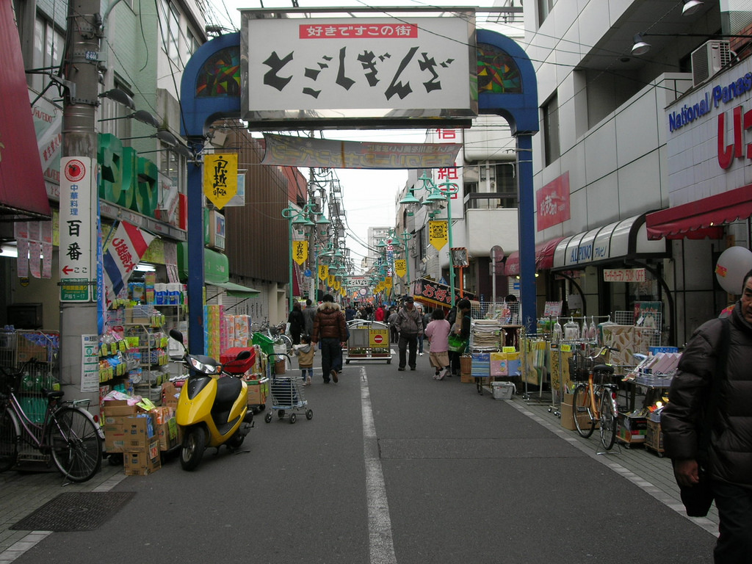
tohashi, Flickr 戸越，Flickr
https://www.flickr.com/photos/t-ohashi/4359515422/

Togoshi Ginza is a 1.3km shopping street located in southern Tokyo. It should not be confused with Ginza, which is the highend shopping street located in central Tokyo, although Togoshi Ginza gets its name from it.

The shopping street has over 400 businesses of various kind along it. It is the ultimate go-to spot for any daily shopping, as well as some souvenirs. However, the biggest attraction of all are the numerous restaurants and stands that serve food to be eaten on the streets.

戸越銀座是位於東京南部一條1.3公里長的商店街。它不應該與位於東京市中心的高端商店街銀座相混淆，雖然戸越銀座以它而得名。
該商店街沿途有400多家各類商店。這是任何日常購物以及購買紀念品的終極目的地。然而它最大的吸引力是眾多供應街頭小吃的餐廳和攤位。
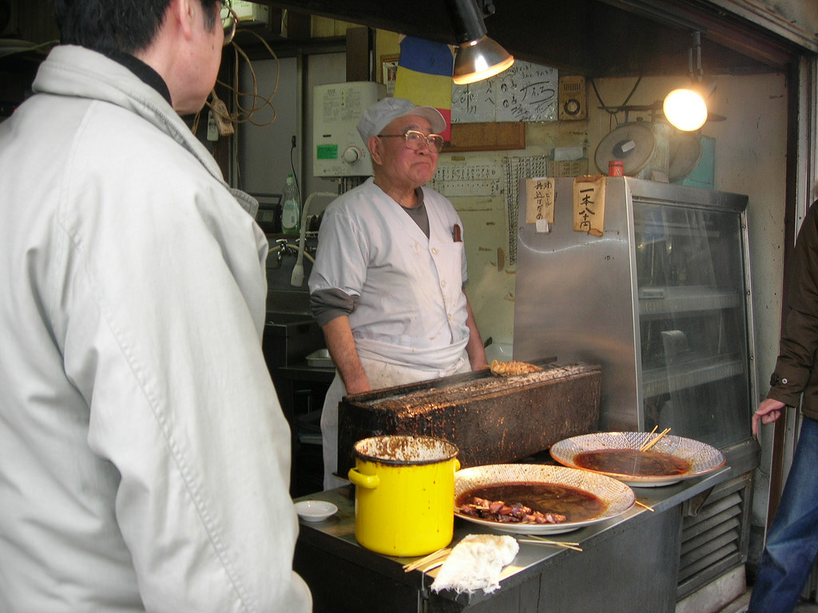
tohashi, Flickr 戸越，Flickr
https://www.flickr.com/photos/t-ohashi/4358774849/

There are dozens of spots where you could buy food and eat on the streets. One of the most popular ones is the yakitori, where the master would roast the chicken in front of the streets. It fills the streets with a savory smell of roasted chicken dipped in special yakitori sauce.
您可以在幾十個地點買到食物然後直接在街上吃。其中最受歡迎的是烤雞肉串，那裡的師傅會在街道前烤雞肉。整條街道都能聞到特殊串燒醬汁的烤雞香味。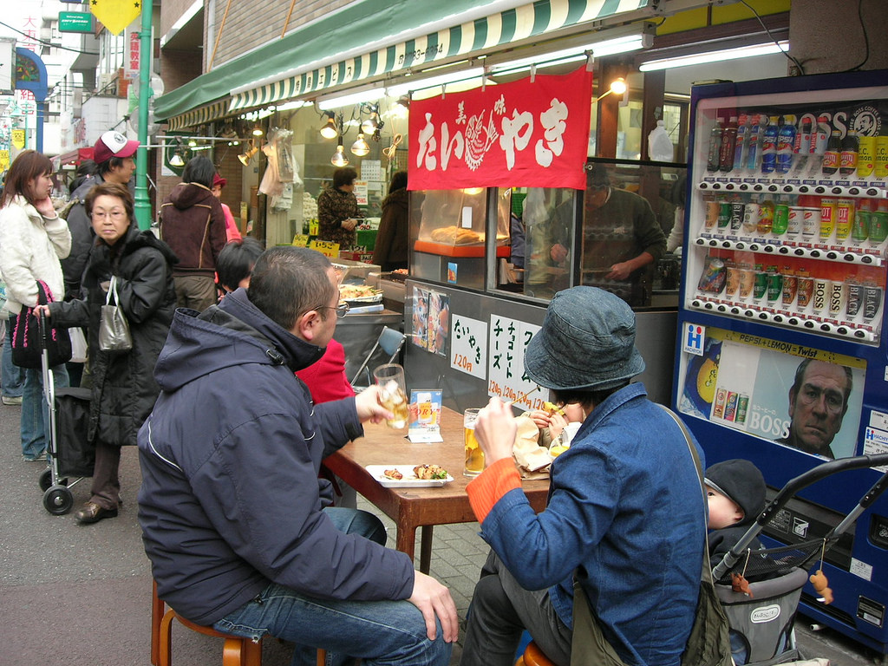
tohashi, Flickr 戸越，Flickr
https://www.flickr.com/photos/t-ohashi/4358777831/

Another great thing about these streets is that there are restaurants which put out stools and tables for people to eat. Here is one taiyaki place which serves drinks as well as a variety of munchies. During summer, they also serve shaved ice, which is an absolute lifesaver during the hot and humid summer in Tokyo.

這些街道另一項偉大的事情是餐廳會在外面擺放凳子和桌子供人們用餐時使用。這是一間供應飲料以及各種各樣零食的鯛魚燒餐廳。在夏季他們還會供應刨冰，簡直就是東京在炎熱和潮濕的夏季期間絕對的救星。
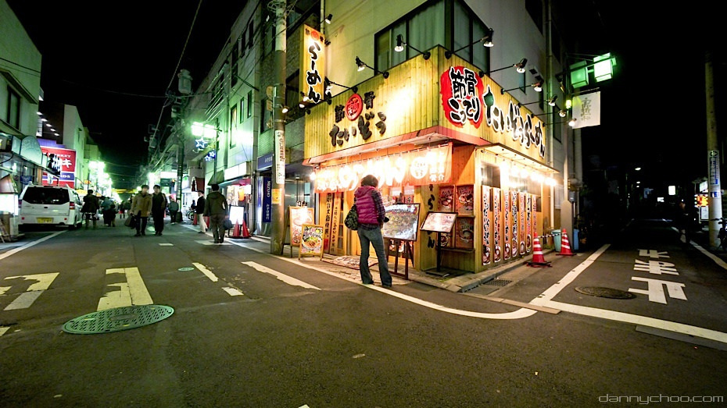
Tokyo Times, Flickr 東京時刻，Flickr
https://www.flickr.com/photos/localjapantimes/5374769746/

The busy streets during the day turns into a restaurant district at night. Although many of the family owned businesses close at this time, there are still a lot of fun in this town. There are ramens, izakaya, Italian food, you name it. Togoshi Ginza might not be the most famous spot for tourists to visit, but it’s a surely fun place to spend a few hours just strolling.

白天繁忙的街道在夜裡搖身一變成為餐飲區。儘管此時許多家族商店已經關店，這座城市還有許多樂趣等著您去發掘。這裡有拉麵，居酒屋，意大利餐，您想吃的都儘管點吧！戸越銀座可能不是最著名的遊客觀光勝地，但它確實是可以花上幾個小時漫步閒逛的有趣地方。

