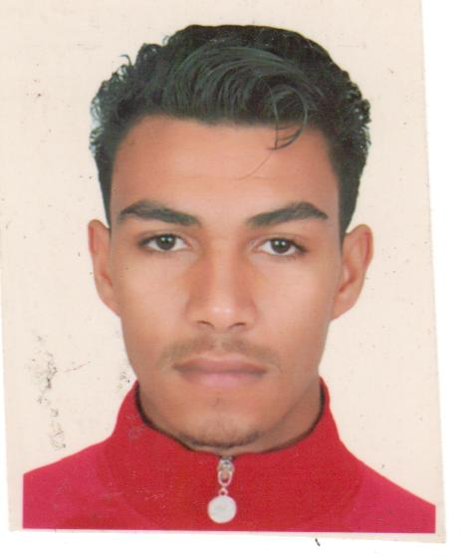
Mohammed BERRAZZAG

25 years old
Hay Elmohammadi LOT Elkhir RUE aloukar #14
Oujda, Morocco
+212 606615442
mohammed_berrazzag@hotmail.fr
EDUCATION

2011-2012 Science baccalaureateISLY High school Oujda

2013 - 2015 Computer Science& Networking, SpecialInstitute of Application technologies (ISTA Lazaret Oujda )
.
S22015 –2017English studies literature option at the University Mohammed the first Oujda

EMPLOYMENTAND EXPERIENCE

July 2008 - September 2008
Temporary work and actively pursuing a career in business.

August 2012 - October 2012 Resident Voluntary worker, orphans shelter, Oujda.
Duties included administration, advocacy work with external agencies. This was a demanding yet rewarding first job.

March 2015-april 2015

Traineeship at Management and IT support department of POPULAIR BANK Oujda region

December 2016 - June 2017

IT Trainer at GROUP INDEX IT & Language Training Center

Jouly 2017-november 2017
commercial agent at Oppo smartphone company
january 2018 tiltt now
web agent at E-M-S [e_marchet Solution]

Professionals Skills
E-marketing: (SEO) search EngingOptimisation , (SEA) Search Enging Advertising,(SMO) Social Media Optimisation,(SEM) Search Enging Marketing ,E-mail Marketing, ADWords
E-Commerce : Built a Shopping Wbesite , Buying online (Ebay,Amazon, Shopify…)
IT Supports, Software & OS : MS Office , MS Exchange , Cisco equipment, Networking Protocols, VertualSysteme (VMware,Vertual Box), DNS, DHCP, Active derctory ,Windows, lunix, Windows Server, Redhart.

IMPROVEMENTS PROFESSIONALS

Project Completion training on BGP protocol configuration via IP version 6.
Cisco CCNA Cisco Certified Network Associate Certification
GOOGLE Digital Marketing Certification

LANGUE
ENGLISH : Academic level / FRANCH : fluently / ARABIC : native language

